An Experimental Demonstration of an Android Mobile Application that utilises Augmented Reality and Text to Speech to Educate the user about the Moon.

**___________________________________**

**Jonathan Roddy**

**K00212118**

A Final Year Project submitted in partial fulfilment of the requirements of Limerick Institute of Technology for the degree of Bachelor of Science (Honours) in

LC 233 Software Development

Supervised by:

Dr. Carol Rainsford



April 2021

Ethical Declaration

I declare that this project and document is my own work except where I have made explicit reference to the work of others. I have read the Department of Information Technology Final Year Project guidelines and relevant institutional regulations, and hereby declare that this document is in line with these requirements.

I have discussed, agreed, and complied with whatever confidentiality or anonymity terms of reference were deemed appropriate by those participating in the research and dealt appropriately with any other ethical matters arising in line with the LIT Research Ethics Guidelines for Undergraduate and Taught Postgraduate Programmes policy document.

_______________________ ____________________

Jonathan Roddy April 2021

# Acknowledgements

I would like to thank my supervisor’s Dr. Carol Rainsford, Desmond O Carroll, and Dr. Niall Corcoran for allowing me to develop MyMoon as a final year project. With their guidance and help I would not have been able to complete this document. They were always available to meet up and discuss any problems and got me to focus on what was important for this project.

I would like to thank NASA for providing me with free to use imagines, textures, and facts that they have gathered and released. Without their continuous commitment of giving the world free education, I would have not been able to create such a high detail of accuracy within this project.

I would like to thank my family and friends for their encouragement who supported me along the way.

R.I.P John Horton Conway (1937 - 2020) who sadly passed away due to Covid-19.

# Abstract

My final year project that I have developed is an Android application that educates users about the Moon using features like Augmented Reality, Text-To-Speech, factual data, and multimedia. I wanted to investigate if it is possible to educate people about a specific topic using an Android application. For this project, I needed to learn how to develop an Android application, how to create realistic 3D models using Blender, implementing augmented reality in Android Studio and to learn best practices for user experience and user interaction. With this project I was able to test members of my friends and family to full see if the implementation I had created is capable of teaching them about the Moon. This project was extremely exciting to create as it allowed me to combine my interest with Astronomy and technology.

Table of Contents

Ethical Declaration i

Acknowledgements ii

Abstract iii

Table of Figures 5

List of Tables 7

1 Research Report 8

1.1 Chapter 1: Introduction 8

1.1.1 Background 8

1.1.2 Aim of Project. 9

1.1.2.1 Primary Objectives 9

1.1.2.2 Secondary Objectives 10

1.1.3 Research Questions 10

1.2 Chapter 2: Augmented Reality 11

1.2.1 Introduction 11

1.2.2 What is Augmented Reality (AR) 11

1.2.3 History 11

1.2.4 Components of AR 13

1.2.5 Architecture Diagram for AR 15

1.2.6 Current uses 16

1.2.7 Edutainment using AR. 20

1.3 Chapter 3: Text to Speech 22

1.3.1 Introduction 22

1.3.2 What is Text to Speech 22

1.3.3 History of TTS 22

1.3.4 Components of TTS 23

1.3.5 Synthesizer 24

1.3.5.1 Concatenation 24

1.3.5.2 Unit selection 24

1.3.5.3 Diphone 26

1.3.5.4 Domain-specific 26

1.3.6 Formant 27

2 Methodology 29

2.1 Introduction 29

2.2 Chapter 1: Android development with Augmented Reality 30

2.2.1 Introduction 30

2.2.2 Technologies required. 30

2.2.3 Hardware Development Environment: 30

2.2.4 Software Development requirements 31

2.2.5 Support requirements: 31

2.3 Chapter 2: Android Integrated Development Environment’s (IDE) 31

2.3.1 What is an IDE? 31

2.3.2 Android IDEs 33

2.3.3 Augmented Reality Application Programming Interface (AR API) 37

2.3.3.1 What is an API? 37

2.3.3.2 ARCore 38

2.3.3.3 Vuforia 38

2.3.4 3D Modelling 39

2.3.4.1 Blender 39

2.3.5 Database 40

2.3.5.1 Firebase 40

2.3.6 Text to Speech 40

2.3.7 Technology Conclusion 41

2.4 Chapter 3: Educating users about Moon via Augmented Reality 43

2.4.1 Introduction 43

2.4.2 The Moon 43

2.4.3 Similar Apps available 44

2.4.4 Resources Required 45

2.4.5 Data Collected 46

2.4.6 Effective edutainment 46

2.5 Conclusion 49

3 Software Report 50

3.1 Introduction 50

3.2 Design 51

3.2.1 Introduction 51

3.2.2 Requirements 52

3.2.2.1 Project Requirements 52

3.2.2.2 Non-Functional Requirements 53

3.2.2.3 Supportability List of Actors 53

3.2.2.4 List of Use Cases 53

3.2.3 Android Design 55

3.2.3.1 Material design 55

3.2.3.2 Fragments 56

3.2.4 Diagrams 57

3.2.4.1 Mind Mup 57

3.2.4.2 Use Case Diagram 58

3.2.4.3 Use Case Documentation 60

3.2.4.4 Sequence Diagram 63

3.2.4.5 Class Diagram 67

3.2.4.6 Flowchart 69

3.2.4.7 Application Wireframe 71

3.2.5 Conclusion 75

4 Results 76

4.1 Chapter 1: Implementation 76

4.1.1 Introduction 76

4.1.2 Project Management 76

4.1.2.1 Microsoft OneNote 77

4.1.2.2 GitHub 78

4.1.2.3 Microsoft Project 78

4.1.2.4 Microsoft Project 79

4.1.3 Learning obstacles 81

4.1.3.1 Certifications 82

4.1.4 Development Process 84

4.1.4.1 AR Model Creation 84

4.1.4.2 Database implementation 92

4.1.4.3 Android Development 93

4.1.5 Conclusion 112

4.2 Chapter 2: Testing 113

4.2.1 Introduction 113

4.2.2 Test Objectives 113

4.2.3 Android Studio Debug 114

4.2.4 Test Cases 115

4.2.5 Test Data 118

4.2.6 Verification/Validation Traceability Matrix 136

4.2.7 Firebase Test lab 137

4.2.7.1 UX/UI Testing 139

4.2.7.2 Accessibility 142

4.2.7.3 Performance Test 143

4.2.8 Integration Tests 146

4.2.9 Conclusion 146

5 Discussion 147

5.1 Issues faced. 147

5.2 Future Work 150

5.3 Reflections 150

6 Conclusion 152

Bibliography 154

Appendices 161

3. Build and Render 3D Models. 162

5. Fact Adapter 163

8. John Horton Conways algorithm to find lunar phases. 169

# Table of Figures

**Figure 1:** Global Stats (GlobalStats, 2020) 9

**Figure 2** History of Augmented Reality (Poetker, 2019) 12

**Figure 3** Core component of Augmented Reality technology (Hui-Jeong Kim, 2020) 14

**Figure 4** AR application Architecture (Herpich, 2018) 15

**Figure 5** Pokemon Go(Statt, 2017) 16

**Figure 6** Augmented Reality in sports (Usman, 2020) 17

**Figure 7** IKEA Place (Dasey, 2017) 18

**Figure 8**: Face Tracking with ARKit (Apple, 2020) 18

**Figure 9** Authorization with Face Recognition (BioID, 2020) 19

**Figure 10** A conceptualized Framework for Edutainment Environment (Hanafizan Hussain, 2003) 21

**Figure 11** Overview of a typical TTS system (Andy0101, n.d.) 23

**Figure 12** Example of Decision trees (Jadhav, n.d.) 25

**Figure 13:** Unity Game Engine (AXON, 2016) 34

**Figure 14:** Visual Studio (Microsoft, 2019) 35

**Figure 15**: Android Studio Editor (Williams, 2019) 36

**Figure 16:** Amazon Sumerian Console (Skarredghost, 2018) 37

**Figure 17:** UI Positions(Dori, 2019) 49

**Figure 18:** Software Development Lifecycle (Kwon, 2019) 52

**Figure 19:** Android Lifecycle (Masters, 2013) 55

**Figure 20:** Android Fragments (mit, 2021) 56

**Figure 21:** Mind Mup Diagram 58

**Figure 22:** Use Case Diagram 59

**Figure 23:** Sequence Diagram Dashboard 63

**Figure 24:** AR Moon Model 65

**Figure 25:** Sequence Diagram Moon Phase 66

**Figure 26:** Basic Class Diagram 68

**Figure 27:** Application Flowchart 70

**Figure 28:** Splash Screen, Home page and Settings 72

**Figure 29:** Augmented Reality Page 73

**Figure 30:** Discover Page. 74

**Figure 31:** Moon Phase Page 75

**Figure 32:** Gantt Chart Page 1 79

**Figure 33:** Gantt Chart Page 2 80

**Figure 34:** LinkedIn Learning Cert 82

**Figure 35:** Android Development UI with Java 83

**Figure 36:** UX for Non-Designers 84

**Figure 37:** Moon Colour Map (Wright, 2019) 85

**Figure 38:** Moon Displacement Map (Wright, 2019) 86

**Figure 39:** Blender Modelling 87

**Figure 40:** Blender Material Texture 88

**Figure 41:** Blender Moon Model 88

**Figure 42:** Blender Toothpick flags 89

**Figure 43:** Europe Texture Layout **Figure 44:** Blender Flags Texture Mapping 90

**Figure 45:** Blender Moon with Flags Locations 90

**Figure 46:** Blender Moon Model with Flags 91

**Figure 47:** Blender of Earth and Moon Animation 91

**Figure 48:** Firebase Storage Rules 92

**Figure 49:** Firebase Storage 93

**Figure 50:** MyMoon Splash Screen 94

**Figure 51:** Dashboard Navigation Screens 95

**Figure 52:** Extended Home Page 96

**Figure 53:** Settings screen 97

**Figure 54:** Contact us Page **Figure 55**: Contact us Sending email. 98

**Figure 56:** About Us page 99

**Figure 57:** Augmented Reality Dashboard 100

**Figure 58:** Augmented Reality Instructions 100

**Figure 59:** Augmented Reality fragment 102

**Figure 60:** AR Core SLAM 103

**Figure 61:** Augmented Reality Download 104

**Figure 62:** Augmented Reality Ready 105

**Figure 63:** Augmented Reality 105

**Figure 64:** Augmented Moon with/without flags and Earth models 106

**Figure 65:** Discover Moon Facts **Figure 66:** Discover Mission Facts 107

**Figure 67:** Discover Facts CardView 108

**Figure 68:** Discovery Video 109

**Figure 69:** Discover Video CardView 109

**Figure 70:** Discover Image. 110

**Figure 71:** Moon Phase Screen 112

**Figure 72**: Project Statistics 113

**Figure 73:** Verification and Validation Traceability Matrix 136

**Figure 74:** Firebase Test Lab Console 138

**Figure 75:** MyMoon Crawl graph 141

**Figure 76:** Firebase Test Lab Accessibility Overview Pixel 2 142

**Figure 77:** Firebase Test Lab Accessibility Overview Pixel 4 142

**Figure 78:** Touch Target Size **Figure 79:** Low contrast 143

**Figure 80:** Pixel 2 Performance Overview 144

**Figure 81:** Pixel 2 CPU, Memory, Network Performance 144

**Figure 82:** Pixel 5 Performance Overview 145

**Figure 83:** Pixel 5 CPU, Memory and Network Performance 145

# List of Tables

**Table 1:** Android IDE Comparison 42

**Table 2:** Tested Android Devices 139

# Research Report

## Chapter 1: Introduction

### Background

Have you have ever stood out on a clear night’s sky and watch our celestial neighbour, the Moon, as it slowly moves? I have done this several times in my life and will continue to do so at every chance that I can. Our Moon is a wonderful and scary place to find yourself alone. It is a place where no life has been found nor can a normal human being survive on the surface without external help from a spacesuit. It is 4.51 billion years old (Wall, 2017) which is a bit younger than the Earth at 4.54 billion years old. (Redd, 2019). No one knows exactly how the Earth received a moon but without it, life today would be quite different. There are a few hypotheses that scientists have agreed upon that could explain how we got out moon: Giant impact which states that a large celestial body impacted our young earth, Co-formation which states that the moon was formed around the same time as the Earth or Capture theory which states that we inherited a floating Moon. (Reed, 2017). These types of facts are what my aim is for this project. My interest in astronomy helped me to decide on what this project will be as I would love to use an app like this.

I choose to develop a smartphone application as this allows me to have a much greater target audience. People today have access to a smartphone where they may not have access to a computer or laptop. Ever since the first smartphones were released, the mobile market scene has exploded more than anyone would imagine.

Apple released its very first iPhone back in 2007 which at the time read with them releasing the Apple App Store later in 2008. At the beginning of Apple's success, the apps that they were providing were developed by in-house developers limiting other developers to launch independent apps on IOS. Apple's first iPhone was so successful that other companies were soon to catch up and emulate their success. Google launched its equivalent, Android in 2008. Google's business model allowed all developers to publish their apps creating a burst of third-party app development. IOS and Android are the two common smartphone operating systems, however, there are many smaller options like KaiOS, Windows Phone, Symbian OS, and Blackberry.

Currently as of writing this literature review the current worldwide market share for smartphone devices as of January ‘09 – October’20 is divided as such: Mobile 50.21% Desktop 47.17% and Tablet at 2.62%. (GlobalStats, 2020) From this statistic, the mobile market share is currently in favour of mobile.

***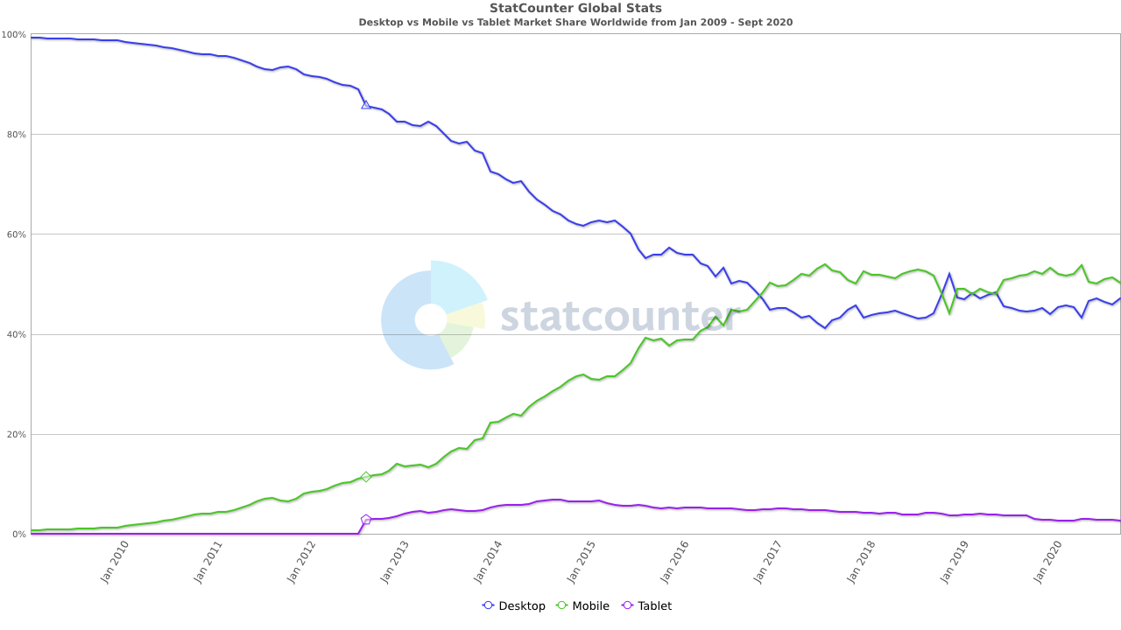*Figure 1:** Global Stats (GlobalStats, 2020)

This project gives me the chance to be able to develop an Android application that teaches the user about the Moon and its surface. The best way for me to portray this to the user is in a way that both excites the user as well as informs them. I have chosen to use Augmented Reality (AR) in my android app as it is an immersive technology. Using AR gives a user something to look at as well as something to manipulate on their smartphones. I plan to use Text to Speech (TTS) within my application to help in narrating some text to the user. The use of both AR and TTS together helps in the immersion of the environment that I want to give to the user.

### Aim of Project.

The aim of my project is to be able to create an immersive Android application that teaches the user about the Moon and its surface using Augmented Reality. To be able to accomplish this I need to have a further analysis of how to develop a mobile application fixating on the educational aspect.

#### Primary Objectives

My primary objective for this project is to develop an Augmented Reality mobile application that educates the users about interesting features of our Moon.

1. Develop an Augmented Reality Android app that connects to a local and online instance on a database.
2. Explore the idea of simulating the lunar surface.
3. Implement and expand upon the text to speech to further aid any user.
4. Conduct an extensive Research review.
5. Learn all aspects of Augmented Reality and its common uses to date.
6. The development of a mobile application
7. Utilizing immersive technologies and their benefits
8. Detailed history on the Moon, structure, and topography
9. How Text-to-Speech enables easier ways to access digital content

#### Secondary Objectives

My secondary objectives for this project would focus on my personal development during this research paper.

1. I aim to meet all the deadlines on time in a professional manner.
2. Take the advice given by my supervisor and lectures and expand upon them further.
3. Learn in detail how to develop an Android app that implements augmented reality.
4. To advance my knowledge and skills as a software developer.

### Research Questions

1. How can Augmented Reality be used in an effective educational environment?
2. How can Augmented Reality and Mobile applications reduce the inaccessibility of environments such as the Moon?
3. How can you explore the lunar surface utilizing Immersive technologies?
4. How can Augmented Reality help educate people on new topics?
5. How much can someone learn about the Moon using an Android device.

## Chapter 2: Augmented Reality

### Introduction

In this chapter, I will discuss what Augment Reality (AR) exactly are, the components that make up an AR application, how developers can implement AR, any limitations, or drawbacks with using AR, and how to use AR in educational entertainment ‘edutainment’.

### What is Augmented Reality (AR)

Augmented Reality is one of the immersive technologies that has grown in recent years with the development of stronger and faster devices. Immersive technology refers to technology that attempts to emulate a physical world through the means of a digital or simulated world. Virtual Reality (VR) is another such form of immersive technology, but it encapsulates the user with a wearable headset and controllers. AR adds digital elements to a live view often by using the camera on a smartphone (Furht, 2011). The use of AR lets the user experience the real world which has been digitally augmented or enhanced in some way. VR on the other hand, removes the user from the real-world experience, replacing it with a completely simulated one. For this reason, I will develop my project using AR as most of my users will not have the correct equipment to utiliser VR. AR can be handled and used with a common smartphone device as well as many other devices. This ability to use AR on smartphones is what is enabling me to peruse this project.

### History

AR is not a new technology by any means as the first attempt was invented by a cinematographer called Morton Heilig in 1947. Figure 1 below, shows us a detailed roadmap of where in time did a breakthrough happen (USC School of Cinematic Arts, 2020). He invented the ‘Senorama’ which delivered visuals, sounds, vibration, and smell to the viewer. It was not computer controlled but it was the first example of an attempt at adding additional data to an experience.

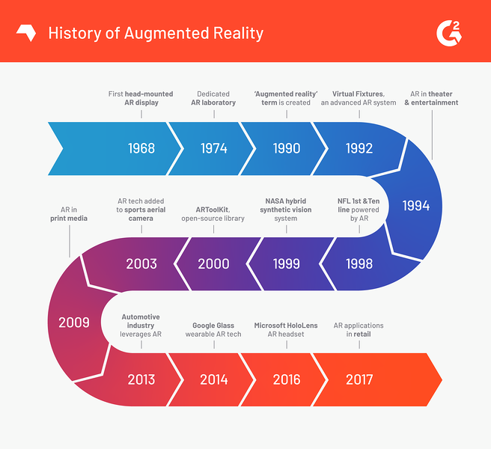**Figure 2** History of Augmented Reality (Poetker, 2019)

In 1968, an American computer scientist and early internet influencer, Ivan Sutherland invented the head-mounted display as a kind of window into a virtual world. The technology used at the time made the invention impractical for commercial use.

In 1975, Myron Krueger, an American computer artist developed the first ‘virtual reality’ interface in the form of ‘Videoplace’ which allowed its users to manipulate and interact with virtual objects and to do so in real-time.

In 1980 Steve Mann, A computational photography researcher, gave the world wearable computing.

The word ‘virtual reality’ was not coined up until 1989 followed by Thomas P Caudell of Boeing coining the phrase ‘augmented reality’ in 1990.

The first properly function AR system was developed at USAD Armstrong’s Research Lab by Louis Rosenberg in 1992. This was called Virtual Fixtures and was an incredibly complex robotic system that was designed to compensate for the lack of high-speed 3d graphics processing power in the early nineties. It enabled the overlay of sensory information on a workplace to improve human productivity.

There are many other breakthroughs in augmented reality in recent years such as.

* Bruce Thomas developing an outdoor mobile AR game called ARQuake in 2000.
* ARToolKit, a design tool, being made available in Adobe Flash in 2009
* Google announced its open beta of Google Glass in 2013
* Microsoft announcing augmented reality support and their augmented reality headset HoloLens in 2015.

### Components of AR

AR is achieved through a variety of technological innovations; these can be implemented on their own or in conjunction with each other to create augmented reality. They include:

* **General hardware components –** This refers to the processor, the display, the sensors, and input devices. Typically, a smartphone contains a processor, a display, accelerometers, GPS, camera, microphone, etc., and contains all the hardware required to be an AR device.
* **Displays –** while a monitor is perfectly capable of displaying AR data there are other systems such as optical projection systems, head-mounted displays, eyeglasses, contact lenses, the heads up display (HUD), virtual retinal displays, EyeTap which is a device which changes the rays of light captured from the environment and substitutes them with computer-generated ones (EyeTap, 2020), Spatial Augmented Reality (SAR) which uses ordinary projection techniques as a substitute for a display of any kind, and handheld displays.
* **Sensors and input devices –** GPS, gyroscopes, accelerometers, compasses, Radio-frequency identification (RFID), wireless sensors, touch recognition. Speech recognition, eye tracking, and peripherals.
* **Software -** most of the development for AR will be developing further software to take advantage of the hardware capabilities. There is already an AR Mark-up Language (ARML) which is being used to standardize XML grammar for virtual reality. There are several other software development kits (SDK) which I will further investigate in the below topic.

Below in figure 3, we can see a rough outline of how what are common variables in an AR system.

* *The display device platform* is made up of HMD (head-mounted display), non-HMD, and handheld. Knowing what device your customers will be using is key as it changes the whole development structure according to the resources in hand.
* *Tracking* can be doing using marker-based fixtures like a card or location so that the projection is fixed in place. Developing a marker-less based system allows for the application to 3d scan its surroundings for more of an open approach.
* *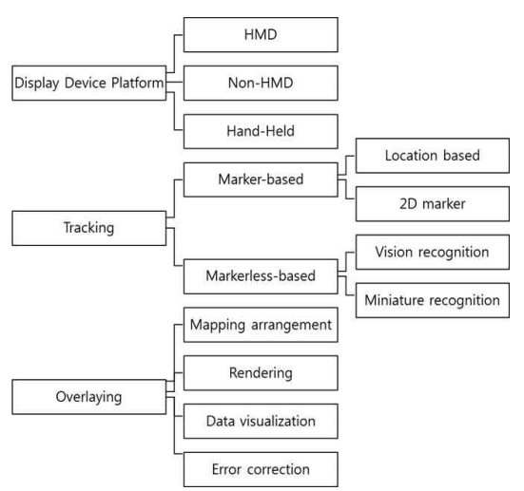Overlaying* refers to the application itself and how it works to ensure it comes out error-free by dealing with map arrangement, rendering, data visualization, and error correction.

**Figure 3** Core component of Augmented Reality technology (Hui-Jeong Kim, 2020)

### Architecture Diagram for AR

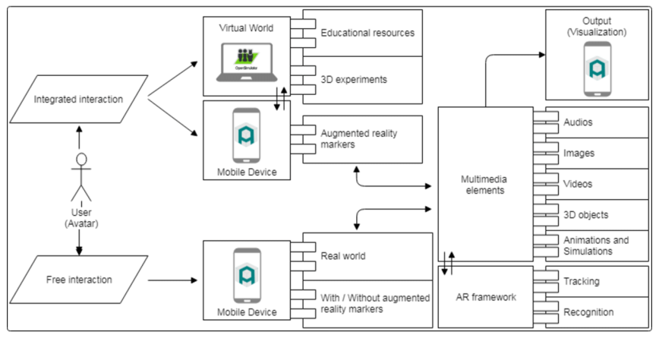Figure 4 outlines an architecture diagram for a full AR application. In the world of AR there can only be two ways in which an object can be shown to a given user, marker, and marker-less interactions. Marker interactions is where the application is looking for a pre-determined picture in real-life so that it may use overlay its models on top of it. These pictures can be either QR codes, logos or an image used within a company. Marker-less however does not need an image to be able to displays its models. This form of AR is a lot more complex as the technology itself is doing a lot more then scanning the area for a picture. Marker-less uses complex algorithms to investigate the environment to assess what can be seen. This technology is called Simultaneous Localization and Mapping (SLAM) (Agrawal, 2020).

**Figure 4** AR application Architecture (Herpich, 2018)

Navigating through the above diagram the user has the option for both integrated interaction and free interaction, respectively. If they were to go down the route of integrated interaction, they would find themselves using marker-based tools to assist with the application. If they went into free interaction, they would be using the markerless based tools for the application. Multimedia elements would encapsulate all resources like audio, images, videos, 3d objects and animations, and simulations. It communicates with the AR framework which handles the tracking and recognition software. The final project is released with all data coming from the multimedia elements to the mobile application where the application is presented to the user.

### Current uses

There are apps available for or being researched for AR in every industrial sector including:

* Archaeology, Art, Architecture
* Commerce, Office
* Construction, Industrial Design
* Education, Translation
* Emergency Management, Disaster recovery, Medical and Search and Rescue
* Games, Sports, Entertainment, Tourism
* Military
* Navigation

**Interactive Gaming**

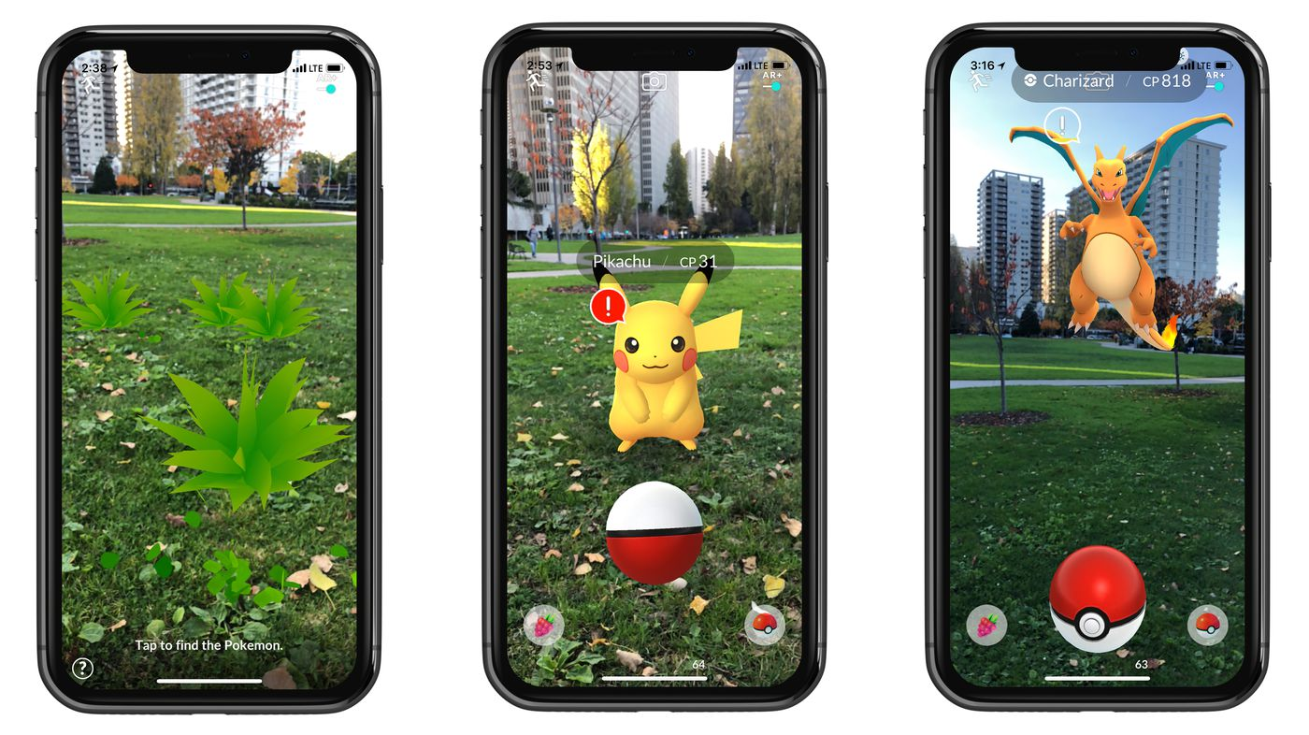When it comes to daily AR users, the Pokémon Go app takes the gold. Based on a playing card game that became popular in the ’90s, this Nintendo gaming app skyrocketed in popularity when it was released as a free mobile app in 2016. Users simply download the app to hunt for Pokémon characters in their everyday surroundings. The app uses your GPS data to determine where you are and reveal the virtual characters within your real world. Pokémon Go has to date, 147 million active users. (Anon., 2020)

**Figure 5** Pokemon Go(Statt, 2017)

**Data-Driven Sports Broadcasting**

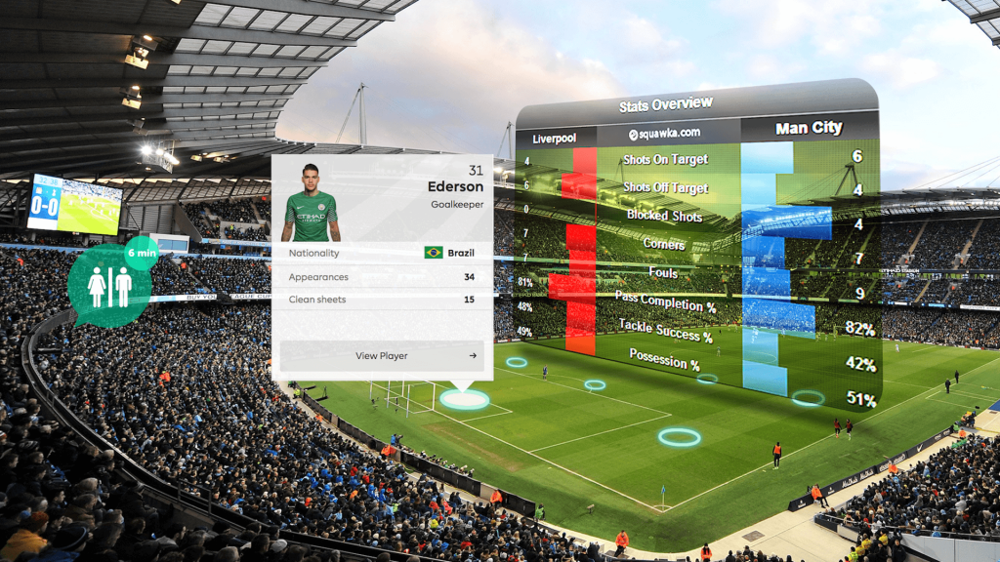These days there is no shortage of AR on a field, rink, court, or turf when it comes to live-action sports. These were some of the first applications of AR praised by mainstream consumers. The goal behind AR in sports broadcasting was to increase viewership by providing additional information during a game. In this case, AR applies 3D graphics and interactive visual elements on top of the live video footage of the game. It is just another way to visualize the trajectories of a ball, puck, or a player with the help of lines and curves. This tool helps the audience see close calls, fouls, and record-breaking achievements in a much more detailed way than ever before.

**Figure 6** Augmented Reality in sports (Usman, 2020)

**More efficient and engaging shopping**

Another common use of AR in our everyday lives is during the home buying process. Using a ‘virtual tours’ option, prospective homebuyers can often view a property from the comfort of their desktop computer or mobile device before making the trek to see the home in-person. These clients can also use furniture placements apps like Houss and DecorMatters to see how they would furnish one of their potential homes. IKEA is leading the charge in this respect using a digital furniture placement app called IKEA Place that also allows you to virtually ‘try before you buy’.

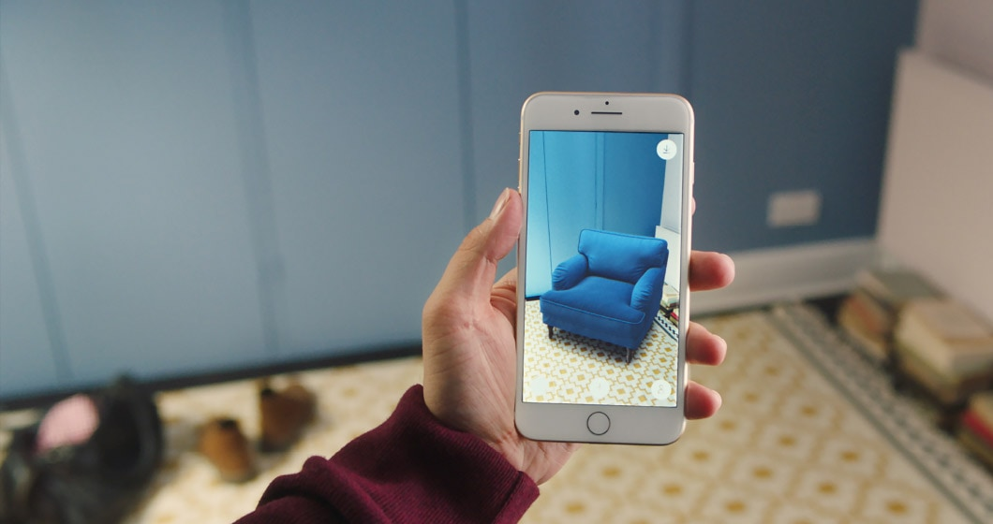**Figure 7** IKEA Place (Dasey, 2017)

**Video Conferencing**

Filters on Snapchat, Instagram, and iPhone Facetime Memoji are just some of the ways consumers use AR every day. Facial recognition software within camera hardware has gotten increasingly more sophisticated. Apple even offers a solution developer kit just for your face. In this case, dedicated front camera arrays, known popularly as the ‘dreaded’ notch, which has become an industry-standard, scans your face with up to 30,000 dots near-instantly to get a very secure read. This provides a unique and in-depth analysis of your face through mathematical ratios. (Apple, 2020)

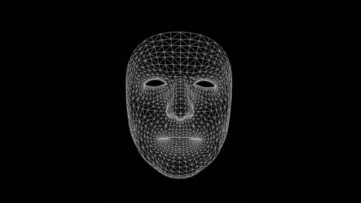

**Figure 8**: Face Tracking with ARKit (Apple, 2020)

Like gaming, family members and co-workers can use this software to build a virtual representation of themselves anyway around the world. Imagine people sitting in a conference room together even though they are in different countries. Or imagine a family gathering taking place in someone is living room, despite being in different cities or other sides of the glove. This increased virtual presence will have a significant impact on consumer's line in the future by cutting back on travel costs.

**Authorization**

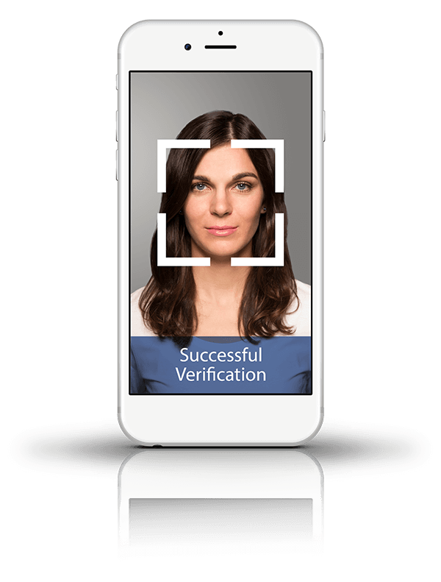The quickest and most common way iPhoneX, or newer users, use AR today is by unlocking their phone with their faces. Long gone are the days of using a thumbprint of pushing a button to unlock your phone. These users are also able to scan their faces as a way of gaining access to password-protected sites. Instead of resetting or looking up a forgotten password, facial recognition software can be sued in place of a username and password to any website or app in just a few seconds. Facial recognition software also allows users to authorize payments through Apple Pay, Google Pay, or Samsung Pay. This applies to mobile, and in-person purchases where stores have readers for mobile devices. AR payment options expedite the consumer process.

**Figure 9** Authorization with Face Recognition (BioID, 2020)

### Edutainment using AR.

‘Edutainment – products such as books, television programs and especially computer software that both educate and entertain’ (Oxford Learner's Dictionaires, 2020)

Hashim and Hanafizan Hussain have created a framework that they describe fixates on the development of a computer game. (Hanafizan Hussain, 2003). They have gathered eight factors that reflect the design of an edutainment environment.

* **Meaningful learning –** computer games provide environments in which children find learning to be meaningful and useful.
* **Goal –** Goals create a sense of mission in children and often they will stay on until they could finish the game.
* **Success –** Accomplishing goals and giving achievements can provide children with a sense of success.
* **Challenge –** Challenges ensure that children would not get bored easily.
* **Cognitive artifact –** Introduction cognitive artifacts enhance our cognitive abilities.
* **Association through pleasure –** Children need to associate learning with some pleasant memory enforcing that the concepts remain with them.
* **Attraction –** Game design can create environments in which children get excited about embedded learning activities and therefore are willing to be immersed in it and spend time learning it.
* **Sensory stimuli –** Educators must have sensory stimuli so that the fun of playing the game and make the learning more enjoyable and memorable**.**

They have argued that the most common issues that children have when it comes to learning anything are motivation and psychological needs. Keeping the user’s motivation active ensures that they will be using the application or game for longer. In Figure 10, you can see that edutainment is built upon several components pulling from both the educators, game design, and multimedia. To get a complete edutainment environment it needs to allocate for each of those problems.

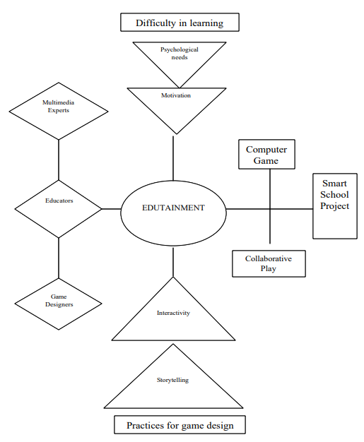

**Figure 10** A conceptualized Framework for Edutainment Environment (Hanafizan Hussain, 2003)

## Chapter 3: Text to Speech

### Introduction

In this chapter, we will investigate the technology of Text to Speech (TTS), the history of TTS, different versions of TTS systems, and common problems this technology faces. The use of TTS today is widely used as an accessibly to those who cannot read or see well enough to read.

### What is Text to Speech

TTS is a speech synthesis feature that is used to create an audio version of the text in a computer document, such as a help file or a web page. Speech synthesis is the computer-generated rendering of a human voice (Allen, 1987). The use of TTS can enable a visually challenged person to read and communicate with a computer display.

A smart TTS program that can help people who have visual impairments or reading disabilities interact and read along with the computer with little to no resistance. Fortunately, a lot of time and research has been developed to enable us with a smarter and more diverse TTS system. Most of our devices we use daily have some form of TTS enable API’s built in.

### History of TTS

Humans have tried to mimic human speech for a couple of hundred years, long before the invention of electricity. The most popular origin inventors would be ‘Brazen Heads’ who involved Pope Silvester II (d. 1003AD), Albertus Magus (1198-1280), and Roger Bacon (1214-1294).

A German-Danish scientist in 1779, Christian Gottlieb Katzenstein won the first prize in a competition for the models he built of the human vocal tract that could produce the five long vowel sounds (a, e, i, o, u) (Helsinki University of Technology, 2006) . From this invention, the bellowed-operated speech machine came from Wolfgang von Kempelen of Pressburg, Hungary. (J. B. Degen, n.d.). This machine was different from the first iteration as this model was fitted a tongue with lips so that they could sound out constants and vowels.

The next iteration of this design came in 1837, where Charles Wheatstone produced a design based on the last design, and in 1846, Joseph Faber exhibited the ‘Euphonia’. (G.Mattingly, 1974)

In 1930 Bell Labs developed a new way forward for TTS as with his invention, the vocoder could change sounds into its fundamental tones and resonances. The inventor Homer Dudley then proceeded to continue his work by creating a keyboard-operated voice-synthesizer called The Voder (Voice Demonstrator), which he exhibited in 1939 at the New York World’s Fair.

At Haskins Laboratories, Dr. Franklin S. Cooper and his colleagues developed the Pattern playback in the early 1940s but did not complete it in 1950. This machine was different from all other forms as it approached the design differently. They investigated the method of using the acoustic wavelength of the word to be recorded and played back. This way of design allowed scientists to discover acoustic cues for the perception of different important phonetic sentences.

### Components of TTS

A complete TTS system is made up of two parts, a front, and a back end. (Jan P.H. van Santen, 1997) In figure 11, we can see what is described as an overview of a TTS system.

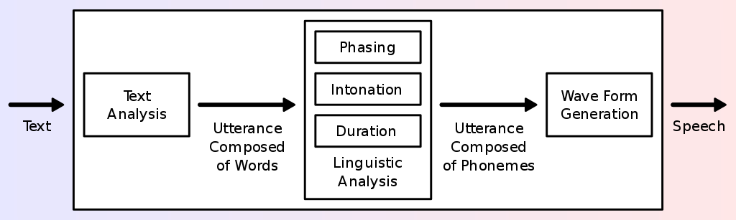The front end has two major operations that it needs to handle, it must first translate the raw text passed into it into each symbol like its corresponding numbers and symbols. The second job it must do is to assign each letter, symbol, or letter into its respective phonetic transcriptions and divides and marks the text into each of its prosodic units, like phrases, clauses, and sentences. Phonetic transcriptions and prosody information together make up the symphonic linguistic representation that is output by the front-end.

**Figure 11** Overview of a typical TTS system (Andy0101, n.d.)

The back end is called the synthesizer as this part is the output from the front end. The back end converts the symbols it has been received into what it believes that symbol sounds like. (Santen, 1994)

### Synthesizer

Naturalness and intelligibility are the most significant properties of a speech synthesis device (Taylor, 2009). Naturalness defines how closely the output sounds like a human voice, while the ease with which the output is understood is intelligibility. The perfect synthesizer for speech is normal as well as intelligible. Systems of speech synthesis typically aim to optimize all characteristics.

Concatenative synthesis and formant synthesis are the two primary technologies that generate synthetic speech waveforms. There are strengths and disadvantages in each technology, and the expected uses of a synthesis method will usually dictate which approach is used.

#### Concatenation

Concatenation synthesis is a process for synthesizing sounds by concatenating short samples (called units) of captured sound. The unit length is not precisely specified and can vary depending on the implementation, varying from ten milliseconds to one second. Concatenative synthesis has three major sub-types.

#### Unit selection

Unit selection synthesis uses broad recorded speech databases. Every reported utterance is segmented into any or all the following during the creation of the database: individual phones, phones, half-phones, syllables, morphemes, sentences, phrases, and phrases. "Usually, with some manual correction afterward, the division into segments is carried out using a specially adapted speech recognizer set to a "forced alignment" mode, using visual representations such as the waveform and spectrogram (Black, 2002).

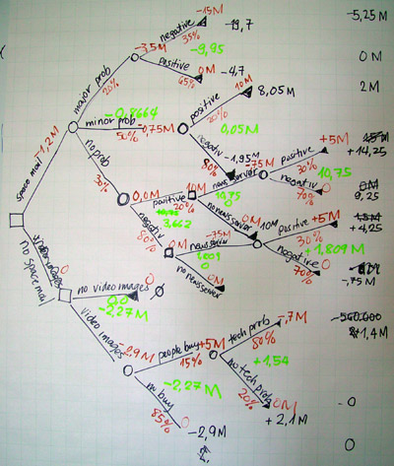 Based on the segmentation and acoustic parameters such as the fundamental frequency (pitch), length, location in the syllable, and neighbouring phones, an index of the units in the speech database is then established. The desired target utterance is generated at run time by deciding from the database the best chain of candidate units (unit selection). As shown in Figure 12, this approach is usually performed using a specially weighted decision tree.

**Figure 12** Example of Decision trees (Jadhav, n.d.)

The unit selection offers the greatest naturalness since the recorded speech only applies a limited amount of digital signal processing (DSP). DSP also makes recorded speech sound less natural, although some devices, at the point of concatenation, use a small amount of signal processing to smooth the waveform. Sometimes the output from the best unit-selection systems is indistinguishable from human voices, especially in contexts where the TTS system has been tuned for. (John Kominek, 2004).

Unit selection algorithms have also been known to choose segments from a position that results in less-than-optimal synthesis (e.g., minor terms are unclear) even though the database has a better choice. Researchers have recently proposed numerous automated methods for detecting abnormal segments in speech synthesis systems for unit selection. (Zhang, 2004).

Researchers have recently proposed numerous automated methods for detecting abnormal segments in speech synthesis systems for unit selection. (William Yang Wang, n.d.).

#### Diphone

Diphone synthesis uses a minimal speech database containing all the diphones (sound-to-sound transitions) occurring in a language is used in diphone synthesis. The number of diphones depends on the language's phonotactic: for example, there are about eight hundred diphones in Spanish and about 2500 in German. In diphone synthesis, the speech database only contains one instance of each diphone. The goal prosody of a sentence is superimposed on these minimal units. At runtime, these minimal units are superimposed on the target prosody of a sentence using automated signal processing techniques such as linear predictive coding. PSOLA (ppgb, 2001) or MBROLA.

More recent techniques, such as pitch modulation using discrete cosine transformation in the source domain (R.Muralishankar, 2004). Diphone synthesis suffers from concatenative synthesis acoustic glitches and formant synthesis's robotic-sounding nature and has few of the advantages of either method other than a small scale. As such, its use in commercial applications is decreasing, although it continues to be used in research since many software implementations are readily accessible.

A teaching robot, Leachim, invented by Michael J. Freeman, is an early example of diphone synthesis (cyberneticzoo.com, n.d.). Leachim had information about the curricular class and some biographical information about the forty students it was expected to teach. It was tested in the Bronx, New York, in a fourth-grade classroom (World Future Society, 1978).

#### Domain-specific

To construct full utterances, domain-specific synthesis concatenates pre-recorded terms and phrases. It is used in systems where, including transit service announcements or weather forecasts, the variety of texts the device can generate is restricted to a certain domain (L.F. Lamel, 1993). The system is quite easy to incorporate and has long been in commercial use in devices such as talking clocks and calculators, for a long time. The level of naturalness of these systems can be extremely high because the variety of sentence types is limited, and they closely match the prosody and intonation of the original recordings. Since the number of sentence forms is small, and they closely follow the prosody and intonation of the original recordings, the degree of naturalness of these structures can be exceedingly high. They are not general-purpose and can only synthesize the variations of terms and phrases for which they have been preprogramed because these systems are constrained by the words and phrases in their databases.

However, the blending of words within the language spoken spontaneously will also create difficulties until the differences are considered. "In non-rhotic English dialects, for example, the "r" is usually pronounced in words such as "clear" /klə/ only when the following word has a vowel as the first letter (e.g., "clear out" is realized as /ˌklɪəɹˈʌʊt/). In non-rhotic English dialects, for instance, the "r”. Likewise, in French, if preceded by a word that begins with a vowel, an effect called liaison, several final consonants become no longer silent. A basic word-concatenation scheme, which would require extra sophistication to be context-sensitive, will not replicate this alternation.

### Formant

Formant synthesis, at runtime, does not use individual speech recordings. Instead, using additive synthesis and an acoustic model (physical modelling synthesis) (Darmouth College, 2011) the synthesized speech output is generated. To construct a waveform of artificial speech, parameters such as fundamental pitch, voice, and noise levels differ over time. This approach is often referred to as rules-based synthesis, but there are also rules-based components in many concatenative schemes. Artificial, robotic-sounding speech is created by multiple systems based on formant synthesis technology that can never be mistaken for human speech. Maximum naturalness, however, is not always the goal of a method of speech synthesis, and formant synthesis systems have benefits over concatenative systems. Also, at extremely high levels, formant-synthesized speech may be accurately intelligible, eliminating the auditory glitches that usually affect concatenative systems. The visually impaired use high-speed synthesized speech to easily access machines using a screen reader. Formant synthesizers are normally smaller programs than concatenative systems since they do not have a speech sample index.

In embedded systems, where memory and microprocessor capacity are particularly small, they can also be used.

Because formant-based systems provide full control of all facets of the speech production, it is possible to generate a wide range of prosodies and intonations, conveying not only questions and declarations, but a spectrum of emotions and tones of voice.

# Methodology

## Introduction

In this section of the paper, I aim to continue to explore all aspects needed for my final year project further beyond what I have covered in my literature review. In my literature review, I have researched two main technologies that I will be implemented for my project: Augmented Reality (AR) and Text-to-Speech (TTS). Having done this, it allowed me to be able to familiarize myself with both technologies so that I can be confident enough in utilizing them. I learned what they are, how they started, what is evolved when implementing them, and the components that are made from them.

This paper's goal is to highlight the technical knowledge required as well as the theme of the project. That includes aspects like Android Development, implementation of Augmented Reality, integrating Text-to-Speech, and being able to teach users interesting knowledge about our Moon. I will be researching each of those in-depth so that I may be able to be confident in my knowledge and my technical preparation before heading into the development stage.

There are several ways to complete a respectable Android application and I indent in finding the best solution that will both benefit this project as well as improving my studies and skills as a Software Developer. The needs for my technical research would include an Integrated Development Environment (IDE) for developing the software for the application, the correct Augmented Reality Application Programming Interface (AR-API) to utilize, what 3D rendering software is needed as well as a suitable database storage solution. Once I have researched and found the correct architecture infrastructure, I can continue with researching the theme. At the end of this project, I want to be able to teach users about the Moon, but I do not have any experience of teaching users over an application. Once I am happy that I have enough information I need, I will continue this projects life cycle into its design and implementation section.

## Chapter 1: Android development with Augmented Reality

### Introduction

In this chapter, I will delve into what technical knowledge and skills are needed to be able to develop an Android application that implements an Augmented Reality (AR) Application Programming Interface (API). I have not developed an android application before I started this project so this will be my first time developing an application. This brings new challenges and opportunities to which I can better myself with these new technologies and techniques. Such as, developing on an android integrated development environment, utilizing an AR API and TTS, 3D modelling and rendering as well as communication with a cloud database.

### Technologies required.

To be able to develop my final year project successfully I would need a mixture of hardware and software requirements. From my investigation in my literature review, I know what is required to build an Augmented Reality (AR) application. I have delved into the area of AR so I now can deduce what hardware components are required. I have listed below under each section what I need in preparation for this application. The list of technologies is as follows:

### Hardware Development Environment:

* Desktop computer: for the development of the application
  + Processor (CPU)
  + Graphics card (GPU)
  + Random Access Memory (RAM)
  + Motherboard
  + Power Supply Unit (PSU)
  + Input/Output peripherals
    - Mouse
    - Keyboard
    - Monitor
* Internet connectivity: to be able to connect to the internet for research and references.
  + Stable bandwidth connection
* Android Smartphone: for the implementation of the application
  + Processer
  + RAM
  + Integrated Graphics
  + Battery
  + Rear Camera
  + Screen (LCD or AMOLED)
  + Gyroscopes
  + Touch screen(digitizer)
  + Wi-Fi receiver
  + Android version 8.1 (API 27) or later.

### Software Development requirements

* Windows 10 (Operating System to house all applications)
* Android IDE (Programming the code)
* AR API (Import the AR libraries)
* TTS API (Read Text aloud to the end-user)
* Firebase (Google cloud Database)
* Blender (3D Model creation)
* Scene Viewer (3D Rendering)

### Support requirements:

* Supervisor meetings with L.I.T. given me their professional guidance and experience as needed.

Now I would like to talk about each component further explaining to you what they are as well as some common tools available.

## Chapter 2: Android Integrated Development Environment’s (IDE)

### What is an IDE?

An IDE can be defined as a developer’s toolkit. When you deal with a programming language, having a good IDE will make all the difference. It can help you prevent mistakes that would not otherwise be caught until it is time to compile or test your code. A good IDE has several essential features that it gives to the user which helps productivity move smoothly.

**Code editor:**

Most of the time is spent typing text into an IDE. To type your code, an IDE must have a place where you are comfortable to use you. If the editor is inefficient or clunky, then you will not want to spend your day using it. A good IDE even has editor emulation modes so that the same key combos that have already committed to muscle memory.

**Syntax highlighting**

An IDE display keywords from the language you are using in one colour, variables in another, libraries, and functions in another, etc. This emphasis is a small addition to your life in coding, but one that gives context to what would otherwise be a flat monotone text wall.

**Code Linting**

An IDE highlights your errors for you if you make a mistake while typing your code. This automated checking of code is known as ‘linting’.

**Code correction**

Linting is the error catching process and based on a rudimentary schema of expected syntax, many IDEs can do that. Although a brilliant IDE implies error correction. Best still, sensible corrections resulting from the way the programming language operates in real life should be proposed by an IDE. In other words, improvements that make sense for Java, not C# or Python, are recommended by a Java IDE Of course, it is not all perfect. Only a fix based on following a language standard can be suggested by an IDE, and in the wrong sense, that can ruin your project. It is important to have your interpretation of the terminology and what you are attempting to do but auto-corrections are useful for detecting apparent mistakes.

**Project awareness**

Code and assets are packed together with either physically or digitally so that you cannot leave any critical elements behind until you are about to deliver the code. The configuration of your code and its libraries is abstracted by certain IDEs such that you can see anything on which your code depends, both the system-wide toolkits you built by default (but your users do not and the custom code you built locally.

What amount of granularity you do require depends on your management abilities, the monitoring of dependencies, and the vocabulary and libraries you are using? But no matter how complicated or basic your project is when looking for archives, libraries, and properties, it is easy for your IDE to know which directory to default to.

**Environment awareness**

Typically, an IDE has a management framework to support you customize which code libraries to use the runtime, compiler choices, and to regulate version control. On any device, this is important, but on a production computer with many iterations of tools mounted, it is critical. For eg., it is common to install both Qt4 and Qt5 toolkits, Python 2 and 3, various Java runtime versions, 32-bit and 64-bit libraries, GCC and LLVM, and so on. It is good to have an IDE to monitor how the idea is designed and bundled for predictable performance.

Another essential convenience feature is designing, running, and debugging your code from inside your IDE. Of course, to also run your compiler or launch a debugger, you do not need your code-editing application, but having those features in the same interface brings unity to a process that is often different.

Now that we have a quick understanding of what a great IDE is, I will research and document a few IDE’s that can be used for android development. I will investigate each one to make sure they follow best practices and based on the use case of my application what best suits my needs for this project.

### Android IDEs

During my time as a student of software development, I have encountered several IDE’s both for my academic course as well as my personal development. I have experience with both good and bad IDE’s so I will use my intuition, the segments talked about in section 2.3.1 above, as well as the use cases in which the application will be used.

**Unity**

Unity is, as of 2018 a cross-platform game engine developed and owned by Unity Software Inc, (doing business as Unity Technologies). This game engine can be used in several ways to create, render, and code assets in three-dimensional, two-dimensional, virtual reality and augmented reality as well as simulations (AXON, 2016). However, this game-engine was first developed to be used for the gaming industries, it is now not limited to this. Its constant growth and evolvement each year has allowed it to be used in the film. Automotive, architecture, engineering, and construction. Unity Technologies offers a wide range of support and assets to its users and developers. They offer a program called Unity Learn which is an online learning course with more than 750 hours of on-demand content for all skill levels (Unity Tecnologies, 2021). Unity is free to download software that can be installed in a matter of a few minutes. It can be downloaded for Windows, Linux, and MAC and can be used for up to 25+ different platforms. Eg. IOS, Android, Windows, WebGL, PS4, Xbox, OcalusVR, Android TV, tvOS, Nintendo Switch, ARCore, Microsoft HoloLens, and Magic leap. However, you must create a free trial account to be able to develop and explore the ecosystem. If you wish to release anything or get full support, you must create a subscription-based on the user’s needs. Unity offers a wide range of licensing for its different solutions.  
Unity Mars one of many software solutions released by Unity but its sole function is to build powerful intelligent AR applications. It can compile real-world data in real-time on the Unity editor while being able to customize and build to any AR ready platform. This does not come for free as the annual license is $600. (Unity, 2021)

**Figure 13:** Unity Game Engine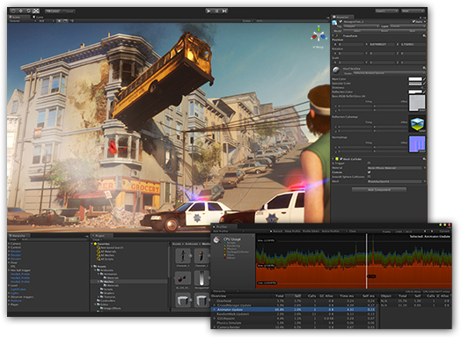 (AXON, 2016)

**Microsoft Visual Studio**

Visual Studio is an IDE created by Microsoft. It is a creative launching pad that can be utilized to edit, debug, build, and then publish an application. It is commonly used to develop programs for computers but can be utilized for websites, web apps, web services, and mobile apps. The most popular productivity features offered by the visual studio are as follows: squiggles and Quick Actions, Code Clean-up, Refactoring, Visual Studio Search, Live Share, Call Hierarchy, CodeLens, Go to Definition and Peek Definition (Microsoft, 2019). All these features are added together to ensure that visual studios perform as a great IDE to use for any developer and their projects. The Visual Studio ecosystem allows the developers to install plugins and API’s as they need them instead of having to install everything all at once (Anon., 2019).   
Visual Studio is a free download that can be downloaded to Windows while a separate version can be found for macOS. This free version will allow you full access to the Visual Studio ecosystem. During my educational studies, I had access to Visual studios community edition 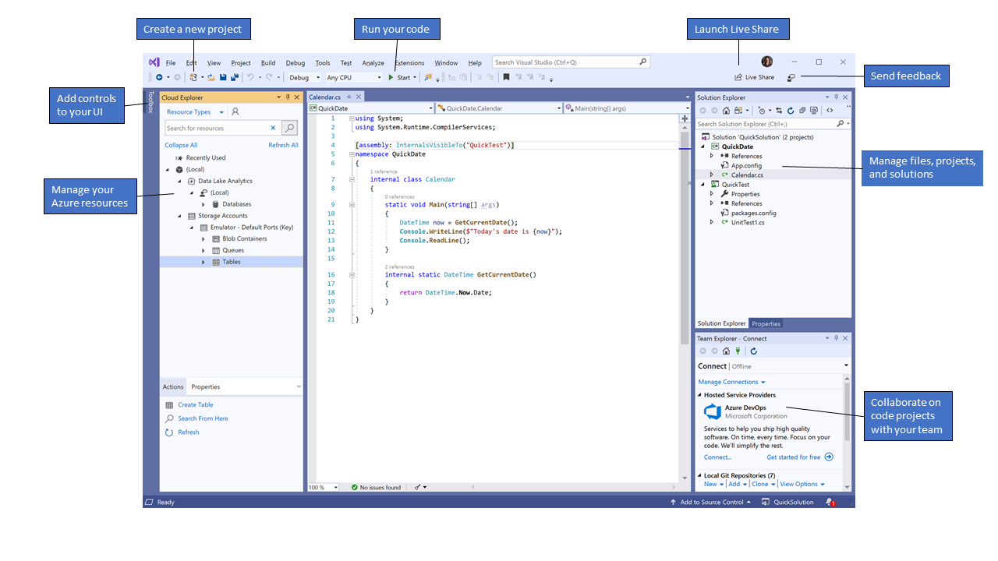and was using it for three years allowing me to get familiar with its features and UI.

**Figure 14:** Visual Studio (Microsoft, 2019)

**Android studio**

Android Studio is Google's official IDE-based to develop native android applications on the Android operating system. Android is built upon a Linux distribution, so it is an open-source operating system. Android studio works on the IntelliJ IDEA and IntelliJ IDEA Community Edition which both are open-sourced and free to anyone. IntelliJ IDEA is just an IDE that was built on Java. Google has decided that they will provide the IDE and all its tools for free which will allow a lot more developers to use this. Google Inc owns and distributes Android OS so having their IDE makes sense. It can be downloaded for free on Windows, Linux, and macOS and can be downloaded via a subscription-based service (Google, 2021). Since its release, Android Studio has had Java as its main programming language but as of May 7th, 2019 Kotlin has become popular with Google themselves (Lardinois, 2019). Kotlin is an already existing programming language that is both powerful and simplistic to use. This is very appealing for any developer. If an application is to be released, then a once-off payment of $25 is required. I do not have prior experience before starting this project but completed a semester of mobile 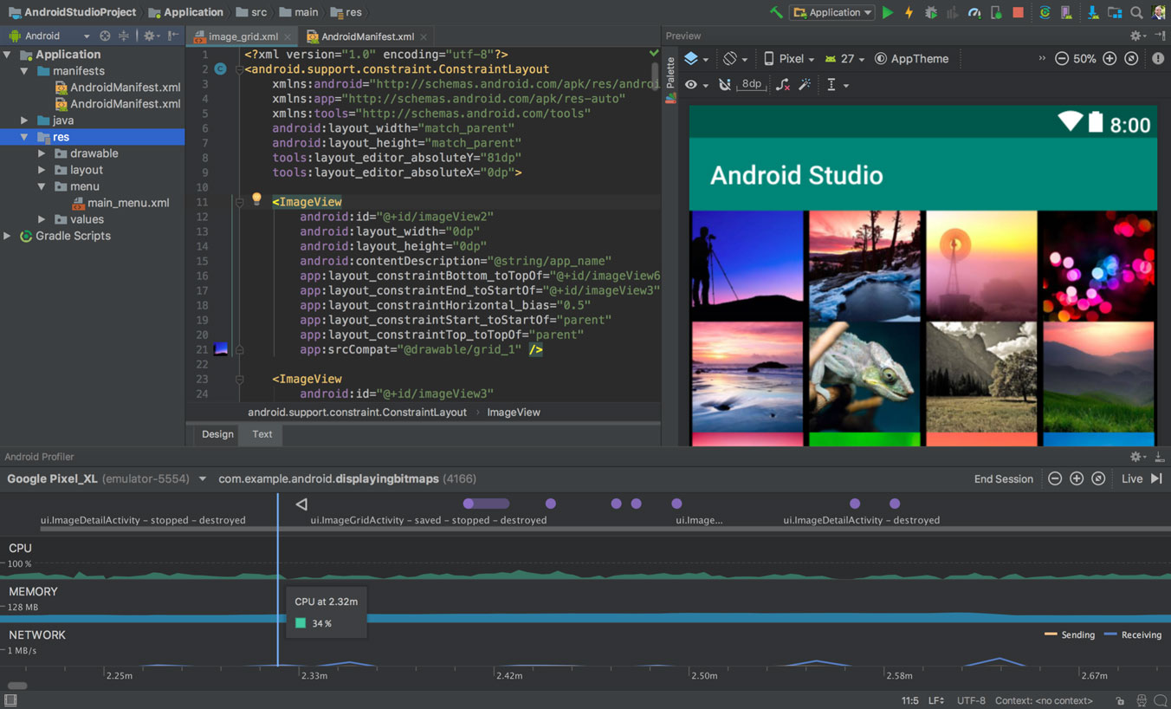development using this giving me quite an insider of the IDE and its many functions.

**Figure 15**: Android Studio Editor (Williams, 2019)

**Amazon Sumerian**

Amazon launched Sumerian in November 2017 which is a game engine that runs completely on the web. This approach is different from most as it does not require you to download or install anything on your computer. This follows Amazon's Web Services approach to computing in cloud architecture. This allows developers to simply log into their console and start working on an AR or Virtual Reality (VR) environment without the need for a good pc. There is no IDE that is being used as the software itself is encapsulated into Amazon's web console. The only coding that can be uploaded or changed is JavaScript (Amazon, 2021).  
If you want complete freedom with the projects developed with Sumerian this cannot be done due to it being locked into the Amazon environment. The price of using this software solution depends on the needs of your application. There are two different types of pricing schemes you can apply for. 3D object storage and Scene Traffic. You are charged for what you use and no more, so the more complex the application the higher the fees. was lucky enough to have a quick meeting with one of the lecturers in Limerick Institute of Technology who has had hands-on experience using this software. He gave me great advice such as the limitations of the online IDE, use cases where this is better over other ones, complexity, and fees. Once I gave him my project information, he advised me that though this is a good online IDE it will not benefit me to use this due to its limitations and functions. I found a great tutorial on the implementation of Sumerian for a basic set up which the author gave great examples of uses and restrictions on this software (Skarredghost, 2018). From reading this and from comparing my implementation 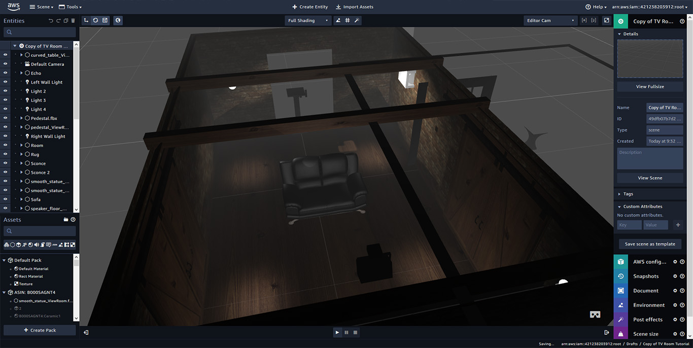research this solution is ideal for this project.

**Figure 16:** Amazon Sumerian Console (Skarredghost, 2018)

### Augmented Reality Application Programming Interface (AR API)

Now that we have gone through some of the most common Android IDEs on the market that is being used for AR development, I would like to take some time to talk about AR Application Programming Interface. I need to use an API in my development because of its fast superior functions and features available. In my literature review paper in Chapter 2, I have discussed what AR is, the main components needed, where it is being used today, and security. I will use the knowledge gathered here to help me find the best AR API that is available to me. There are a few AR APIs out there that have different approaches, so it is important I find the correct one for this project. I have picked the top two AR APIs that are used within Android development to investigate as they all offer great aid while also being unique to one another.

#### What is an API?

Typically, an API is a series of protocols, routines that aid the developer to complete a task. An API also defines how two or more programs communicate with one another. There are loads of free or paid API’s that one can use, and they usually do not need more than a few lines of code to connect into. With a connection established an API allows a developer to have extra features or functions that they did not program themselves. It can also add complex mechanisms to extend functionality (Fisher, 1988). They can be found in all operating systems, websites, and applications. Thousands of APIs are used daily with new additions being made available with every new update or software release. API’s have one of three purposes: System API, Process APIs, and Experience APIs. The job of a System API is to access and maintain some data while also managing the configurations of a system. A Process API then takes the take from the System API and incorporates it to create a new view. The Experience APIs add substance to both the System and Process APIs (Norton, 2019).

With each type of API, there are complex architectures and implementations in place but for this research paper, I am only interested in APIs that are for AR. Having an AR API allows me to import libraries and functionality already set out by the community to aid me in my development faster. I have combined the following two APIs and will compare each of them.

#### ARCore

ARCore is Google's platform that they have developed and was released on the 1st of March 2018. Its sole purpose is to aid in the development of augmented reality. This software allows the user's phone to understand its environment and capture its surroundings. It is made up out of three key components, Motion tracking, Environmental Understanding, and Light estimation. Motion tracking works by using the cameras on the back of the smartphone to its advantage. It scans the area and makes a 3D representation of its surroundings. It will ask the user to slowly tilt the phone left to right and will pick certain markers as a reference point. ARCore uses Simultaneous Localization and Mapping (SLAM) to understand the position in which you are standing. Environmental Understanding is where the reference points are used to determine a flat area such as a floor or tabletop. This allows the 3D models to be placed on that area for the user to see. Light Estimation is where ARCore detects light from what it can detect and try to mimic that on the 3D models for more of a realistic representation. ARCore will work on most android phones that have Android 8.1 (API 27) or later (Google, 2020). They have a full list of supported devices on their website for anyone to check. It however cannot be used on any other smartphone outside of native Android. It can be implemented in Android Studio, Unity, Unreal Engine, and IOS. Implementing it comes for free and only takes a few lines of code for it to be fully supported and working.

#### Vuforia

Vuforia is another such API that offers great AR aid. Vuforia can only be used with the Unity IDE so it limits itself with other IDE options. The features are remarkably like what ARCore has to offer but it is not as advance as it. It too has Motion tracking, environmental understanding, and light detection but ARCore is much more adapted to knowing its surroundings and its environment in which it orientates (Dudkin, 2019). Once Vuforia is implemented with Unity it can be used on any AR-ready device not only on Android. This allows a further reach in comparison to ARCore. Developing with Vuforia is free but if you want to publish your application then you will need to buy a license.

From my project, I can tell that ARCore offers me a better outcome as its features are more adapted and advance than that of Vuforia. I do not mind being restricting to only Android devices as this project was solely aimed at Android devices in the first place.

### 3D Modelling

Now that I have investigated IDEs and AR APIs the next area is the 3D model aspect of the application. I have not made any models before for an application, but I have studied AutoCAD during my secondary level education. AutoCAD is used to sketch up and design 3D models with the help of 2D drawings. This experience should help me develop my models for this project such as the Moon, Earth, and spacecraft. 3D models are vital for AR as that is the models that the user will be interacting with via their smartphones. These 3D models can be anything if they are readable with whatever AR API that it is being called by the IDE.

#### Blender

Blender is the most common and popular of all 3D rendering software as it is free, and it is open source. It can be downloaded on Windows, Linux, and macOS. Not only does it allow users to create 3D models, but it also supports the entirety of the 3d pipeline. This means that it can be used for such things as rigging, animation, simulation, rendering, compositing and motion tracking, video editing, and 2d animation pipeline (Blender, 2021). There is a vast community that has grown together as blender did with each update. They provide helpful videos and training to get up to scratch with everything you might need to be able to start developing with Blender. 3D models that are created inside Blender are not restrained to any software system as it can be exported as different object files as well as being able to import other files. You do however would need a strong enough computer to be able to work effortlessly as the system itself is quick heavy to use on its own. It uses the power of the computer's graphics card to be able to render the image, scene, or model in the highest quality that the user has given. Utilizing Blender for my project is a must as the features and functions it provides are next to none.

### Database

Having a database nowadays is a must for any application that can connect to the internet. The ability to store data online that can be accessed anywhere, and at any time is beneficial beyond belief. It allows applications to be less heavy on storage as no files or data are being saved locally. If a database is set up correctly following best practices it should be secure, reliable, and efficient. For my project, I will be utilizing a database as I want the product to be lightweight on each device. For me to do this I will need to implement a database that can store 3d objects, data in plain text, and coordinates on each model. From researching my needs one such database solution has popped up and that is Firebase.

#### Firebase

Firebase is an online real-time no-SQL database that has been developed by Google for mobile applications as well as web applications. A no-SQL database differs from an SQL difference in the ways that there are no relationships set up between tables or columns. Each table is created as a JSON object for faster more effective data transmission. Firebase comes free to use and can be set up online via a web browser or implementing via Android Studio IDE. There is a free plan that has no restrictions on any features but once a certain threshold has been passed then it will charge the user. What it offers is authentication. Cloud Fire store, Cloud Functions, Hosting, Firebase Machine Learning (ML), Realtime Database, Storage, Test Lab, and Google Cloud Platform (Google, 2021). If the needs are more complex, then Google will charge you monthly for what you need and nothing more. Android Studio can implement most of the features of Firebase insides its own IDE as Google owns both ecosystems.

### Text to Speech

One of my objectives for this application is to enable the use of Text to Speech (TTS). In my literature review paper, under chapter 3, I have talked about what TTS is, the main components that makeup TTs as well as the main components that make up the technologies. Here I would like to talk about how I would implement this in my project.

There are many ways in which I can achieve having TTS in an Android application like having a pre-recorded narrator read outlines of text or having a computer synthesize the text in real-time. Having an actual human narrator would have been the way to go if not for the growth of TTS technology. Nowadays it is a lot easier for an API to do the talking as not only is it much cheaper to run but the synthesized voice can speak in many languages. When decided on the correct implementation of TTS I will look at each of my potential IDEs to see if they have pre-existing libraries. For both Unity and Android studio there is indeed a library that a developer can import that has all the necessary features to run a full TTS engine. Visual Studio has a separate System. Speech only works on the .NET framework. All my IDEs have TTS functionality, but Unity and Android Studio share the same library. Google has complete documentation on how to use it as well as how to manipulate it within Android Studio itself. Unity is relying on plugins and external documentation to help developers use this library.

### Technology Conclusion

I have now talked about IDEs, AR APIs, 3D Rendering, TTS, and databases that I believe could be used to develop and implement this project. Below in table 1, I have captured some data and compared them with each of the other IDEs to help aid me in the decision of the IDE that will be used. Since I will be aiming for this project of mine to be developed for Android, I believe that Android studio is more than capable of what I need. It can be downloaded to my workstation for free, it comes with great online support and documentation and can be used fluidity with ARCore and Firebase. Having my project encapsulated within the Google ecosystem not only gives me great resources, but they have also been developed to be used together with little to no resistance. So, I will be using Android Studio for my android development IDE with the use of the TextToSpeech engine, ARCore for my AR API implementation, Blender for my 3D modelling and rendering, and storing it all on Firebase.

|  |  |  |  |  |
| --- | --- | --- | --- | --- |
| **Topics** | **Unity** | **Visual Studio** | **Android Studio** | **Amazon Sumerian** |
| Development Platform | Windows Linux macOS | Windows macOS | Windows Linux macOS | Browser |
| Price/Licensing | Unity Enterprise: 10 Person Team @ $200/month = $2,000/month Unity Pro: 1 person / annual plan = $1,800 Unity Plus: 1 person / annual plan = $480 Unity MARS: 1 person / annual plan = $600 per seat Unity Free trial: 30 days | Community edition: Free Business: $45/month Enterprise: $250/month | Free release app to PlayStore: $25 | Free trial: 50Mb with 100views(5Gb) for one year Scene Storage: $0.06 per GB/month Scene Traffic: $0.38/month |
| Languages | C#, Boo, JavaScript, Unity Script | C, C++, C++/CLI,  Visual Basic, .NET,  C#,  F#,  JavaScript,  TypeScript, XML,  XSLT,  HTML,  CSS, Python,  Ruby, Node.js,  M | Java, Kotlin, C++,  C#,  Xamarin,  LUA,  JavaScript | Sumerian editor JavaScript HTML |
| AR API | Vuforia | ARKit | ARCore | Sumerian |
| Personal Experience | None | Intermediate | Basic | None |
| Notes | Great IDE Pricing is too much for me right now Trial period too short for learning and implementing on | Great IDE Great choices of programming languages Most comfortable using Would need professional version to release to public | Great IDE Nice choices of programming language to choose Fits perfectly into the Google ecosystem Free to use with all features available Locked into only Android devices Open Source | Basic IDE Expensive to run Locked into Amazons Ecosystem Little to no coding required Basic in functionality |

**Table 1:** Android IDE Comparison

## Chapter 3: Educating users about Moon via Augmented Reality

### Introduction

For my second chapter, I will talk about the theme of my application, educating users about the Moon. This project will utilize AR and Text Speech technologies to aid in education about the Moon. During my literature review, the word ‘edutainment’ came up which bests describe this project I am about to undertake. Under section **2.7** of my literature review, I talk about the components that make up a good edutainment environment. Edutainment is a process in which you are entertaining people while also teaching them something new that they did not know before. This can be done via software, programs, or television (Cambridge Dictionary, 2021). There are plenty of edutainment programs and television shows that not only entertain their audience but also educates them as well. The top three popular edutainment shows online that flearningstudios.com has rated are as follows, The Mind Explained Series by Vox, which uses abstract art over real-life footage, CrashCourse which is an animated YouTube series and Ted-Ed which is a subsection of TED the talk seminars.

I choose to develop an application based around the Moon as I find myself fascinated with Astronomy and with the Moon. I would love to use an application like what I will develop to help my knowledge grow further. For this to happen I need to be able to: Understand how to educate users effectively and efficiently, what assets will I show to users, what assets about the moon do I need, a timeline of previous, current, and future space missions, etc. I must portray this information in the best way possible to ensure the most information is displayed.

### The Moon

First off, we need to describe what a moon is. A moon is described to be any celestial body that orbits around a planet or dwarf planet. A moon cannot be described as an object that orbits its parent star however it does so by orbiting around its planet. The name ‘Moon’ was first given to the Earth's Moon way before the realization of other planets moon. It is the only celestial body that has the same name as the defining characteristic that describes it. We do not know how, when, or why Earth got its Moon, but it has been around before life itself. There is three hypothesis that has been agreed that could explain how we got out the moon. I will explain these when gathering my facts later in section **3.5.**

The Moon has been visible to us for our entire human civilization and longer. It has inspired religions, art, culture, and music throughout the years down to its mysterious nature. For centuries people believed that Earth's Moon was one of a kind, but thanks to the progressive improvement of technologies, telescopes allowed us to see beyond what was possible. It has inspired me enough to want to do my final year project around it. I will gather as many interesting public facts and knowledge that has been gathered collectively by governmental organizations to use for this project. There have been several space missions to the moon as well as ones that survey it. Man has even landed on the moon several times but not since 1972 on the Apollo 17 mission. There are plans that NASA will have men back on the moon in 2024.

Without the involvement of both the Sun and the Moon, Earth would not have the ability for its tides to go in and out as it has been. It is tidally locked to our planet which means that only one side of the moon can ever be seen from Earth. There is so much that we as humans know about the moon but there is far more that we do not. Without it, the world we know of today would not have been able to thrive as we did.

So now let us look at what apps are out in the public right now that compares to my educational AR app and see what they do. Researching other application is important as it allows me to make sure what my plan is for my project is unique.

### Similar Apps available

Let us talk about similar apps that let the user explore the Moon. I am only looking at the Android Play Store for reference as my application will not be for IOS. The applications I will be looking at must have the following similarities: must be an Android application, uses AR to help display models of the Moon, must be free to download, and must be easy to use.

* **Giant Moon AR:**

This application is simple but fun. It allows the user to point their phones to the sky and it will display an overall enlarged version of the Moon using AR. The user can then see what this new oversized Moon would like in real-time.

* **Apollo’s Moon-Shot AR:**

This application has many more features that it gives to the user. It is based on the Apollo space missions that NASA has conducted and teaches users about the men, spacecraft, and tools needed. It has videos showing the different missions, the journey to the moon, previous space missions that lead to the Apollo program as well as much more. It AR in a few exciting ways, it shows models of the spacecraft, the rockets flying out of the atmosphere, the moon itself and you can take selfies as if you were on the moon itself.

* **Moon AR:**

This AR app displays a model of the moon to the user showing a small window of facts at the bottom of the screen. If the user moves towards the Moon, you can see a small Apollo spacecraft that orbits it.

* **Moon Locator 2021:**

This application gives the user a defined path in which the moon itself will show depending on the user’s geolocation coordinates. It uses AR to show on the screen what path in the sky the moon will take.

* **Moon Atlas 3D:**

This application is not an AR one, but it does have a similar idea. It shows a High Definition (HD) model of the Moon with an overlayed atlas on top. The user can zoom in and out from within the model to be able to see all the meteor's holes and landing spots.

* **Missions to the Moon:**

This application uses AR within it, but it is marker-based meaning it uses a picture that is on a flat surface to display its models. This application is part of a scientific book that has the same name as the app. It overlays 3d models over some items and plays videos in some image boxes.

All these applications are fun and educational to use. They all have one main objective and do it well. There are a lot of other similar applications, but they do not either use AR, not free, or available on the Android PlayStore. None of the above applications have a defined learning objective nor do any of them use Text to Speech.

Now that I have talked a little about the Moon, and applications that are similar I will now talk about the resources that I need to build my application.

### Resources Required

For me to be able to build a successful application that teaches users about our Moon I need to be able to make sure the facts I tell are 100% and are credit correctly. None of the information that protrudes should be fake nor made up. I will gather as much as I can, and I will narrow down the selection to build the project in time as this project is limited due to its time. I will use the governmental website as much as I can over normal websites with little to no reputation.

Moon:

* I need accurate images and topography of the lunar surface. NASA has released HD images of the Moon so that they can create an accurate 3D model and I intend to use them.
* I need a geologic map of the moon that highlights different sections of the Moon. NASA can provide this, and it is for the public to use.
* I need a complete timeline of all manned, unmanned missions to the Moon. NASA has built a timeline of all missions ever since 1959 to the present and the future.
* I need a Moon phrase calendar API that is accurate for 2021.
* I need a list of interesting facts that can be shown to the user.
* I need data and images to show the user what a Red Moon is.

**Earth:**

* I need accurate images of the Earth to be able to build an accurate model.

### Data Collected

Please see Bibliography for a complete reference of the below assets. I have gathered resources that are accurate in its data below.

* Colour and displacement assets of the Moon (Wright, 2019).
* Geological Map of the Moon (Corey M. Fortezzo (USGS), 2020).
* Timeline of all missions to the Moon (Williams, 2020)
* Moon Phases API (wdisseny, 2021)
* Interesting facts about the Moon (Space Facts, 2019)
* Red Moon data (Kher, 2021).
* Texture image of the Earth (Shahrai, 2020).

With the resources and data above, I will be able to use this information to build my application that will be accurate and truthful throughout. I can use these assets with Blender to be able to build realistic models that I can use within Android Studio.

### Effective edutainment

To be able to portray the data that I have gathered above in an effective edutainment environment, I need to follow best practices that I have eluded too in my literature review. Under section **2.7** I learned that you need to pull together three different areas to build an effective learning environment. When developing I need to pull aspects from educators, game design, and multimedia. I will need to keep these into consideration when continuing with my design and implementation section of this project. I want to use the best user interface (UI) and user experience (UX) to aid me throughout the development stage.

When trying to teach someone something new you need the user to not lose interest fast as they will not be able to hold any of the information. Kevin Daum, a successful entrepreneur has given out a five-step process in which you can teach anyone anything (Daum, 2013). His five steps are as follows:

1. **Create a clear curriculum -** Have structured content with clear objectives and milestones.
2. **Make the material matter -** Create detailed documents, videos, and pictures.
3. **Present with purpose and passion -** Be enthusiastic about the subject and energized.
4. **Let the learners lead the learning -** Allow users to have their exercises that encourage further questions.
5. **Reinforce with repetition and response -** People tend to learn more from their failures so provide frequent specific feedback.

When talking about the best practices someone needs to be able to effectively use multimedia, I have found twelve principles that Mayer and Moreno have developed. These principals were developed to aid people with digital learning environments (Mayer, 2009). They are as follows.

1. **Coherence Principle** – Remove any extraneous words, pictures, or sounds.
2. **Signalling Principle** – Add cues that highlight the material.
3. **Redundancy Principle** – Using graphics and narration together rather than pictures and plain text.
4. **Spatial Contiguity Principle** – Place words and pictures close together instead of far apart.
5. **Temporal Contiguity Principle** – Place the words and pictures simultaneously instead of successively.
6. **Segmenting Principle** – Keep the lesson user-paced instead of continuous unit.
7. **Pre-training Principle** – Using names and characteristics that are previously known.
8. **Modality Principle** – Using graphics and narrations instead of animation and plain text.
9. **Multimedia Principle** – Use words and pictures instead of plain text alone.
10. **Personalization Principle** – Use of conversational style rather than formal style.
11. **Voice Principle** – Use a friendly voice instead of a robotic one without tone.
12. **Image Principle** – Not a need to have the narrator’s image on the screen.

These five educational steps and the twelve principles of multimedia will both contribute to my implementation. I will use these to my advance when designing the application. From the above, I can plan out a strategy to educate users while following all the principles to the best of my ability.

The last aspect I would like to look at would be game design. I have not made any form of game before, but I need to be able to do so for this project. They are many different types of games available between video and board games as well as the subcategories within them. For this application, I would like to investigate android game design and see what professionals advise. I do not aim to make my project a game, but I will investigate what helpful information they can offer me. Gamedev.net has a list of their best game design user experience best practices (Dori, 2019). This comes from a senior android game developer who has created several well-reclaimed apps.

1. **UI Positions** – Figure 17 shows a great representation of a good UI Position for both smartphones and tablets. Have all the important buttons close the easy side of the screen (Store button, more apps, ads), and anything you do not want the user to click have them out of reach (exit).
2. **Sliders** – Utilise sliders where possible to allow for more content to be visible to the user. This can allow the user to stay in one scene. If showing a lot of content make sure there is an item half in view so the user can see there is more to see.
3. **Pop-Ups** – Good for delivering abstract messages to the user. Make sure to have the background out of focus and transparent compared to the pop-up. If there is information you want the user to see, make the close button small or hard to see initially.
4. **User Choices** – Plan out what choices you want the user to take. Associate a positive colour with the choices you want and give a negative colour to those you do not. For example, having green buttons and red buttons.
5. **Rewarded videos** – Give users the choice to watch a video so that they can get an in-game reward for spending their time. Usually, this video will be ads. Try not to tell the user what reward they will get so their curiosity kicks in.
6. **Draggable Objects** – Utilise the ability to drag items as it the user a false sense of control. Make sure the dragged item can still be seen even though it will be covered by a finger.
7. **Rate us dialogs** – Prompt the user to give a positive review of the Play store after a while of using your application. With more positive reviews, the better your application will be represented by other future customers.
8. **Store Dialog** – The design of your application store should be important. Have any characters in-game appear facing the user, make sure there is always a sale on, so the user believes it is more worth it than is, update the content on the store regularly.

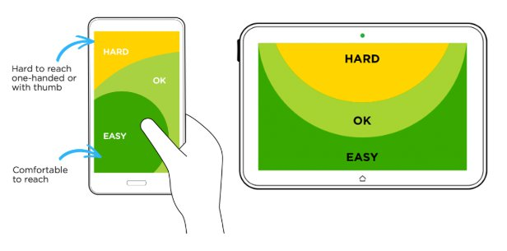

**Figure 17:** UI Positions(Dori, 2019)

## Conclusion

Developing an AR Android application takes a lot of components to fulfil, from hardware to software specifications. This research paper has allowed me to investigate aspects that I have not done so before. I had to take into consideration the options of all the technologies that I could use as well as the edutainment rules. I have never developed an android application before so giving some time to the technologies helped me out. From developing this research paper, I now have a much clearer picture of what needs to be done and how it can be accomplished. I now know what Android IDE best suits the use cases, what AR API to use, more information on the database solution as well the TTS engine. Developing an application that teaches its users about the Moon needed me to be able to not only need the resources that allow me to display but also to teach. Getting some insight on what edutainment is as well as the different components that make it up. I look forward to continuing this projecting as the next stage is designing the application from the ground up.

# Software Report

## Introduction

In this paper, I aim to continue in the development of my final year project by moving on to the design and implementation sections. By having done both my literature review and my research paper I am no equipped with tackling this stage. To work on this project while adhering to software development's best practices, I will be developing under the agile methodology. Agile is currently the best way to develop a successful project without the worries of code scrap of code redundancy. It states that both the customer and developers have constant communication with one another and are updated frequently. Agile is an iterative approach so during the design and implementation drawings and ideas might change and that is to be expected. What developers used to utilize was a waterfall, but this led to many issues in the development as things would be designed and implemented without the thought of updates. From being able to develop a group project in the third year I was able to utilize the spiral waterfall method which I will use some parts of this as well. In my work placement, I was taught how to life SCRUM with the aid of agile and this will benefit this project's lifecycle a lot. SCRUM is a business lifecycle were a team meet up daily/ twice a week to talk about any issues that one might have so that the whole team is included in one another’s task. They can offer insight of help if any issues arise that they can tackle together. I will use this to write down any issues I have in the development stage so that I can see what tasks or issues came to be so that I can later investigate them further. I will record each action that comes up during this section so that I can have a compressive archive of the project’s lifecycle.

For this project, I am playing the role of customer and the developer so I can easily iron out any issues or faults that must be addressed. Since coming up with this project I have been thinking about the look and feel a lot as I knew this would take a considerate amount of time to perfect. This project is a limited resource project so I know that I may not have everything complete in time, but I will try my best to meet my set timelines. Knowing what I have gathered already I will aim to develop further on the requirements, diagrams like use case, class diagram sequence diagrams, and more.

## Design

### Introduction

This chapter will document my journey in continuing further into my project’s lifecycle. So far, I have talked about Augmented Reality and Text-to-Speech in my literature review, I have talked about the technologies that I will need for this project as well as the overall theme as well. I now wish to talk about the design of the project. I have gathered some good resources ahead of implementation, so this gives me a good chance in completing what I sought out to accomplish. As previously mentioned, I completed a group project in my third year which enabled me to work as a team to accomplish a project within a timescale. I was able to use design elements that I had learned in the previous years to better grow my knowledge and familiarisation with them. This form of exposure granted me the best practice for my final year project as I intend to use those diagrams here.

At the beginning of this project, I was just starting my final year at Limerick Institute of Technology and knew what this project was going to entail. I was lucky enough to be able to do the mobile application elective which I knew would help me a lot for this project. I went from having no prior experience with designing and developing an android application to now having completed that module. I will use the knowledge I learned in that module to my advantage as I know have had a chance to use Android studio and Google Firebase for a separate project I needed to complete. I learned about UX and UI design and how to best utilize a device for all its components like camera, screen, and notifications.

As Mentioned before this project is being developed under the agile methodology so I expect updates and iterations of one design until the final project is completed. I will use the feedback I receive from my supervisor as well as my research to be able to draw out a successful plan. As an inspiring Software Developer, I have learned that following in the Software Development Lifecycle (SDLC) is the best way in which I can complete any project. This lifecycle consists of five stages that we must follow for the best possible outcome. As seen in Figure 18 below it is made from these five stages are Requirements, Design, Implementation, Testing, and Evolution. This diagram is a great representation of the SDLC as arrows are connecting each one into the next. This means that once we are at the evolution stage we are not finished; we continue again to make sure all aspects have been looked at for further improvements.

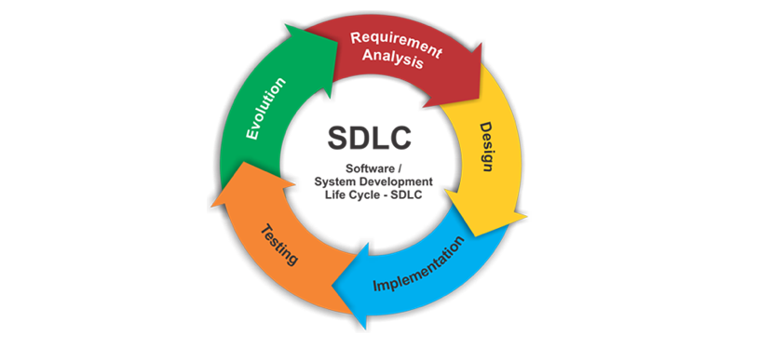**Figure 18:** Software Development Lifecycle (Kwon, 2019)

### Requirements

Like any software project lifecycle, the requirements stage is vital as that is the starting block to which the project can begin. Any requirement can be given by the client at the early stages but can come at any stage of the project’s lifecycle. If requirements are skipped or not properly looked after, then that may lead to customer dissatisfaction as well as a poorly design application. I will write down the requirements that this project needs to have so that I can pull use cases from those. I will also write down non-functional requirements what was not specified. These non-functional requirements relate to aspects of the application that the customer has not asked for, but we know as developers that they need to be included. This thing can be security, scalability, privacy which the customer would have thought about in the early stage.

#### Project Requirements

* An android application running on the latest version of Android.
* Free to download the application.
* Utilize edutainment soul for the user to learn all aspects of the Moon.
  + Actuate images and facts about the Moon.
  + Have a Moon phases section with inputted dates from the user.
* Implements Augmented Reality to help engage with the user.
  + Have an accurate model of the Moon available.
  + Have markers on the moon showing interesting pointers and locations.
* Implements the library Text-to-Speech to aid in the immersion.
* Applies best UI and UX approaches
* Implements new Android Development features
* Available for all screen sizes under the given Android API
* Have a section where the user can scroll through facts, videos, and images.

#### Non-Functional Requirements

* Security
* Scalability
* Ease of use
* Reliability
* Privacy
* Resilience
* Platform compatibility
* Performance / response time
* Testability
* Usability

#### Supportability List of Actors

* User
* Google Firebase

#### List of Use Cases

* Install the android application.
* Connecting to Wi-Fi
* Not connected to Wi-Fi
* Check the Phone version for compatibility.
* The phone is not compatible with ARCore.
* The phone is compatible with ARCore.
* Check android screen size.
* Log exceptions
* View Application home page dashboard
* Use the links on the dashboard to open AR screens.
* Ask the user for access permission on the rear camera.
* Connect to Firebase database
* Database connection not found.
* The database sends the Moon model to the system.
* The database sends the Earth model to the system.
* The database sends Moon Portal to the system.
* Render Augmented Reality Moon Model
* Render Augmented Reality Earth Model
* Render Augmented Reality Portal Model
* View Augmented Reality Moon Model
* View Augmented Reality Earth Model
* View Augmented Reality Portal Model
* The user interacts with the Moon model.
* A user interacts with the Earth model.
* The user interacts with the Portal model.
* Display pens, markers, and names on augmented models.
* Use Text-to-Speech to call out text on each model.
* View Discovery page
* Retrieve video links from the Firebase database.
* Retrieve data from the Firebase database.
* Use Text-to-Speech on retrieved data.
* View Moon phase page
* Calculate Moon Phase by a given date.
* Update Moon phase screen

### Android Design

When designing this application, I need to think about what I have learned during my mobile development elective so that I can carry over the knowledge here. If I were not able to do that elective I would not be as confident in the design process. I learned about the importance of material design, android architecture, fragments, Google APIs.

Figure 19 below shows the basic lifecycle for an android application. When developing any android application this needs to be included in the early stage as each stage alters the application in some way. For example, if the user moves off from the application you do not want the app to instantiate itself instead of continuing where the user left off. I will be considering the lifecycle.

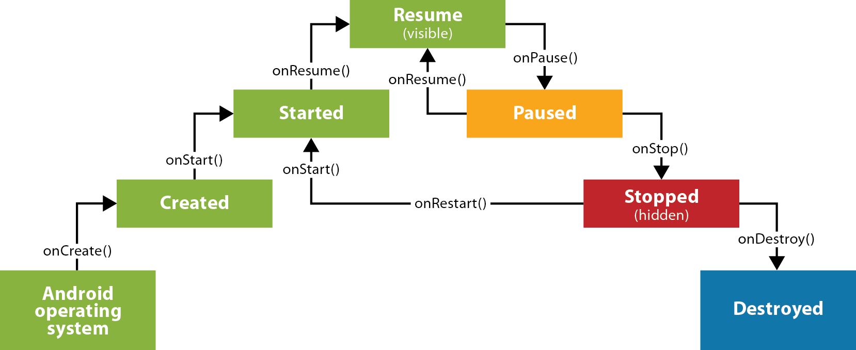

**Figure 19:** Android Lifecycle (Masters, 2013)

#### Material design

Material design was introduced by Google in 2014 as a design language to be used in android development. It is a comprehensive guide to aid in the visual, interaction, and motion design across its many platforms. It is made up of design best practices, common conventions, and visuals to help build expressive apps that feel professional on any device (Google, 2021). Since Android 7, they have added more features to the existing development that help with material design. They added a new theme to style all the UI widgets, they added more complex widget views like lists and cards, and new APIs for custom shadows and animations.

The addition of the new themes allows the application to be forced into whatever colour scheme the developers want. The most common themes are light and dark, and they can change the texts, fonts, and buttons accordingly. It is best practice to add at least one UX patterns in your design as they add to the overall implementation. You can promote your UI’s main action by adding a Floating Action Button (FAB). Usually, they are located on the bottom right of the screen and appear to be hovering over the screen. This is pulled off but having shadows and shaders underneath promoting a sense of depth. Another common UX is implementing a Navigation Drawer which helps the user swap from screen to screen more effectively. Whenever possible it is advised to use predefined material icons on the navigation menus and buttons. These icons are small vector images that describe what the action is, i.e., the back button has a left arrow, email has a letter. Recycler View and CardView allow the developers to add a card layout to their application that automatically changes depending on its input. You only need to create on Card View to any scale and when you call it inside the Recycler View you can change the layout to suit the needs. I plan to utilize most of these in my design as it will make the end application feel more professional as well as more pleasant to look at.

#### Fragments

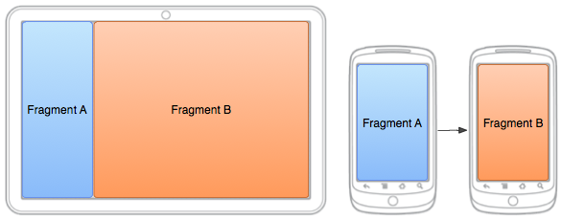Fragments have been around since Android 3 and they offer a lot to developers. Before they were introduced developers had to start a new activity whenever they wanted to move onto another screen. With the need for more complex applications, this approach was causing issues. What developers can do now is combine one or more fragments to build a single activity or even reuse fragments across multiple activities. Developers can no update different portions of their UI on the screen that corresponds to what the user has navigated onto without updating the entire screen. With every growing difference in Android devices with all their types of screen sizes ranging from small smartphones to large tablets, fragments allow more flexibility. On smaller screened devices we can have one fragment loaded doing one action while on a tablet we can have two fragments side by side doing the same actions as before.

**Figure 20:** Android Fragments (mit, 2021)

### Diagrams

It is important to have diagrams of all types designed and ready before implementation as this gives a general representation of how the software system will look. This allows the developers and the clients to share ideas and iron out any issues that they might have before committing to the code. I have created and generate the below diagrams for this project, and I will be describing each diagram. They are as follows:

1. Mind Mup Diagram
2. Use Case Diagram
3. Sequence Diagrams
   1. Dashboard
   2. Augmented Reality Moon
   3. Moon Phase
4. Class Diagram
5. Flowchart
6. Application Wireframes
   1. Splash Screen, Home Page, and Settings
   2. Augmented Reality Page
   3. Discover Page
   4. Moon Phase Page

#### Mind Mup

Being able to know what areas I need to look at is a huge helping hand in starting this project. Mind Mups are a brainstorming diagram that people use to show the correlation between different aspects of a given project. I have added figure 21, below which is the final Mind Mup file that I created to help myself figure out the areas in which I will be working with.

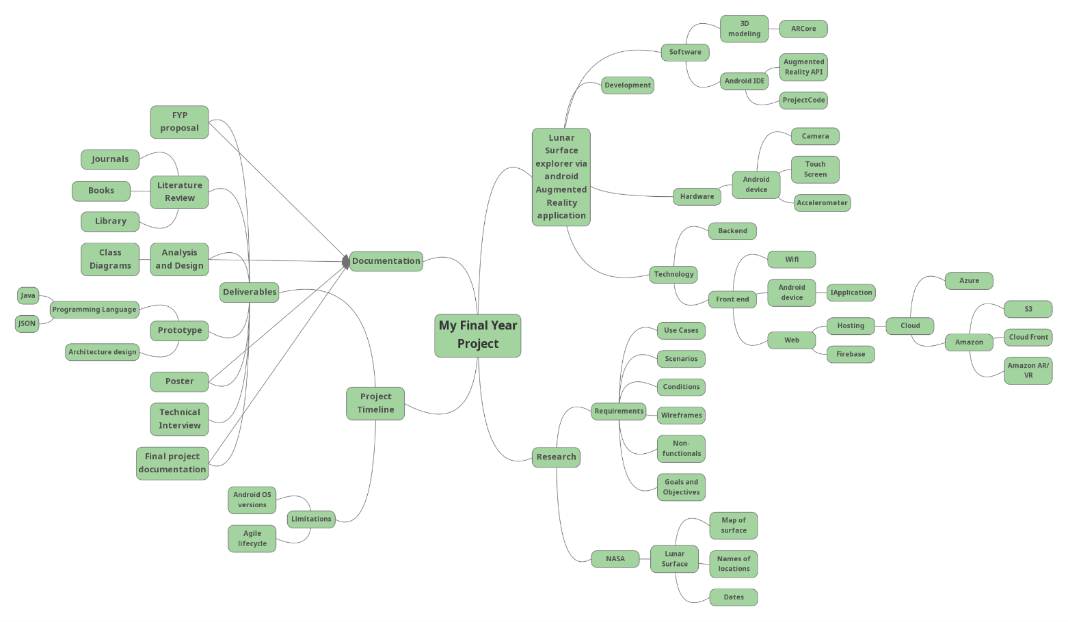

**Figure 21:** Mind Mup Diagram

#### Use Case Diagram

A UML Use Case diagram can be described as the simplest way that we can represent the user’s interaction with a given system. It is a high-level diagram meaning that it does not go into the fine detail that the system is built upon. These diagrams are created right after the requirements have been successfully gathered. The users of a system are represented as ‘Actors’ while interactions are annotated as ‘novels. The arrowed lines represent a connection between the actors and the use cases.

Figure 22 below is the use case diagram of the application. We can see two actors, User, and Firebase. The user is acting as the physical user who would be interacting with the system while the Firebase is acting as the cloud database. I have added the Firebase as an actor as it is responsible for sending out the models to the user in real-time. If there is an update to be made on the models, the database will be updated and not the application allowing for a lightweight system. The user can pick four routes that each use case is connected to. The use cases are included to one another in a way where they are connected to another via an ‘include’ statement.

I have created the allocated use case documentation as well below the diagram. Use Case documentation is great as it allows the developers and clients to talk through the entire process on interaction from start to finish. If anything is missing, then developers will go back onto their requirements and begin again.

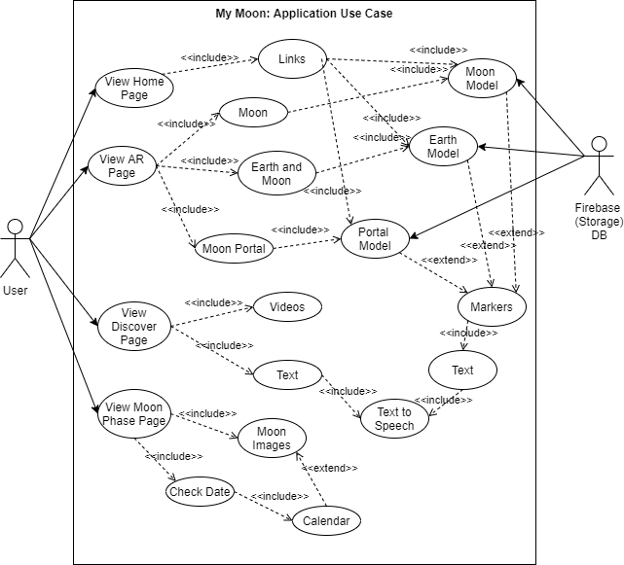

**Figure 22:** Use Case Diagram

#### Use Case Documentation

##### Use case one.

**Use Case Name:** Launch the application dashboard.

**Participating Actor:**  User

**Entry Conditions:**

1. The user has an Android smartphone in hand.
2. The user has the application already installed on their phone.

**The flow of Events:**

1. The user locates the application icon on their smartphone and clicks to open it.
2. The application presents the user with a splash screen containing the logo, title, and slogan.
3. The application checks to see if the user has been connected to the internet.
   1. **If:** The application is not connected, the application sends a message to the user asking to connect to the nearest Wi-Fi router.
4. The system builds the navigation menus, application fragments, and connection to the Firebase database.
5. The user is greeted with the home page on the dashboard.

**Exit Conditions:**

1. The user has been successfully presented with the application's dashboard.

**Special Conditions:**

1. The android device is higher than the Android 9 Pie (API level 28).

##### Use case two.

**Use Case Name:** Launch the augmented reality, Moon.

**Participating Actor:**  User

**Entry Conditions:**

1. The user has an Android smartphone in hand.
2. The user has the application already installed on their phone.
3. The android smartphone is connected to the internet.
4. Google Firebase database is stable and operational.

**The flow of Events:**

1. The user opens the application and successfully views the dashboard.
2. They click on the AR navbar button to open the augmented reality screen.
3. The system responds by displaying the AR fragment that houses three icon buttons, Earth, Moon, and Portal.
   1. **If** the user clicks on the Earth button, the system will contact Firebase for the ‘Earth’ model stored online.
   2. **If** the user clicks on the Moon button, the system will contact Firebase for the ‘Moon’ model stored online.
   3. **Else if** the user clicks on the Portal button, the system will contact Firebase for the ‘Portal’ model stored online.
4. Once the system confirms that the user has clicked the Moon button, it generates a local copy of the model from Firebase.
5. The system displays the fragmented screen to the user.
   1. **If** it is the user's first time opening this screen, the system will require the user to allow permissions to use the camera.
6. On confirmation, the system uses the rear camera to show an image in real-time with a button overlay on the bottom of the screen.
7. The system calls ARCore library to translate the environment using SLAM. This gives the system variable information about its surroundings.
8. The user clicks the button, they will be able to drop the model onto the surface.
9. A 3D model that represents the moon is displayed to the user for their interaction.

**Exit Conditions:**

1. The user has been successfully launched and interacted with the augmented reality Moon.

**Special Conditions:**

1. The android device is higher than the Android 9 Pie (API level 28).

##### Use case three.

**Use Case Name:** Check the moon phases on a given date.

**Participating Actor:**  User

**Entry Conditions:**

1. The user has an Android smartphone in hand.
2. The user has the application already installed on their phone.

**The flow of Events:**

1. The user opens the application and successfully views the dashboard.
2. They click on the Moon Phases navbar button to open the Moon Phases screen.
3. The system responds by displaying the user the picture of the moon, some text asking the user to choose a date, and a button.
4. If the user clicks the button, the DateDiaglog window appears with today’s day asset to default.
5. When the user clicks on the 28th of January, the system response by updating the image with the correct Moon phases for that night.
6. The system will update the text on the screen to show the user how much of the moon is illuminated as well as the name of the Moon cycle.
7. The user can see that on the 28th of January that it will be a Full Moon, and the lamination is 100%

**Exit Conditions:**

1. The user can see that there is a full moon on the 28th of January.

#### Sequence Diagram

UML Sequence Diagrams are another form of interaction diagram that software developers use while creating an application. These types of diagrams help aid in the development as they show the interaction between components relative to time (Visual Paradigm, 2021). Using the vertical axis on the diagram, one can see the order in which a message is sent back and forward between components. The solid black arrows facing the right represent a message call while the dotted arrows to the left represent its response. In a sequence diagram, every message call must have a response call. These diagrams usually are high-level diagrams as they do not go into the finer details of a system or its subsystem. When a component is not needed anymore in the diagram there will be an ‘X’ at the end of their lifeline to show that the lifeline will be terminated. If the X is not present, then the component stays active within the system.

For the use’s cases, I have developed in the above section I have created their representation in their sequence diagram. I had to pull data from what I learned over my research stage to include into these diagrams. Such things as Android lifecycle as well as their requirements. I have learned a lot about the android lifecycle from the mobile development elective that I have completed last year.

##### Dashboard

**Figure 23:** Sequence Diagram Dashboard

In the above diagram, Figure 23, we see the sequence diagram for viewing the dashboard. For the user to be able to see the dashboard there is a series of calls that need to be done by the system. The system does these automatically without the user’s interaction like calling the AppCompatActivity, Builder, Navigation, and navigation. Once they are called and retrieved the system sends back the data to the user.

The diagram below, figure 24, is the sequence diagram for viewing the augmented reality moon. This diagram is more complex than the others due to their needing to be more components called and stored. From the actor's first message call there are all the calls that the system needs to first call. From my research paper I learned that ARCore, the chosen Augmented reality API will only work on a set of few android devices. The system must check if the user’s phone is compatible as if not the system will crash and cause runnable problems. The system does a method call on itself called ‘checkIfSupportedDeviceOrFinish’ and this will pull the Android version into a double variable. If that does not match the compatible version, it will display so in a Toast message. A Toast is a pop-up dialog box that appears on the bottom of a screen that can display any data that is being passed into it. When the system is happy to continue it will move on and connect to the Firebase inside the fragment. A Fragment is a type of viewable screen inside the android development system. It allows a viewable container to be scaled to size or have a defined look on each screen size. The system needs to initialize a database connection and needs to pass the child ID model so that it can allocate a file in memory. The database sends the model data to the phone and once all the data is compiled it will send it over to the Throwable component. A Throwable component is a library inside ARCore that allows the movement, scale, and rotation of a static model within an application. The conversion needs to be done to this model so that the user may interact with it fully. Once the conversion is complete it will be sent back into the fragment to be displayed on the screen.

##### Augmented Reality Moon Model

Jonathan Roddy 1-Jun-21 65

**Figure 24:** AR Moon Model

##### Moon Phase

**Figure 25:** Sequence Diagram Moon Phase

In figure 25, we see the Moon phase sequence diagram. From my experience in mobile development to correctly pass data inside a navigation view the system must be separated into a view and model container. This allows the data to communicate loosely within the entire system. Once the user calls on the PhaseFragment the system begins by calling the ViewModelProvider. This action will allow the system to call the views to the user and scaling to the screen size. This use case calls for text views and button interaction so the system must find them before moving on. It finds the reference to each of them and stores a local connection with them. The actor will then click the button which will initiate the ‘OnClick’ method call. This message will pass the chosen date that the actor has selected into the DateDiaglog fragment. This DateDiaglog is a build-in asset inside the android development and its sole purpose is to display a calendar to the user. This Date is then sent back to the system for it to calculate the algorithm accordingly.

#### Class Diagram

Class diagrams are especially important for project development as it goes further into the details of the system. A good class diagram allows developers to do less code as its layouts the different classes that make up a system. Class diagrams are the only diagram that can represent object-orientated languages. They describe the attributes and operations that a class will undertake as well as their relationship with one another. Developers will take a lot of time to design a class diagram as the more information that is represented here results in better, cleaner code. The purpose of class diagrams in the design phases is to analyse the view of the application, describe the responsibilities of a system, the base for component and deployment diagrams, and finally to forward /reverse engineering. Each class is presented as a square with its name, attributes (variables), and operators (methods). Each attribute can be denoted as public, private, static, read-only, and protected while the operators can have the method call. The lines that connect one class to another is called an association and acts as a relationship between those linked classes. There is a wide array of associations and annotations that developers can add to their class diagrams, like a generalization, dependency, usage, aggregation, composite aggregation, and many more. There should always be a relation within classes in an object-oriented system (tutorialspoint, 2021).

Below in figure 26, I have created a package class diagram. This diagram has the classes that I will need for the system and it is presented inside each of their packages. The overall application is called ‘MyMoon’ and has four classes inside of it and four other packages. The packages and classes outside of this system are all needed here as they either represent parent classes or other classes are dependent on them. That means that those classes are needed for their functions and pass them down to their children. For example, we can see that MainActivity, Dashboard, AugmentedPortal, AugmentedMoon, AugmentedEarth are all dependant on android. appcompact. app class and GoogleFirebase so they are denoted with a dotted arrow facing up. The android. frament.app class as this is acting as a parent class to its children’s classes, HomeFragment, ARFragment, DiscoverFragment, and PhasesFragment as the children classes inherited methods from its parent. That is denoted with a solid black line facing up. We can see the inside each of the UI packages inside MyMoon, the ViewModel classes are connected to the fragment class via aggregation which means ‘has a’. So, we can say that HomeViewModel has a HomeFragment.

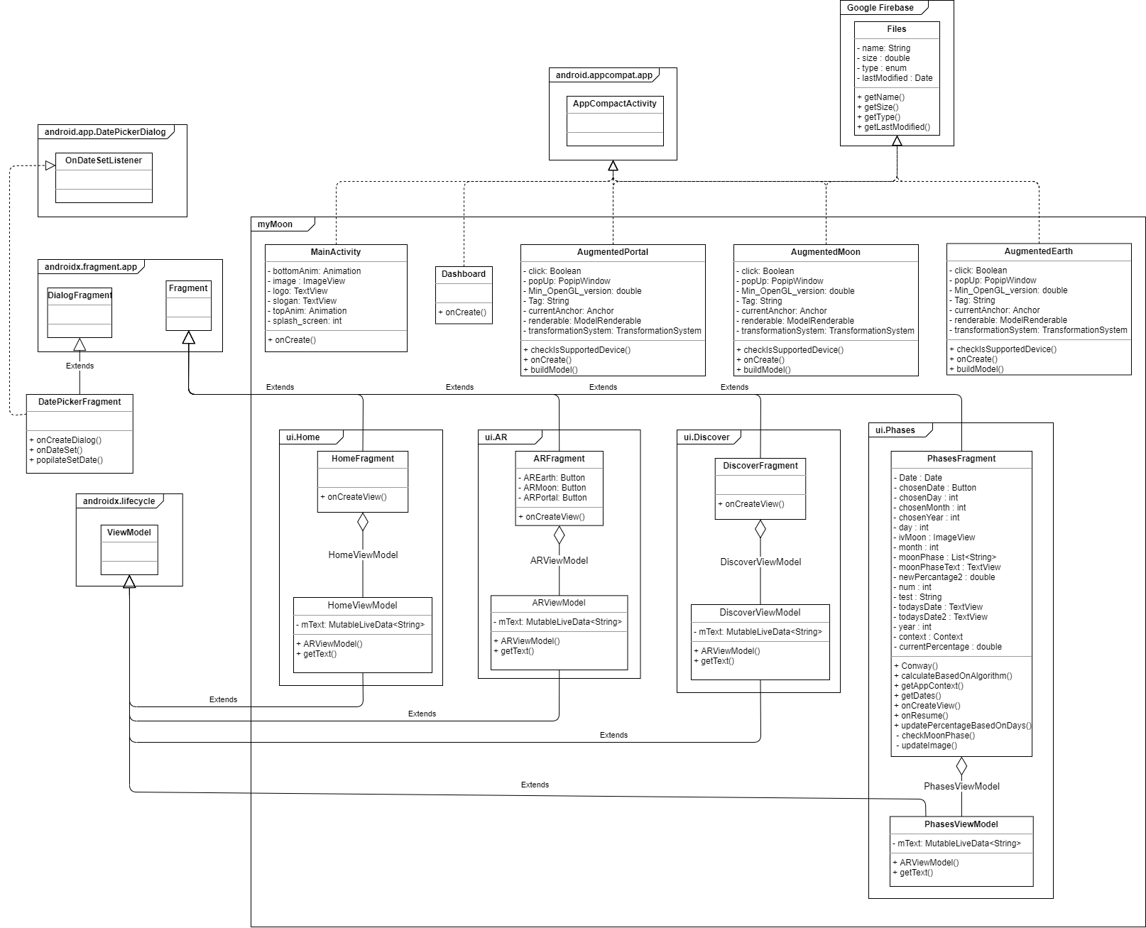

**Figure 26:** Basic Class Diagram

#### Flowchart

Flowcharts are a visual representation of the steps and flow of a given application. Each step in the process has its unique diagram shape ranging from circles, ovals, rectangles, diamonds, and more. It gives the presenters a flow of decisions that can be made within the application but having connected lines with directional arrows. Flowcharts were originally used by industrial engineers to structure work processes in their assemble manufacturing but today they are used in all areas of business.

I have used a flowchart to demonstrate the flow of events within this application down below in figure 27. We can see the most common actions that will be done in this diagram and the decisions a user can do while navigating. There should be no code in this diagram as this is a high-level diagram. Its detail is in the navigation of the application compared to the internal methods. The flowchart begins on the green icon ‘Start’ and ends on the red ‘End’ icon. Any rectangle represents a process that the application does on its own like ‘onStart ()’ or ‘SettingsPage’. Any diamond shape represents a decision the user must do to continue like ‘Navigation Bar’ and ‘Choose AR Model’. The rectangles with one side as a point and the other as a curve represents a display process like ‘Display Settings Fragment’ and ‘Display Home Page’. Any rhombus shape represents an input of any type like ‘Moon’ and ‘Display Button’. The cylinder shape is a database so here it represents a database. Finally, the rectangle with a convex and concave curve on the side represents the data storage process. In my application, this is the process when the AR Model is being saved from the database.

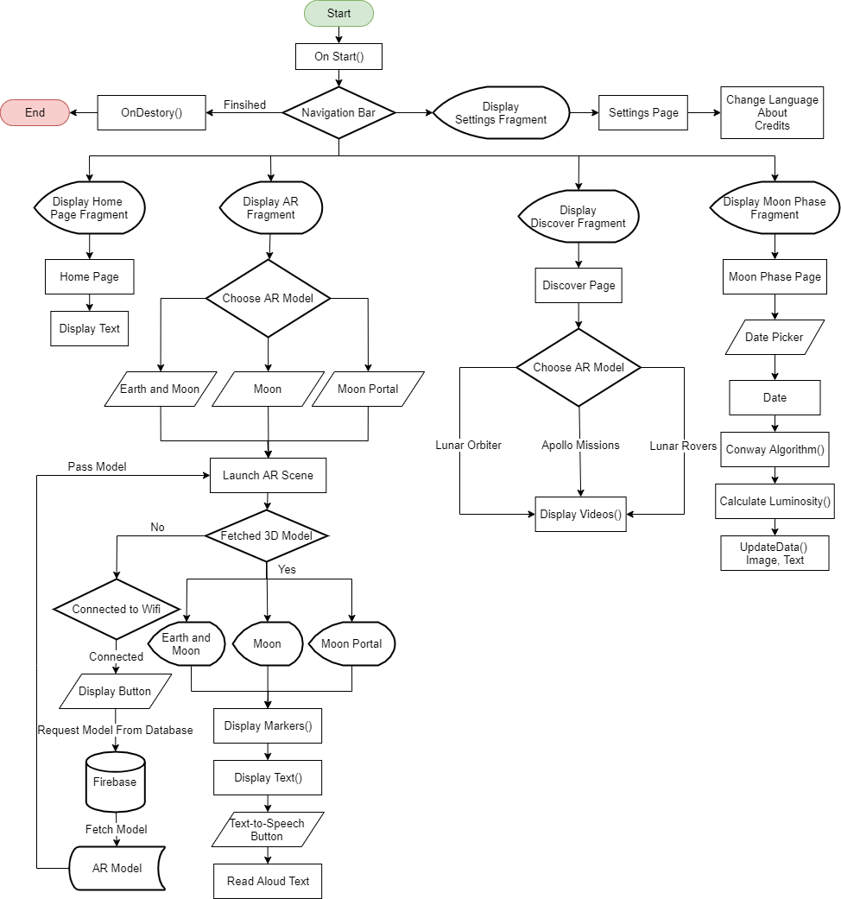

**Figure 27:** Application Flowchart

#### Application Wireframe

Wireframes are used as a visual aid when developing any web or mobile software application. They are used to show the User Experience (UX) of an application. It is a 2D representation outlining the different screens of a system with icons, text buttons, and more. It is known to be the earliest form of a prototype as with the wireframes you can follow along using arrows to point to the connection between each screen. Typically, wireframes are monochromatic, meaning black and white, but they can be developed with colors for a better visual representation. Using wireframes in the design stage helps the client to know the features of the proposed system and allows for their input before development can begin. This is great as it irons out any concerns that the client might have before spending time on concepts that the user might not have agreed on.

I have created a complete application wireframe outlining the different screens that my application will have. By having wireframes drawn out it helped me to visualize the application as I had complete control over how the application will look like. I had to use my knowledge of material design and UX to be able to generate the best outcome. I have connected different screens with arrows to show you the flow of events starting with figure 28 below.

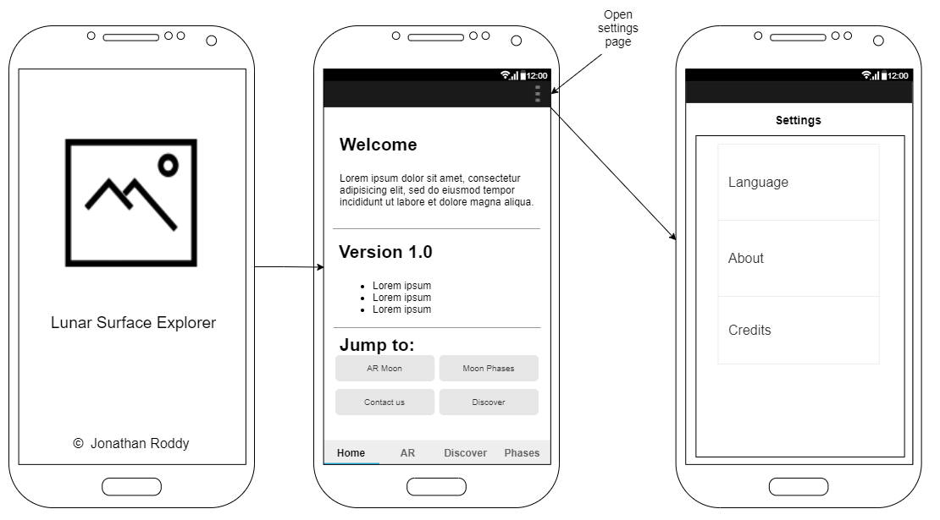

**Figure 28:** Splash Screen, Home page and Settings

Figure 28 shows us what the splash screen, home page, and settings page will look like. A splash screen is a name given to the first screen that the user is presented with when launching an application. I will have an image of the Moon followed with some text underneath to greet the user when loaded. After the splash screen has concluded the user will be faced with the homepage screen. The home page will have a welcome section, version number, and any new updates that have been added as well as some links to some special parts of the application. On the top right of the application, you can see three dots, a menu icon that will be on each screen going forward. This menu icon will launch the settings page, giving the user the option to change language, about page, and the credit section. I have added a bottom navigation bar to help the user navigate between the different pages on the application. I have added this to adhere to the best practices of material design. If any of the buttons on the navigation bar is clicked the screen will be updated with the appropriate screen.

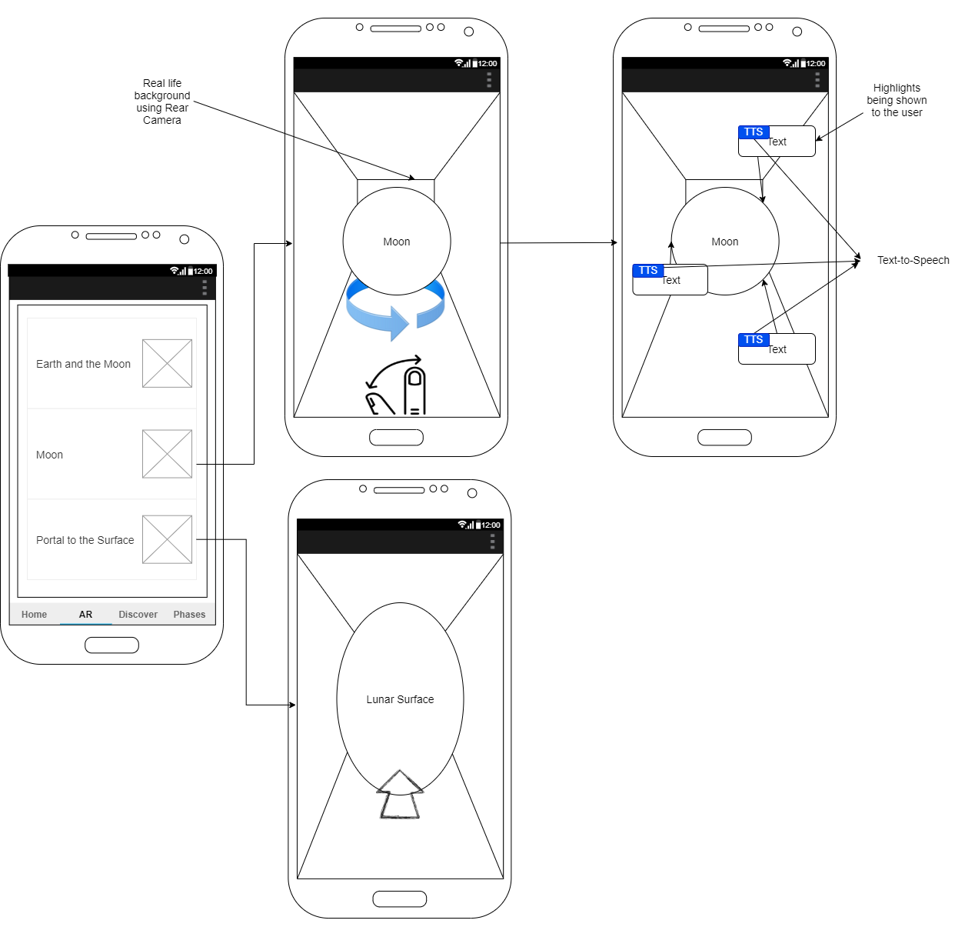**Figure 29:** Augmented Reality Page

Above in figure 29, we can see the AR screen with its corresponding actions. On the AR screen, we can see three different buttons with an image of each of the actions. For either the ‘Earth’, ‘Moon’ and ’Portal’ the button will launch the same screen but will call the different model. This screen will be built using ARCore, scene form, and Android fragments. Building it as one page that will be updated reduces the code. From the above image, you can see a circle that represents the moon. The fingers underneath represent the user’s ability to move, twist and scale the model itself. This ability gives the user full control of them where they want the Moon to be placed. The Moon will have markers, pins, and text over it highlighting important aspects that the user has chosen to interact with. There will be a Text-to-Speech (TTS) option on the moon so the application will read out any of the text aloud. The Earth Model will also have the same option as the Moon screen. The Portal screen will allow the user to walk into the 3D model and it will transport them onto a virtual environment of the Moon’s surface.

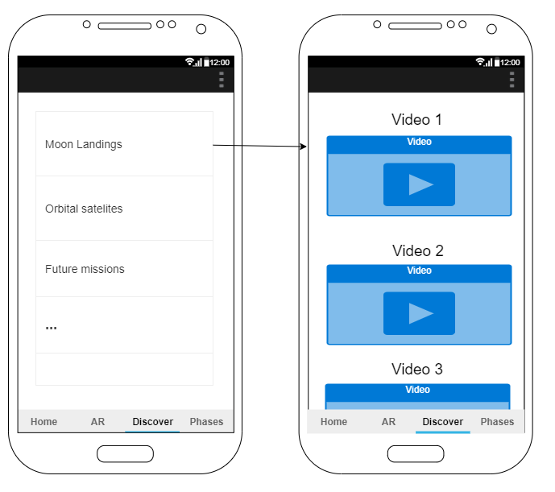**Figure 30:** Discover Page.

In figure 30 we can see the Discover page being represented to the user. This section and the next will be built using RecyclerView and CardView to again, adhere to the best practices when it comes to android design. I will have a list of options that will be shown to the user giving them choices like Moon landings, Orbital satellites, future missions, and more. Whichever one the user clicks a new page will be called and will populate information to the user in the form of videos or some text that can be read aloud to the user using TTS

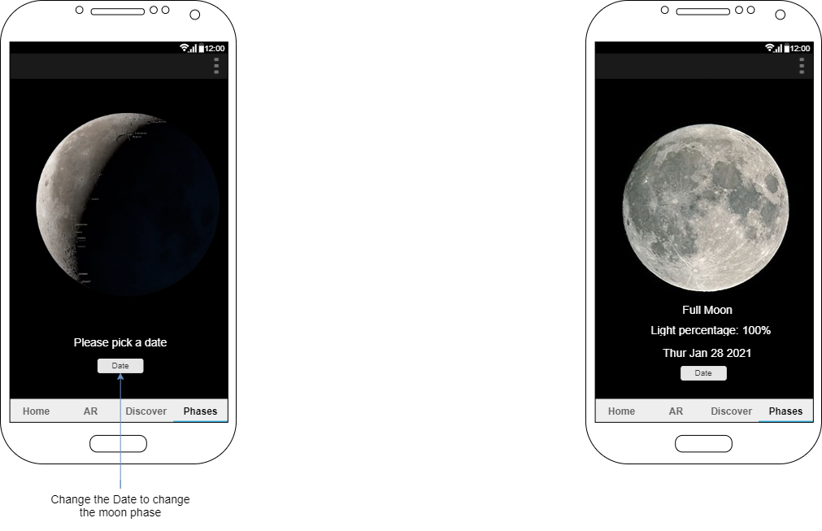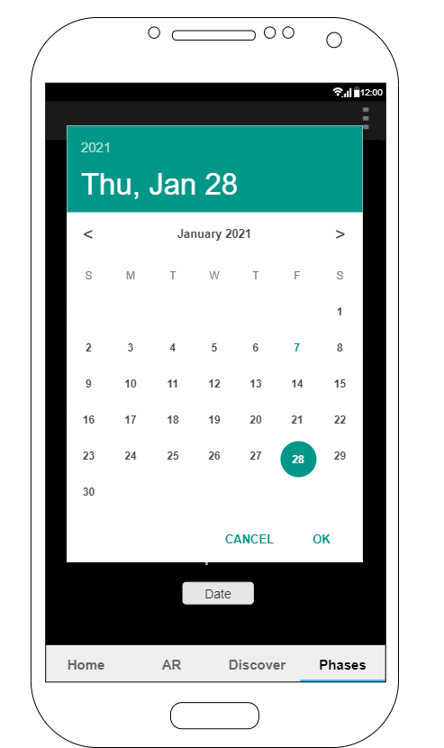

**Figure 31:** Moon Phase Page

The last wireframe I have is the Moon phases screen. This screen will allow the user to pick any date that they want, and the application will show its corresponding moon phases. On initial load, the application asks the user to pick a date with a button underneath. A calendar will appear to the user to which they can input any date they so wise. After the application has retrieved the date, it will update the image, and texts to the correct information. It will display the name of the Moon phases, the light percentage that it is currently, and the date again. The user can choose another date by clicking the date button.

### Conclusion

With these wireframes complete, I have finished the designing stage for the project. I have spent some valuable time coming up with concepts based on the research I have committed during the project’s lifecycle. The next stage is implementation, where I will start developing this project further. I will use all the diagrams I have created to help with the coding and aid me in getting this project complete on time.

# Results

## Chapter 1: Implementation

### Introduction

In this chapter, I will be talking about my implementation that I have completed for this project. At this stage, I have conducted a research paper where I investigated AR, TTS, and a design chapter. I have used everything that I have learned while undertaking those chapters to complete this section. I tested each stage of the application and once I had my tests complete, I was happy to move on to the next stage. I have developed a few android applications at this stage of the project thanks to my mobile development elective and my personal projects I have development. I felt a lot more comfortable with the software I chose and feel I had a good grasp of what needed to be done.

This project is a limited resource project meaning that I did not have an unlimited number of tools, assets, or time that I can use. I had to plan out the remaining project timeline and keep track of my process throughout. As of writing this project I am still currently in my final semester in my final year, so I did not have all day and night to commit to this project so juggling my time was hard. Each day was vital as I needed to be able to complete this application on time. I needed to divide some time each day to this project on either implementation or research into further development.

That said there is still a lot of steps that I did not know how to complete so I needed to get whatever resources required so that I may have a better understanding of those steps. I had to improve my skill set so that those steps I am unfamiliar with, could be overcome and tackled to the best of my ability.

I will be talking about the development of the application ranging from the database, 3D model creation, Android development, Augmented Reality, and some changes I needed to make during the implementation.

### Project Management

Throughout the implementation stage I needed to be able to track what tasks were completed and which one were not. Some tasks needed to be complete before moving on to the next stage, so I needed to know from the beginning what kind of road map I needed to follow. For me to track what tasks I needed, I used Microsoft Project and Microsoft OneNote to jot down what issues and tasks I had accomplished. I had to update the task list as the project developed as with everything, time was a key factor that needed to be accounted for. By having a way in which I could track my tasks allowed me to be transparent in the projects development as well as keeping myself accountable for my weekly meetings. This was a great opportunity to better equip my project management skills as it will be key for my future career.

#### Microsoft OneNote

Microsoft OneNote is a free digital notebook tool that can be downloaded to Windows, macOS, Android, and iOS. The purpose of this tool is to create notes that can be saved online or locally. It can gather users' notes, drawings, tables, audio files, links, and screen clippings so that they can be saved or shared with others. Many users can have access to different books that each user can be working on at the same time. It was designed to resemble a tabbed ring binder so that users can directly take notes and gather information while keeping a fulfilled layout.

The format of the notes can be sectioned into books, sections, and pages giving a more advanced architecture to their notes. It does not have the same features and functions as Microsoft Office or Outlook but can be integrated into that ecosystem if the user wants it to. If many users are working at the same time, OneNote keeps track of who has said what or when they have said it. It can be fully customizable offering either a dark or light theme display, the ability to change background colours or headings as well as the layout of the notes.

Users can save book layouts as a template so that they can input data faster the next time they might need to create similar notes. Even though OneNote allows users to take down notes and format them with font, sizes colour, and location, it does not have the same stand as Microsoft Word. Similarly, it does not extend itself to be like Excel either. Users must have the right use case when starting with OneNote as it does not replace those other tools. The ability to have auto synchronous notes with other users allows teams of all sizes to share their notes collaboratively giving them an environment where they can work together.

I have used OneNote both in my third-year work placement as well as my own personal life, so its features and functions came naturally to me for this project. I loved the idea of having a cloud-based notepad where I could access anywhere with any device. In several cases I updated my To-do list while I was outside of the house which I could then finalise and finish off using my home PC.

#### GitHub

GitHub is commonly used by software professionals alike to be able to store, connect and commit their code online into separate or collaborative repositories. Repos for short, can be made public or private depending on what the user’s configuration is set up to be. I have used GitHub personally to be able to view other people’s codes, connect to my friends account as well as learning best practices. I have had the pleasure of using Github in my third-year work placement in such a way that I never had before as it was used in a big organisation. This allowed me to learn so much more about GitHub and its features where I did not have the exposure myself.

I use both GitHub Desktop and the command line interface to commit, merge and pull, the latest versions of my project each day I was working. By using GitHub throughout this project’s development, I was able to create transparencies between my development and my updates on my project via the commit history. Commits are, in a sence, a note that developers leave whenever they are pushing their code segments online for anyone else to see. I knew that this project needed to be saved online as I did not want, at any stage, to have to go back and develop sections that I already created due to a software crash. I created a copy of my repo online as well as locally saving it to my pc to ensure maximum assurance that my code would not be deleted accidentally.

#### Microsoft Project

Microsoft Project is a project management product that allows project managers to schedules, assignment of tasks, tracking progress, managing the budget and analyse. I was introduced to this application via an assignment I had for another module I was studying. I never used it before, but I was glad I had the exposure when I did. I have little experience in becoming a project manager so after learning this application I really noticed the power in which this product must give. Of course, there was features and functions that I could not use as my project only had me to develop everything. For this reason, I could not use it to its full potential, but I did use it to help track my progress and the main tasks that needed to be done. I have added figure 32 and 33 below to outline the major milestones and tasks I developed for this project’s success.

#### Microsoft Project

Jonathan Roddy 1-Jun-21 79

**Figure 32:** Gantt Chart Page 1

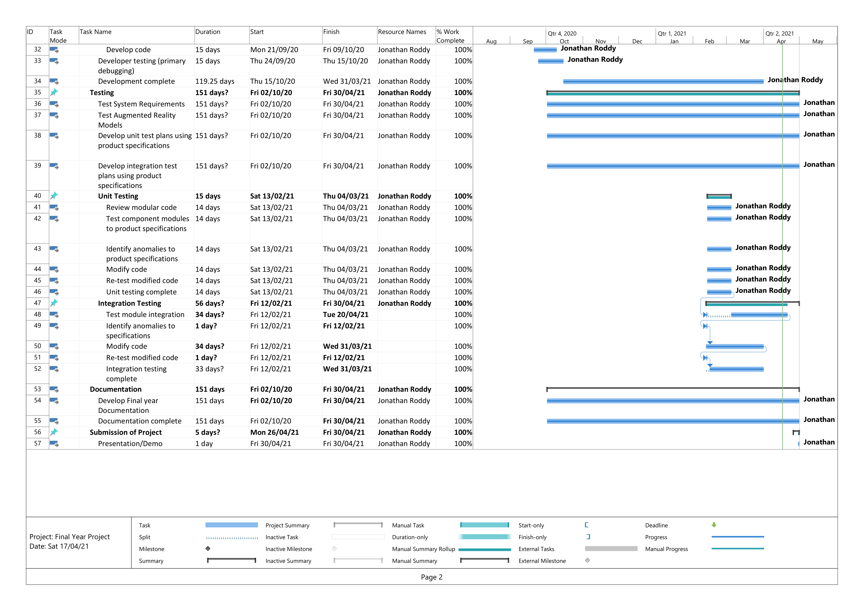

Jonathan Roddy 1-Jun-21 80

**Figure 33:** Gantt Chart Page 2

### Learning obstacles

For this project to be complete, I needed to get educated on some skills that I did not have before. At the early stage of the project, I never made an android application, so I had a lot to do to get ready for its implementation. As mentioned, before I was lucky enough to do a semester of Mobile Development at Limerick Institute of Technology. This elective allowed me to learn so many things about the Android ecosystem as well as getting hands-on with the development process. I learned about material design, Android application lifecycle, connecting to a database online, and best practices to adhere to when developing a complex system. Without having this training, I would not have known as much as I do now, which would have delayed the project further. I have used the knowledge I gained in the above chapter when it came to the design of the application, but I will be continuing to use the skills in the implementation. Since completing this elective, I have created a few applications like a two player Tic-Tac-Toe, live weather application, a fully working recipe book application, and many more. We were using Android Studio throughout this learning, so I was able to get some time to understand and use this IDE. From my prior research, I knew that Android Studio was not the only IDE I could use for this project, so I went out and developed a few applications using Unity. I was able to get some time to use this IDE and see the options that it can give me under a free license. It was a good IDE for sure, but the limitations were on the licensing and publishing of the final application. I wanted to make a demo of Augmented Reality, so I started to learn how to use both IDEs for that purpose. There were many more steps in Unity to perform compared to Android Studio, but both were easy enough to use. I decided to use Android studio instead as it gave me more options while also being completely free.

It was not just the IDEs that I needed to learn and understand as this project calls for Augmented Reality 3D models. From doing research I could see that many people were offering their own skill sets to create a custom rendered model for a set price, but I knew this was not feasible. From my research paper, I concluded that Blender is the best option for me to be able to create, render and export any 3D models that I so needed. However, I have never used such complex modelling software before so I needed to find some resources online that I could use to educate myself. I was reading the documentation online as the Blender community is so massive that there is a lot of forum and websites to aid anyone in their journey.

When having one of my supervised meetings with my project supervisor, they advised me to use LinkedIn Learning. LinkedIn is a social media website used by professionals to interact with other organizations and professionals. They offer online courses for anyone in any area of expertise. These courses can range from only a few minutes to a good few hour long. I found some courses on there that I knew would be beneficial for me and this project. Below under the certification section, I have added the three courses I undertook for this project.

#### Certifications

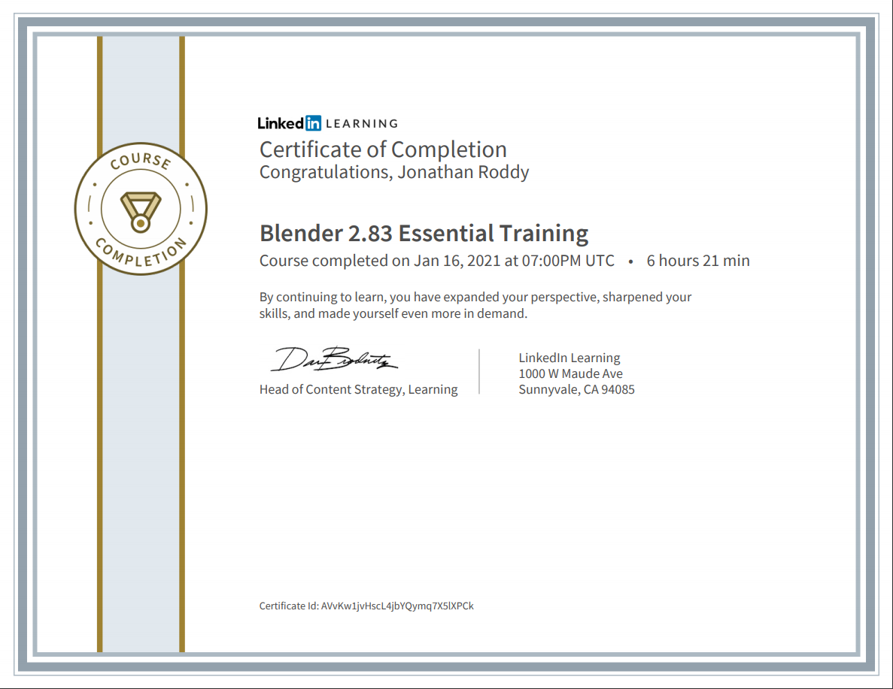The three online courses I decided to undertake was, Blender 2.83 Essential Training, Android Development UI with Java and UX for Non-Designers. Each of these courses gave me so much knowledge that if I did not do these courses, I would have struggled in the implementation. Blender was a nice software I knew I needed to learn and from my 6 hours of training I felt comfortable enough to sit down and start creating my 3d models I needed. The course itself consisted of different sections ranging from modelling, scripting, exporting, texturing and so much more. The instructor for the course was kind enough to give out the source models and code for the participants to use for their further studies which allowed me to have prerender assets that I could manipulate.

**Figure 34:** LinkedIn Learning Cert

From my experience as a junior software developer, I have used Java on many occasions in many different IDE’s. Android studio only offers its programmable code to be written in Java or Kotlin and I had decided to use Java as my main programming language because of my familiarity with it. I was lucky enough to find a quick course on LinkedIn that was teaching users about the practicality of using Java for Android development. This for me was a crash 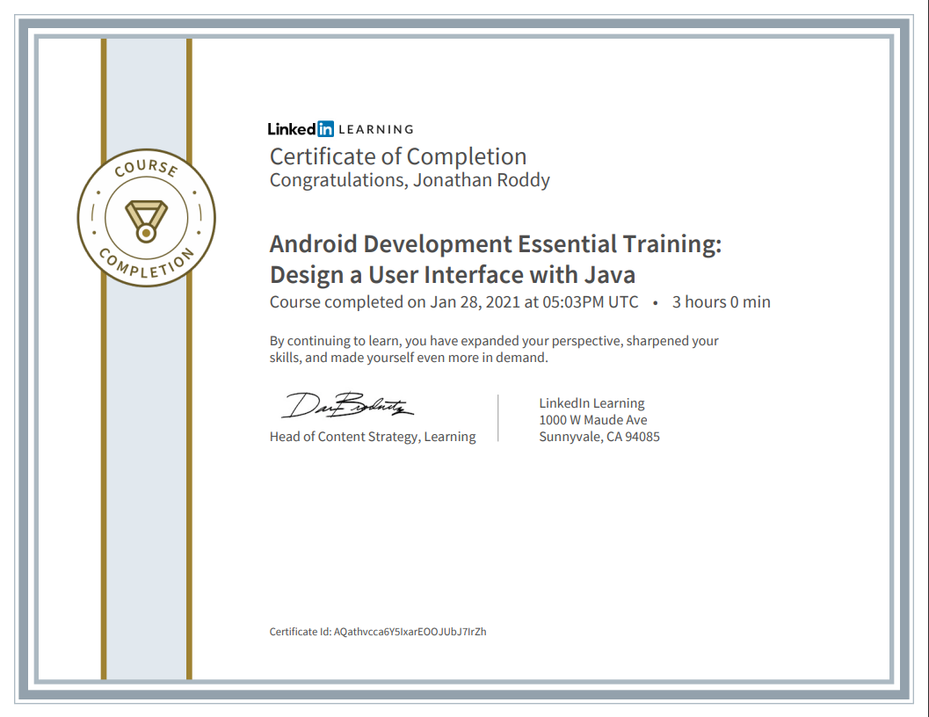course in which I was able to see best practices in terms of designing a good user interface.

**Figure 35:** Android Development UI with Java

Most of my time previously was spent in learning the back end of programming but did not ever spend a significant amount of time in User Interface (UI) and user Experience (UX). The UX for Non-designers was more than helpful to me as this course showed me realistic approaches to why UX is so important in every application. A good application will always have excellent UX in place and will suffer tremendously if done badly. I was able to use the skills from this course in my application but knowing in advance where my buttons, labels and texts should be. It was important to make sure that one screen is not clustered with functionality and is divided into different tabs and navigations depending on the overall theme of the function.

**Figure 36:** UX for Non-Designers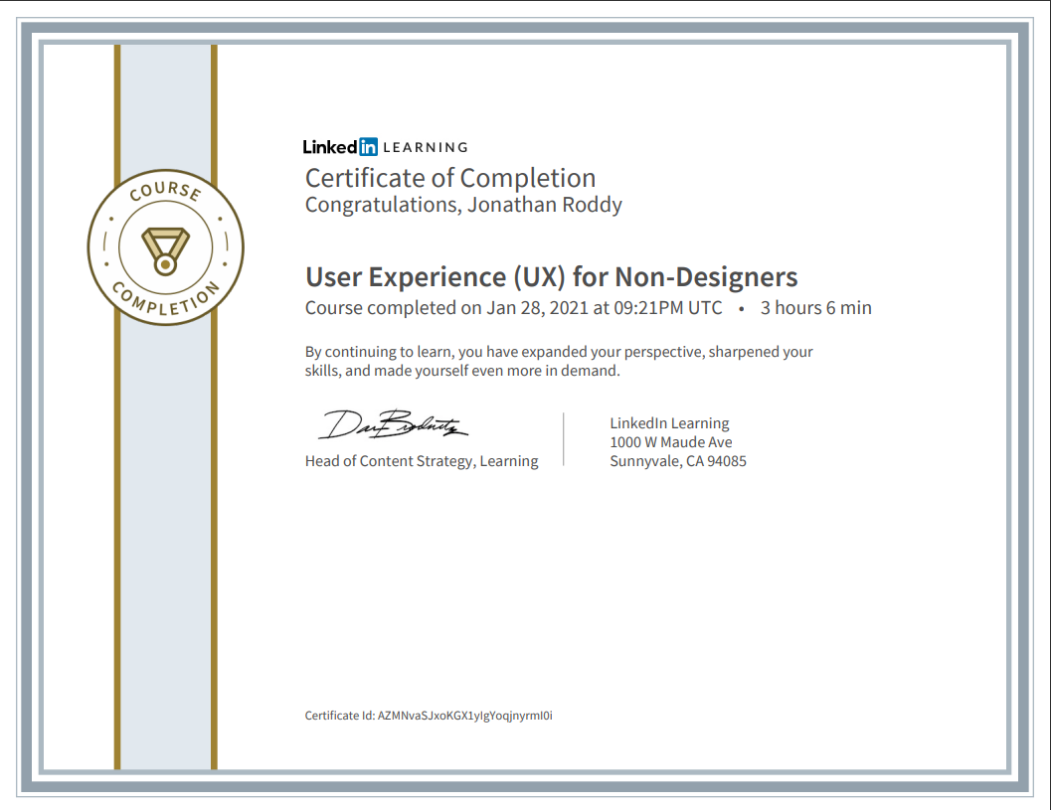

### Development Process

At this point of the implementation, I will be talking to you about the development process of this project. There was several twists and turns that I needed to combat as I was faced with several blockages that I needed to investigate. This came from integration, screen sizes, orientations and compatibilities between emulators and physical devices. I would like to say that the implementation went according to plan but it did not, and I am grateful that it did not. These challenges only allowed me to become a better developer as I learned a lot from them. When one mistake was created, I fixed it and the learned how to correctly implement that function for the next stage.

#### AR Model Creation

This application uses the idea of Augmented Reality to help educate users about the Moon. AR is a fun way that allows users to see and interact with virtual representations of models at the comfort of their smart phones. From my research I had gathered files that was publicly available online that NASA have released for anyone to use. Their kind generosity in freedom of sharing allowed me to use real, accurate data that was peer reviewed by many astrologers alike.

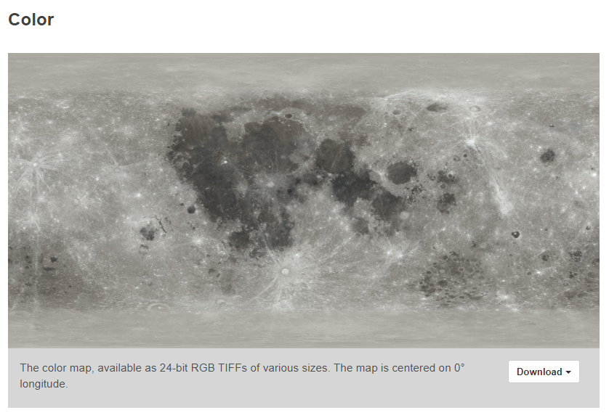NASA’s Lunar Reconnaissance Orbiter (LRO) is a small robotic satellite that orbits the Moon in an eccentric polar mapping orbit. LRO data is essential for planning NASA’s future human and robotic missions to the Moon (NASA, 2021). This little satellite has taken thousands of photos using a range of cameras and sensors that it then sends back down to Earth of investigation. Its work has allowed NASA to create an entire map of the lunar surface down to incredible scale of accuracy at a resolution of one meter per pixel or better. Its images have been combined by NASA’s scientific Visualization Studio to create their very own CGI Moon Kit (Wright, 2019). This website’s sole purpose to circulate realistic colour, figure 37, and elevation maps, figure 38, that can be imported into any 3D modelling software. Without this resource there would have been an immense amount of work to create such a level of fine detail. I was able to use both the colour and elevation maps within Blender to be able to create my realistic Moon model. These maps are to be used by any software products that orientates around the Moon. It is their goal to allow users access to these files as NASA believes that it is important to share factual data everywhere possible.

**Figure 37:** Moon Colour Map (Wright, 2019)

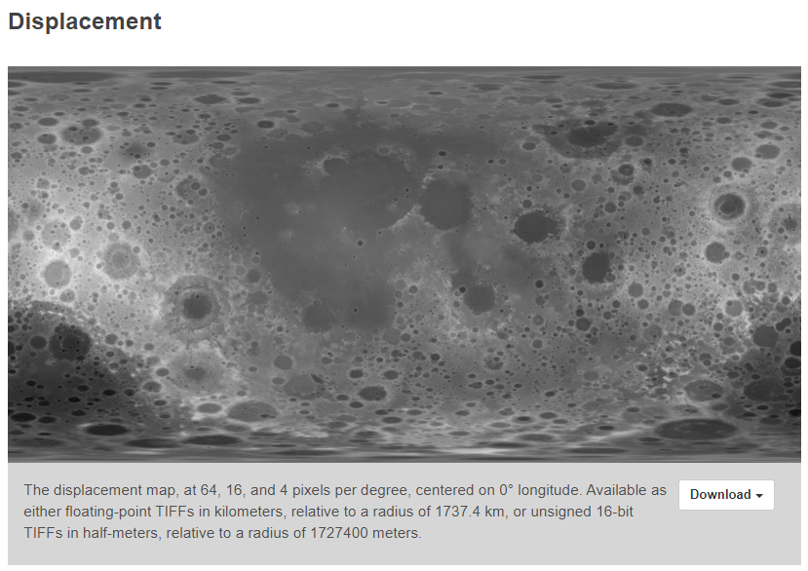**Figure 38:** Moon Displacement Map (Wright, 2019)

##### Blender

Blender was an important tool that I learned how to use as it allowed me to create photo-realistic models of the Moon using the maps provided by NASA. Here I was able to use the knowledge I had learned from my LinkedIn Learning course to create the 3D models I needed. The first thing I did was create a new Blender file and saved it under my GitHub repository for safe keeping. The physical shape of the moon is not that complex as it resembles a sphere. This was the starting point of the model. I deleted the default objects, camera, and lighting as I wanted to be able to create those according to the environment I wanted. I created a simple UV mesh sphere object and scaled it up ten times. This allowed me to have a much bigger sphere then the already given dimensions. From the course, the instructor advised to know the limitations of the lines your object will be wrapped around as this plays an important role in the texturing phase. I allowed my Moon model to be encapsulated with sixty-four vertical lines and thirty-two horizontal lines. These lines represent a visual representation of the dimensions of the sphere and can be incremented by the developer’s as needed, seen in figure 39. I wanted to make a smooth surface, so I added these lines in such a way that there would not be much overlapping on the surface. Once I had my layout lines in place, I enabled the sphere to have a smooth 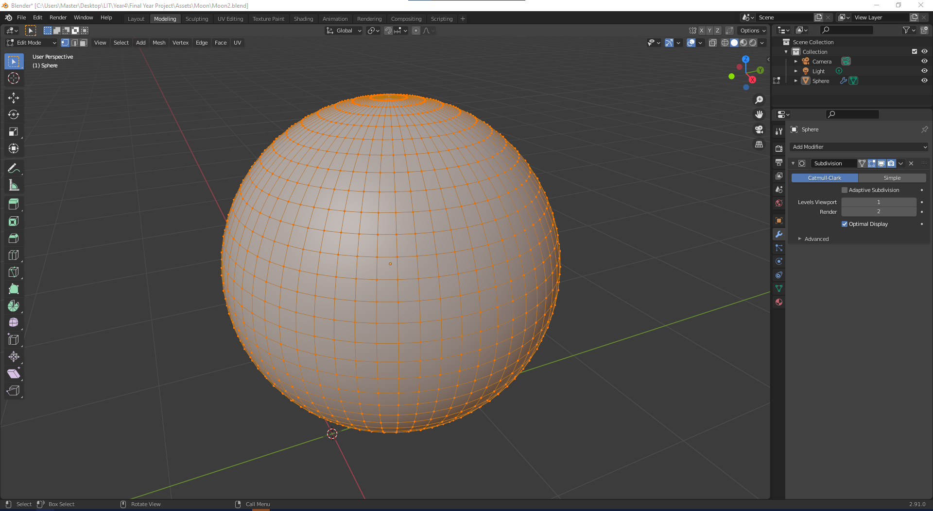surface so it would resemble a complete sphere.

**Figure 39:** Blender Modelling

Once I had the general shape created, I moved over to the texture mapping section on Blender. This feature allows users to add all types of textures and alter them to your liking. Figure 38 below shows the texture mapping that I used to create my Moon model. The green section is the base material that is created when you start a new material. Each other texture is connected to this, to build upon the material. The two orange sections are the texture images I received from the NASA website. One to store the colour map and the other is the displacement map. The colour map was simple to connect as once it was loaded, all I needed to do was connect it to the colour of the material. The displacement map needed further configuration as it needed to be truncated to the sphere. To do this I simply added a displacement add-on which would be added on the output of the material.

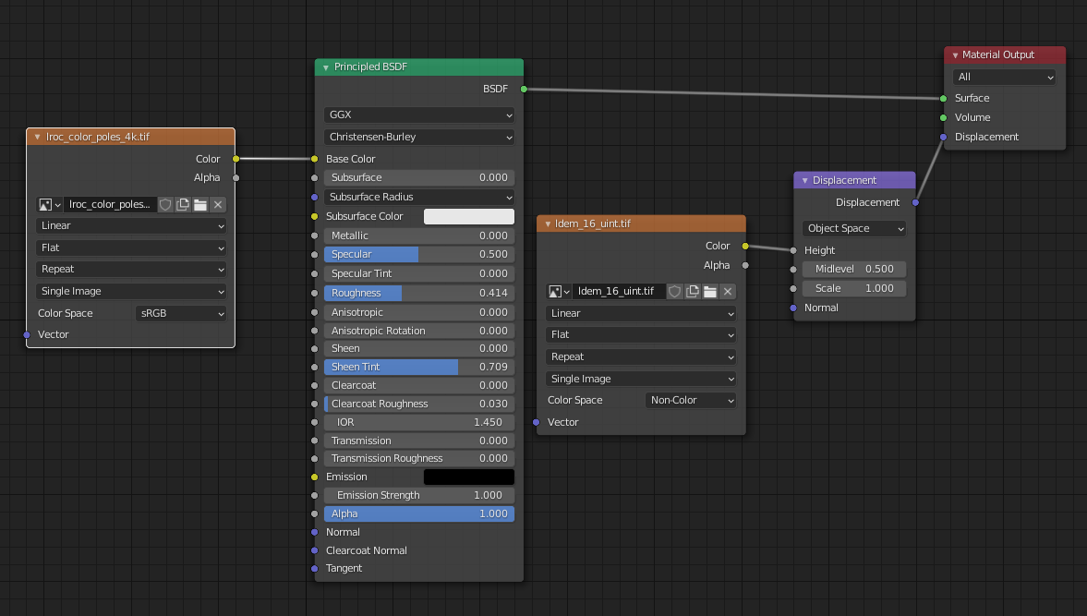**Figure 40:** Blender Material Texture

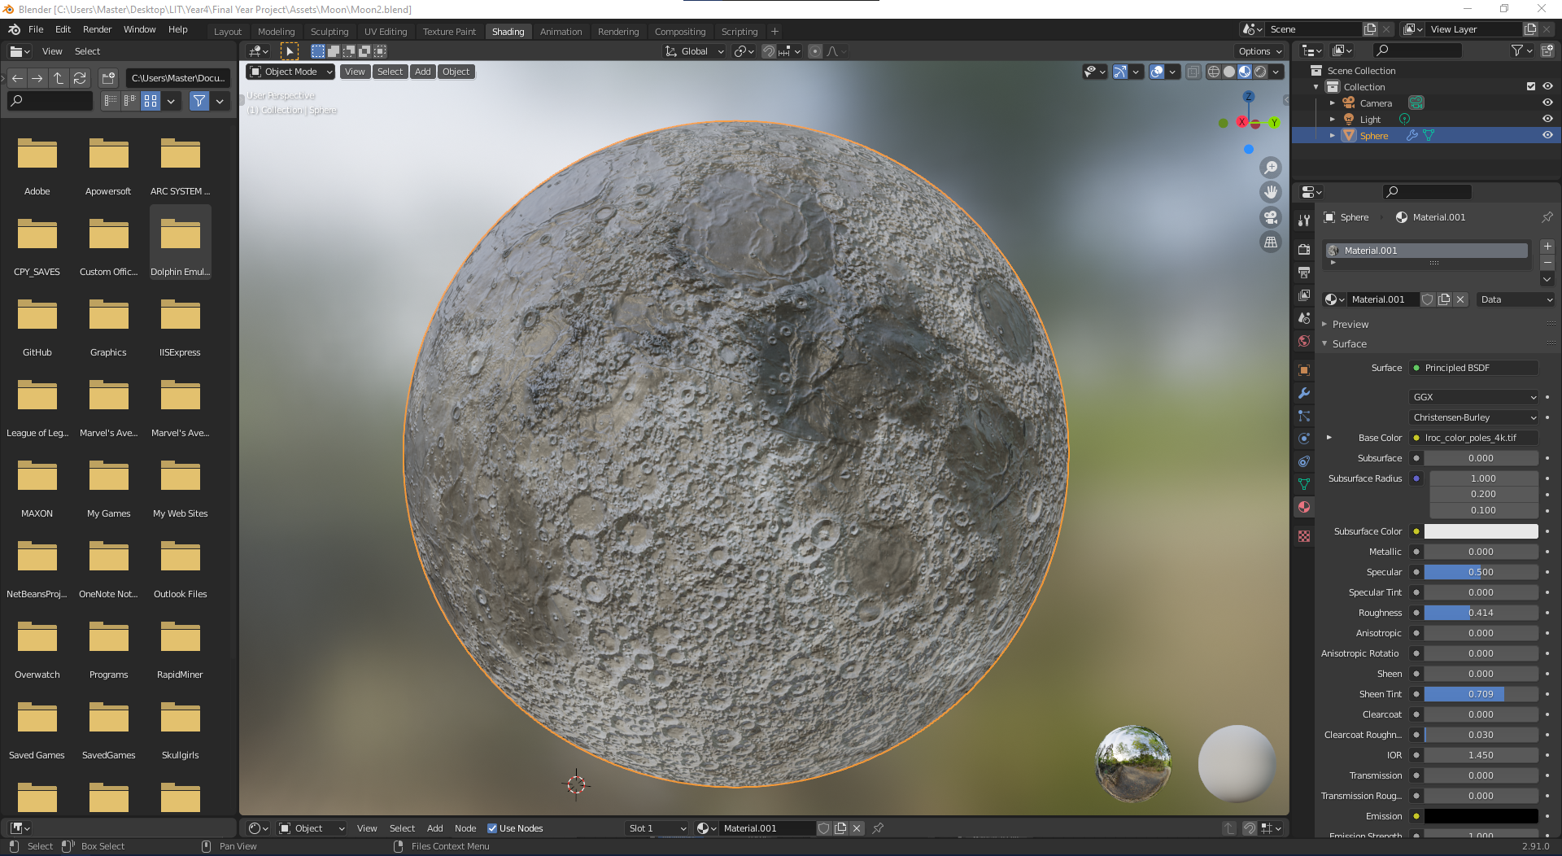With these components the 3D model of the Moon was generated as seen in figure 41 below. Once I was happy with the size and shape, I exported this model as both an ‘.obj’ and ‘. glb’ format so that when it came to implementing it in the android environment, I had some options. The GLB format removes unnecessary files and objects where the OBJ keeps all files.

**Figure 41:** Blender Moon Model

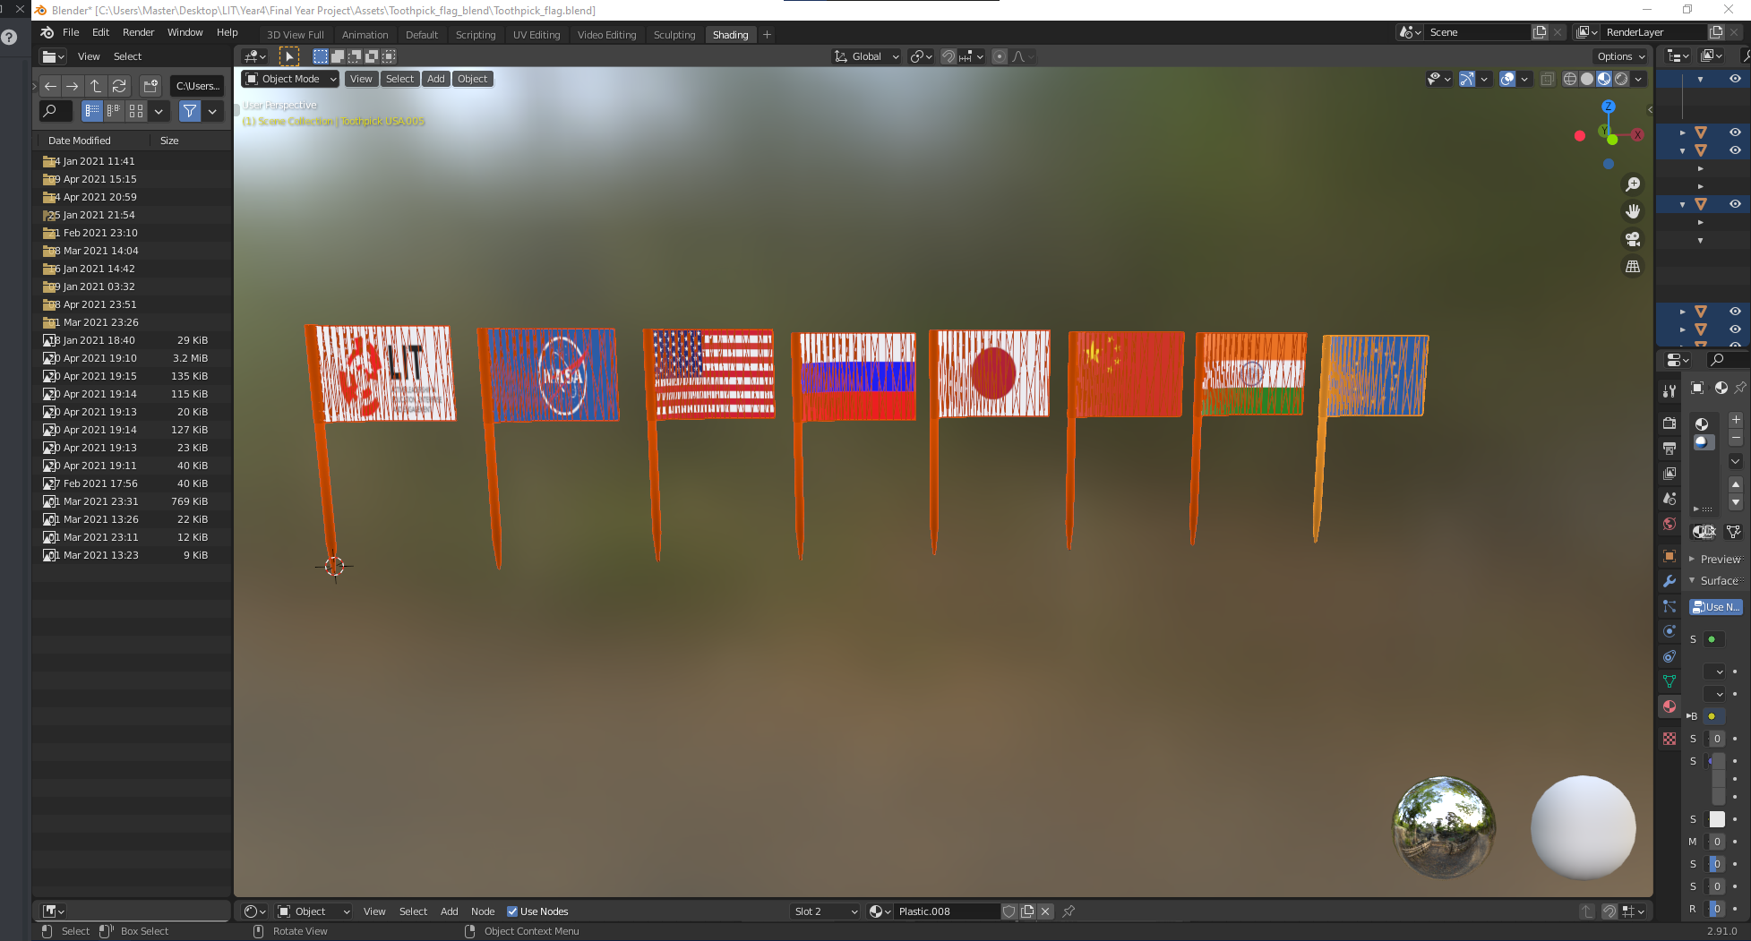From doing further research I found more data release by NASA on all locations where humans and landers have landed on the surface. From here I made a list of all those countries so that I can download and create a visual representation of each of their flags in Blender. See figure 42 below for all the flags I have created. The first flag I created was one for LIT as a training for the other flags as I knew if one were created then I could copy its shape for the others. I added a slight curve on the flag itself so that it could have some texture instead of a plain rectangle. Making sure the flags were in the right place was hard at first down to the complexity of the flag shape but after a few tests I was happy with how the image textures should look like.

**Figure 42:** Blender Toothpick flags

The texture mapping, as seen in figure 44 is much simpler than the moon as there is only one image being imported and that would be the countries flags. I needed to create a new file for each flag as I had to mirror the flag on the underside as well. For each flag I imported the texture layout for each flag according to the countries it represented as seen in figure 43.

**Figure 43:** Europe Texture Layout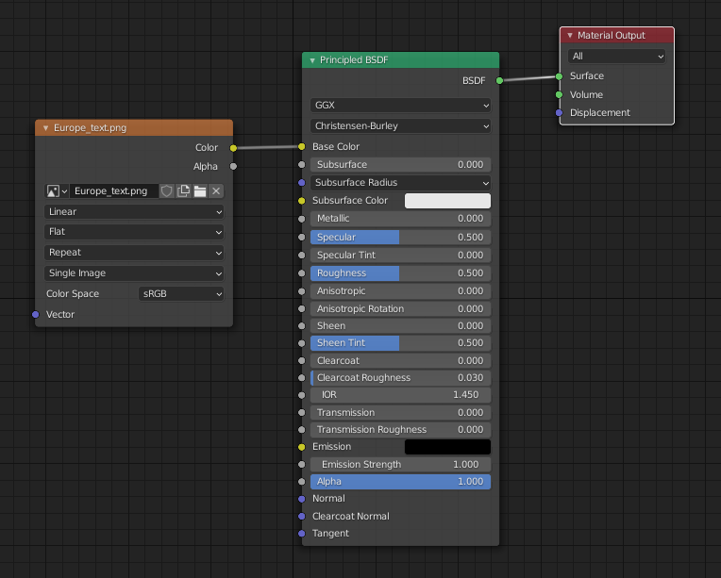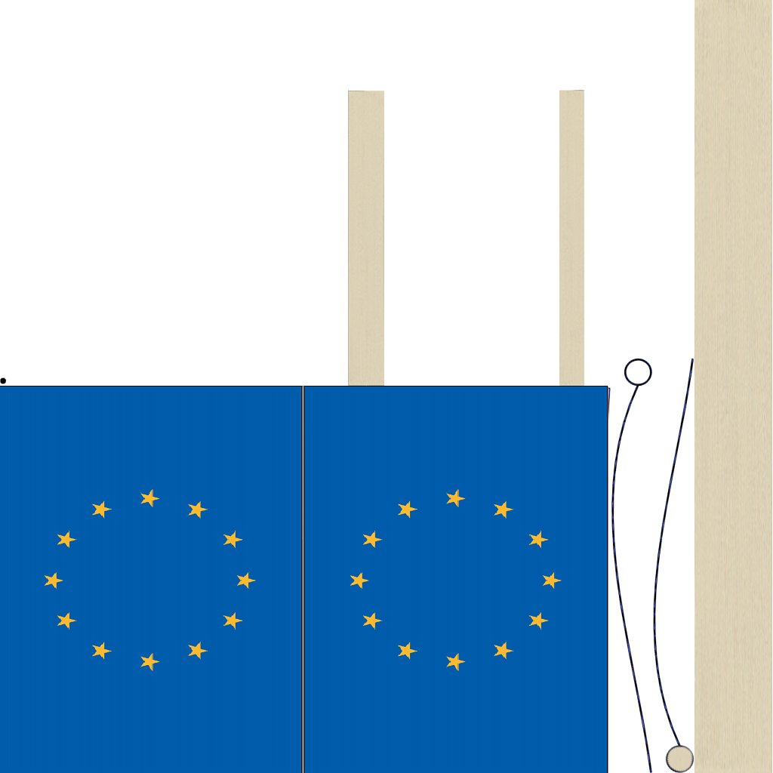 **Figure 44:** Blender Flags Texture Mapping

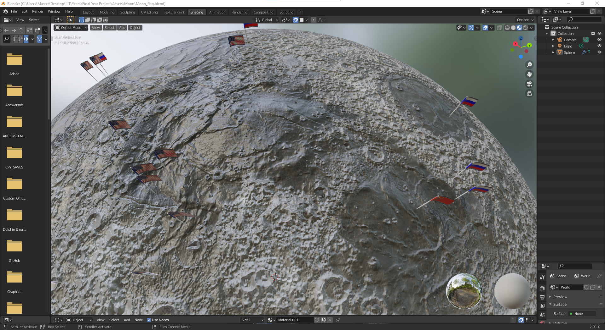Now that I had all the flags created, I used sources to locate the exact locations of all the human interaction. NASAs Moon landing site gave out the exact location that I used to mark the points on the Moon model that I created (NASA, 2017). I moved and copied each flag to match the locations and merged it to the surface of the moon as seen in figure 45.

**Figure 45:** Blender Moon with Flags Locations

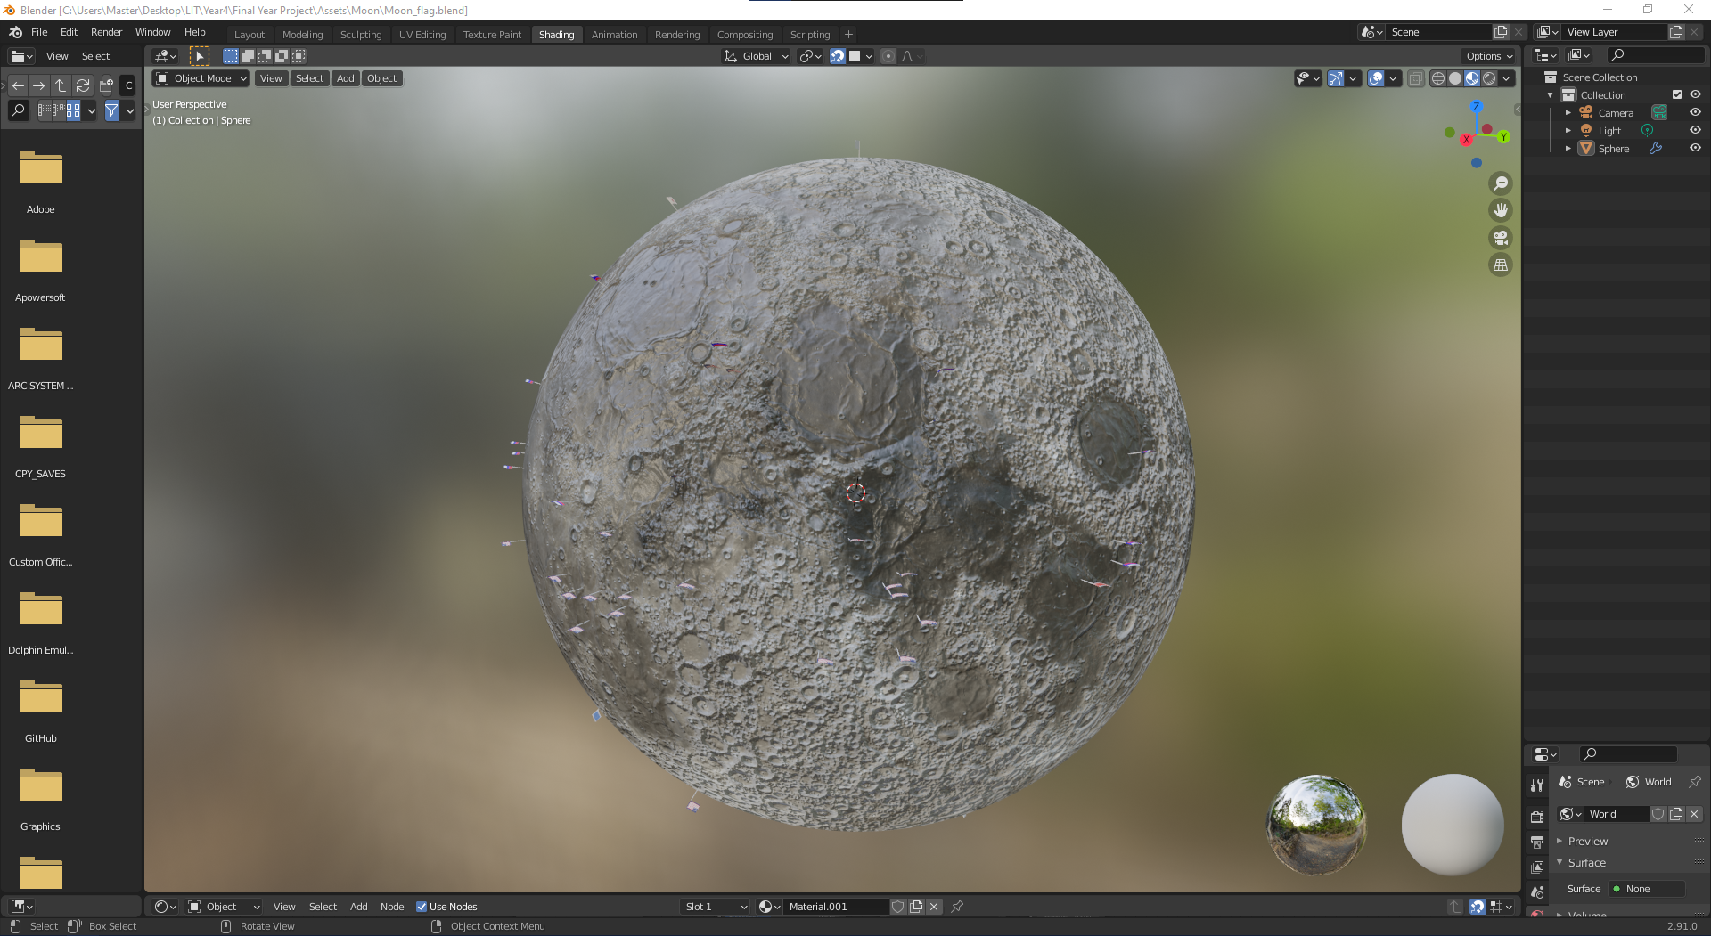After I had pinpointed the locations, I exported this model to be used later Figure 46 shows the second Moon model that I have created for my project.

**Figure 46:** Blender Moon Model with Flags

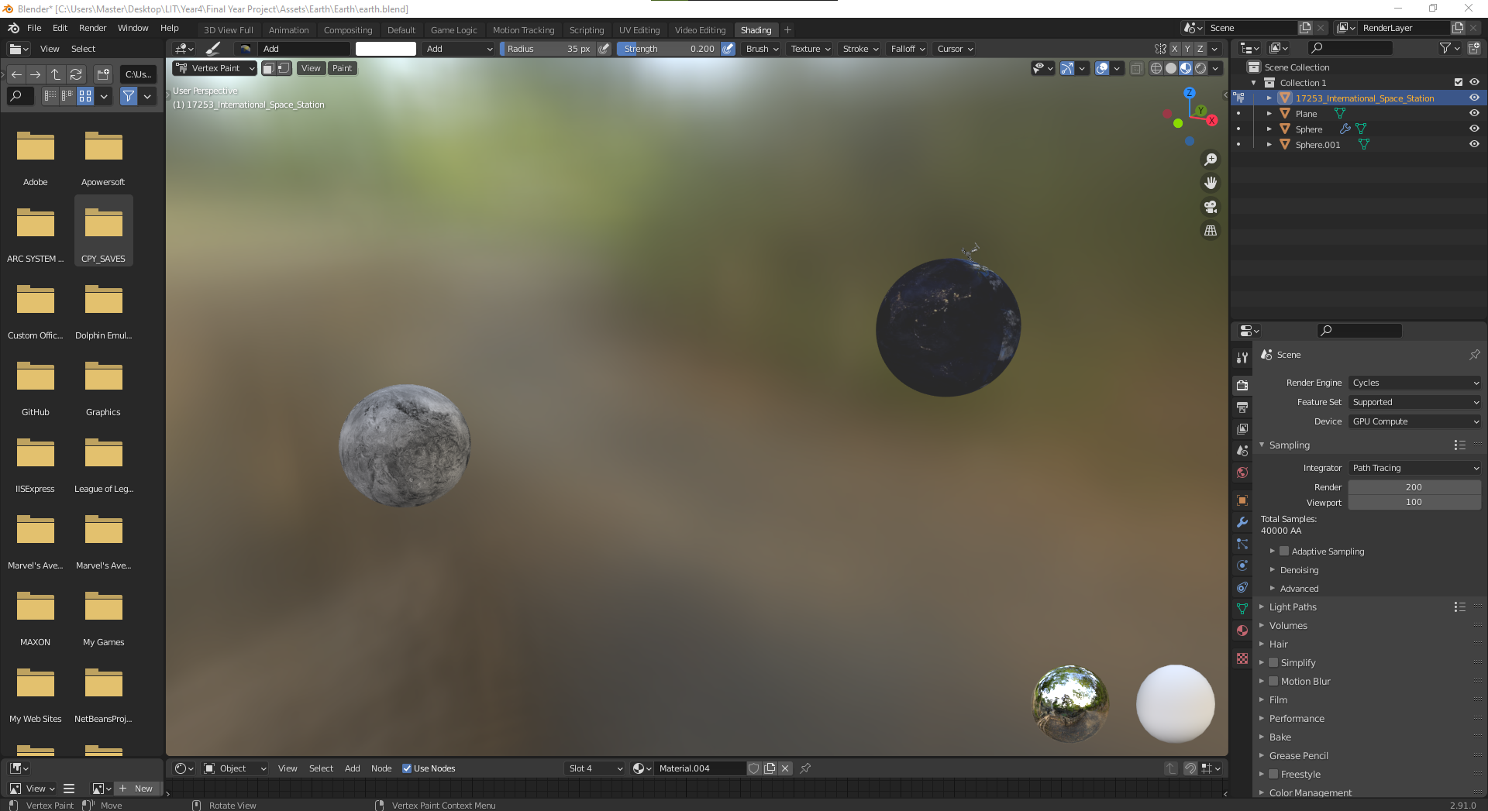Later, when I had both of my 3D models created, I decided I wanted to create a model of the Earth with the Moon rotating around in its orbit. From my further investigated I was able to create a reasonable animation but down to the limitations I could not export that object for my Android application. ARCore does not allow animations to be used. I settled on having just the Earth rendered as a final model instead.

**Figure 47:** Blender of Earth and Moon Animation

#### Database implementation

I knew from my research that I wanted to have my 3D models stored on a cloud database and Firebase was chosen. I wanted the models to be saved online so that at any stage of the application I could simply re-upload my models instead of updating files and code on the Android application. For my files to be stored online I needed to create a new firebase project and used my personal email account as the administrator. Firebase offers many great services that I have used both in storage and in testing.

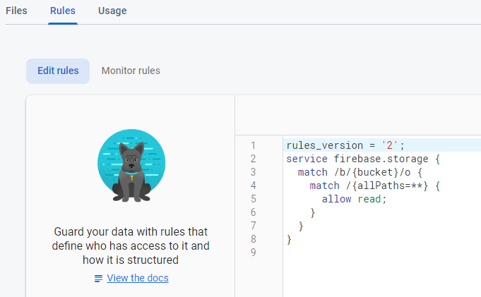I uploaded all my 3D models onto firebase storage and kept a note of their names. For my android application to be able to read these files I needed to update the rules and usage for my firebase account, see figure 48 for the rules.

**Figure 48:** Firebase Storage Rules

For this application, I allowed anyone with access to the database to read data from it, and removed ‘write’ access as I do not wish for any models to be reuploaded via the android device. One I had the rules set up and was happy with my blender files, I moved on to the android development. Figure 49 shows the complete Firebase Storage that has all the objects and files that I have uploaded.

**Figure 49:** Firebase Storage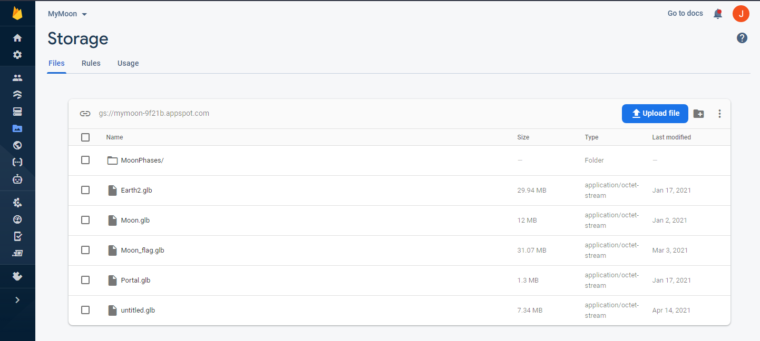

I had to keep checking on my Firebase account as each time the 3D models are being called from the database the usage of the database increases. I needed to make sure that at any time my usage did not exceed that of the account I was under or else the system would automatically update my account. If I were doing a lot of testing the usage and bandwidth would throttle. If this project were to be released, I would want a better account permission so that the database could handle the load of many users and many devices connected to it.

#### Android Development

This section I would like to talk about the process in which I was able to develop an android application using Android Studio. I used the knowledge I had previously learned from studying a semester of mobile development. As stated before, this elective taught me a lot about Android Studio and its layout. I was glad that I was able to study this elective as I would have meant that I would have needed to study another elective as well as Android studio. I used the knowledge of best practices, layouts, and screens through this project’s lifecycle. I used the wireframes I created for the design chapter as the basis of this applications UI and UX. I stayed true to the original design I created with small changes to the UI from the course I undertook. I will talk about each screen separately as they all have a separate function they perform.

I created a new Android Studio file and I made sure that its directory was stored on GitHub under my account. After a few configuration settings I tested to make sure I could commit my project to GitHub. My Android application needed to account for a few parameters that I needed to account for like the compatibility for ARCore as well the several form factors that Androids run on.

From my research I knew that the augmented reality API, ARCore would only work on certain android devices. I created a function that would check the version of the user’s android device and inform them if they are capable to use the AR fragment.

**Splash Screen**

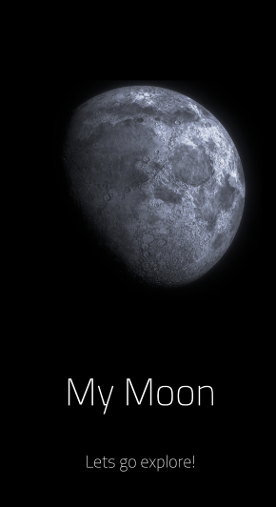The splash screen refers to the first screen that is used when loading an application. Typically, this screen is only used to welcome a user to an application but also can be used to hide the application fetching data on load. For my design I have added a splash screen consisting of the title of the application, an image of the Moon, my slogan as well as some animation effects. Once the application is initialised, the first thing the user will see is this screen. While this screen is loading, the main application is rendering the entire application, as well as fetching all the relevant data it needs. I have added some animations to each component, so it is more UI friendly. The image comes down from the top and the text comes up from the bottom. I added a small fade onto both and gave it a total of 1.5 seconds to load, given enough time for the application to fully load.

**Figure 50:** MyMoon Splash Screen

**Dashboard**

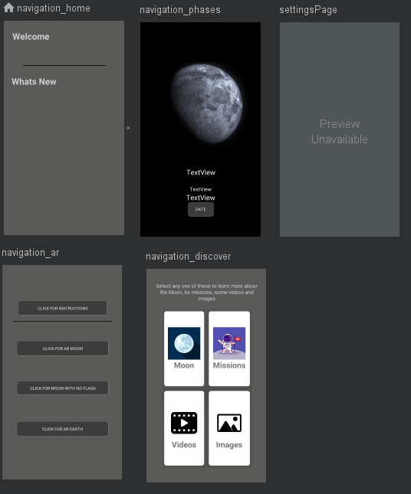This homepage is the default view for the bottom navigation that I have created. This navigation consists of four buttons with an icon and text for each one. The four buttons, when clicked will bring the user to separate fragment screens and can be switched over at any given time. The way fragments works is by replacing a view with another view without changing the overall screen. Replace the screen itself, which I do several times, calls more activities, and usually demands more of the device to render in memory. This allows the user to pick and choose what they want to interact with whenever they want too. The sections are. Home, AR, Discover and MoonPhase. I will talk about each section and how I implemented them.

**Figure 51:** Dashboard Navigation Screens

**Homepage**

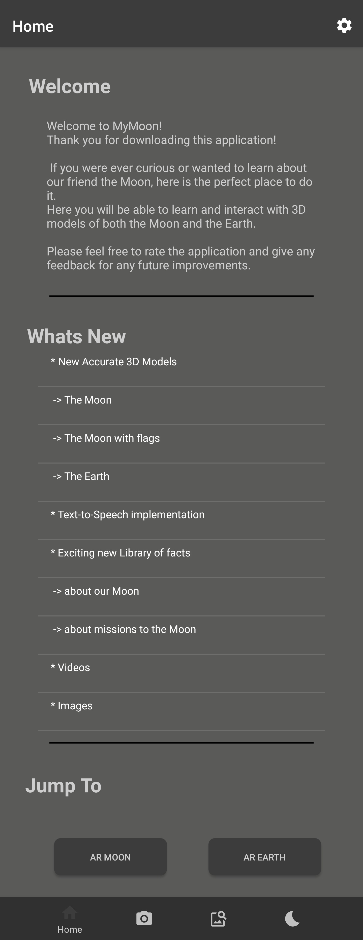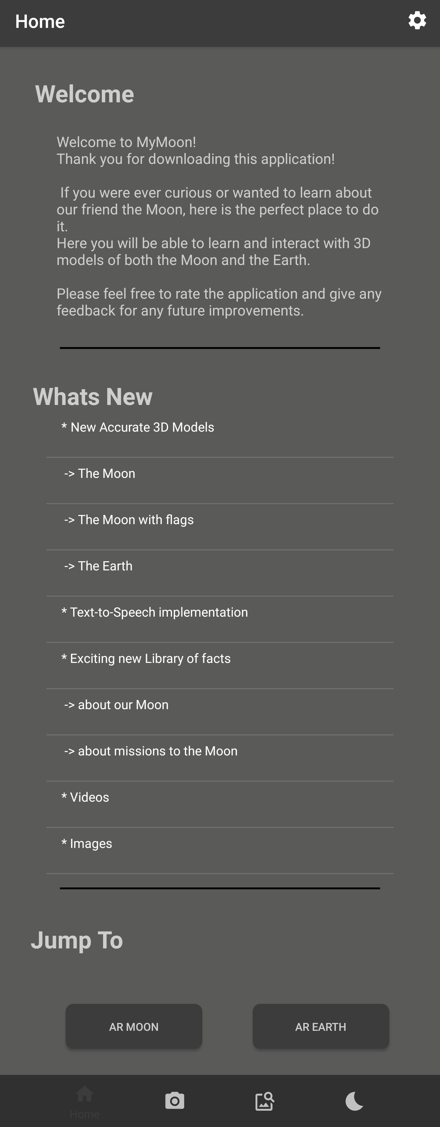The home page stayed true to the design I had created with the only change being the number of buttons located under the ‘Jump To’ section. The home page consists of three sections, welcome, what’s new and jump to. The home page was created on a NestedScroll view meaning that the actual size of the home page does not fit on a normal screen, users must swipe up to see the bottom section. The welcome section is there to greet users once the application has loaded. The what’s new section shows the user what has been added to the application which was updated a few times over the lifetime of the application. The Jump too section has two buttons, one for the augmented Moon and one for the augmented Earth. If the user were to click any of those, the application will immediately open the augmented reality screen for that given model.

**Figure 52:** Extended Home Page

**Settings**

The settings page can be found but clicking the little ‘Gear’ icon on the top right-hand side of the application in any screen. This button will create a new fragment that will replace the complete dashboard. I tried a few ways in which this screen would not replace the screen to reduce memory, but Android studio wanted me to add each page inside the settings page on the navigation bar which is not what I wanted to happen. To combat this, I create a second navigation system inside the settings page so that it would not need to be on the bottom 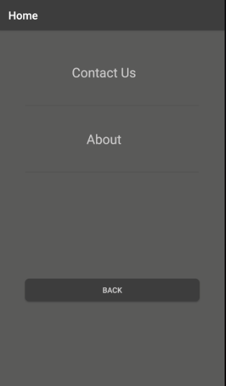navigation bar. Please see the below figure for the settings screen.

**Figure 53:** Settings screen

Originally, I intend on having some options where the user can change the language of the entire application to a select few options. Unfortunately, down to the time constraint I was not able to implement this feature as I needed to get other functions finished and ready. If I were given more time, I would revise this design and have languages as an option on the screen. It would be harder to implement now as it is much easier to develop a system from the start with localisations in place instead of a later iteration.

However, I was able to develop a ‘contact us and ‘about’ page. The contact us page presents the user with three input boxes and two buttons. The goal of this screen is to allow the user to send an email to the developer, “me” via this input box. The system asks the user for their contact’s name, subject header, and email body. There is one button to clear all text boxes and one to send the email.

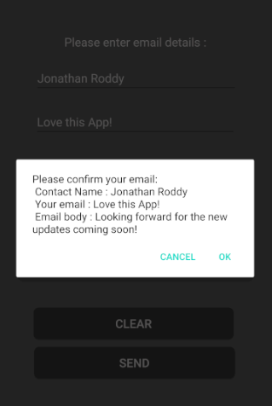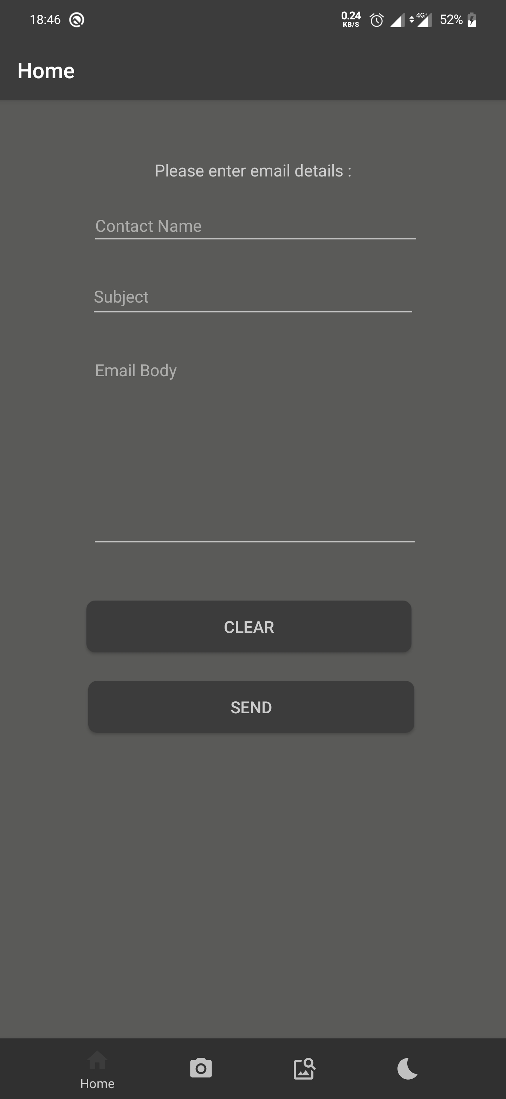**Figure 54:** Contact us Page **Figure 55**: Contact us Sending email.

There is some error handling behind the send button to be able to check if the user has entered a name or email body. When the user is ready and clicks send, the system will send this data into any email service on the user’s Android device.

Initially I wanted the application to handle the process of sending the email but when I went to program this function, I was having issues with getting the write permissions and access to be able to develop this solution. I tried using Google SMTP as well as Java’s SMTP but both occasions I was running into issues. I had created a new email about for this project, ‘mymoonjonathan@gmail.com’ and made sure the security for this email would allow emails to come through. The best solution I could find was to pass all the data here into a pre-defined email service already onto the phone where that have no issues. I could have easily just given the users an email to send but this process entices people to email instead. It welcomes open communication for all.

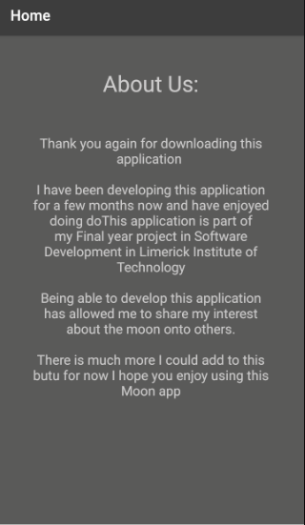The about us page was designed to have a little paragraph about this application, giving more information to the user. I wanted to include this screen as I knew it would be a simple screen to program but from my research, having a section that is friendly enough to show the human side of a system allows for a more natural user interaction. It is common to find applications today that has a small section dedicated to the team or individuals who were involved the making the system.

**Figure 56:** About Us page

**Augmented Reality**

This part of the android application was the longest part to implement down to the learning curve that I needed to combat before even starting this. I spent a lot of my time learning how to use Blender, Firebase and reading up on AR Core to learn how to implement this AR into my project. I knew I wanted to display 3D models on a surface from the very beginning of the project lifecycle, so I was excited to finally get on with this part.

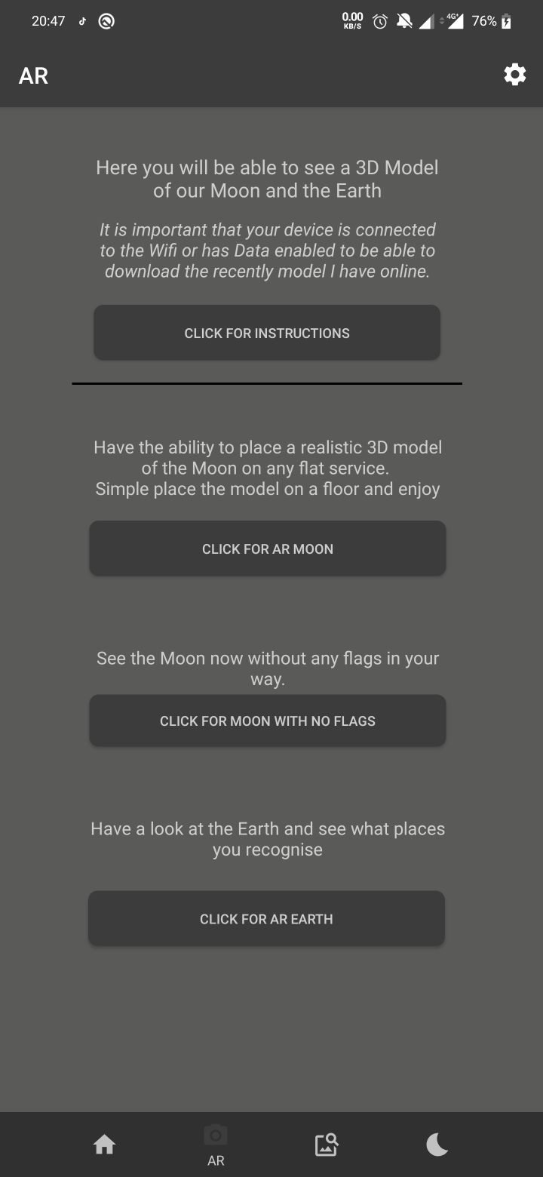I created a sub menu for the AR screen so that the user can choose the model that they would like to view as well as a sentence to entice them to explore that option.

**Figure 57:** Augmented Reality Dashboard

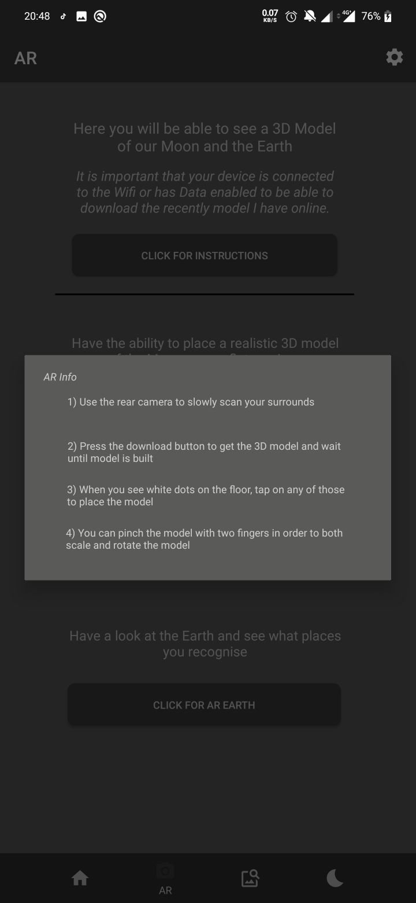I added a list of instructions as well so that at any point, the user can read the instructions and figure out how they can use the AR. Please see figure below of those given instructions.

**Figure 58:** Augmented Reality Instructions

From my design I knew I wanted the user to only see the 3D models on the service and have some text coming out in certain areas of the moon. Unfortunately, when I was developing this part, I realised that this was not able to be done using the technologies that I had chosen. What I needed to use was a game engine that could handle this rendering and processing whereas the ARCore could not facilitate this ask. Using AR core was easy and fun to learn, but I was limited in what I could do with this technology. After spending some time learning how to use depth perception, the models that I exported that would work with ARCore were the ‘. glb’ files. This meant that ARCore could not represent the true depth as GLB are exported using the bare textures. I made sure however, I was able to do all that I could with this library in terms of manipulating the objects.

I developed three separate fragment classes for each of the given models as I did not want the application to be rendering all three of the models at any given time. I separated them this so that I am keeping with the best practice of the SOLID software principles. The SOLID principles are rules and guidelines that software developers should follow when developing software. The rules that I was obeying were the rules that each class should have its own function and responsibilities. It could have been developed using the same class to reduce the lines of code, but I would not be following best practice.

I knew before developing with ARCore that there this technology will only work on certain Android devices. These Android devices can be found here (Google, 2021). My personal phone that I was using was on this list, so I was fortunate enough to be able to use my phone for testing the implementation. I added a fail-safe checker to the AR fragment screen to check whether the user’s device can run ARCore or not and inform the user if they are capable. If this fail safe was not called the application would fail and completely crash. I have added this fail-safe checker down in the Appendix at 1.

The different emulators that I was using throughout the project so far could not run ARCore, meaning that I could only test on my physical one. They could not run AR Core as the devices that they were mimicking was not able to render a false environment.

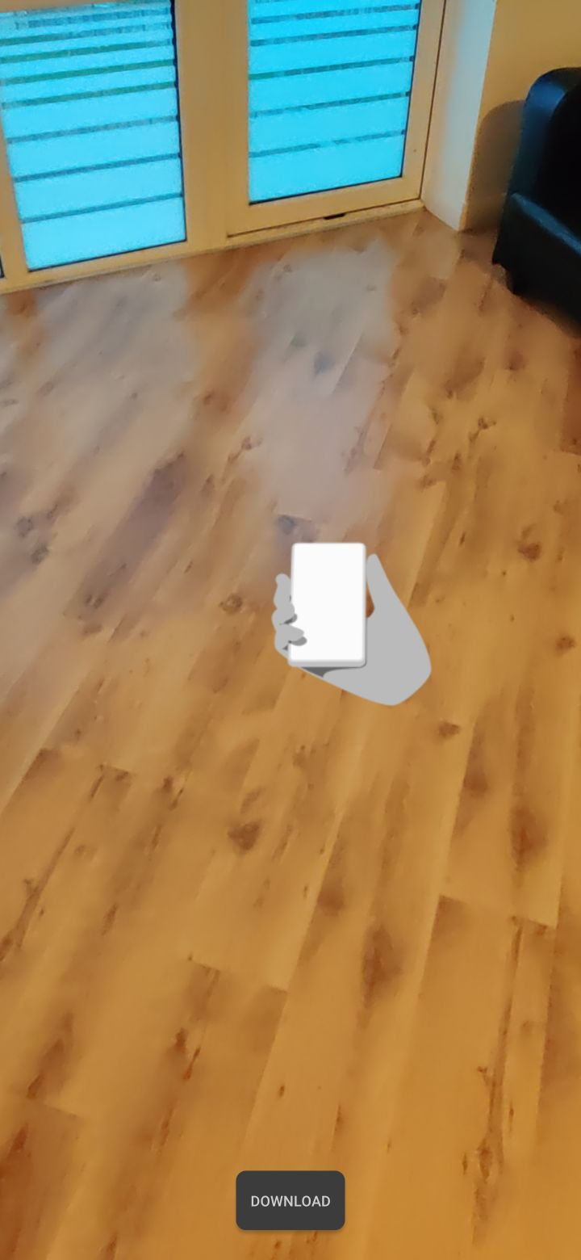Once the system is happy, knowing that the given device can run ARCore it will present the user with the AR fragment as seen with the below fragment. At his point, the system will ask the user for camera permissions and if successful the application will continue even further. This screen consists of only two items, one button to download the 3D model and a fragment view as seen the figure below.

**Figure 59:** Augmented Reality fragment

To get ARCore to take control of the environment, the system passes this fragment view into ARCore library as seen with the following piece of code.

ARFragment arFragment = (ARFragment) getSupportFragmentManager(). findFragmentById(R.id.fragment).

ARFragment is the class that calls ARCore and takes control over the fragment that is passed into it. At this point the fragment view I created will be converted into a camera view. Something I noticed when developing this part and want to point out, the quality of the camera is compressed and does not hold true to the original quality of the phone’s camera. This is down to the way applications are developed on all android applications. Instead of using a direct route to the camera feed, applications are using a screensharing technique which limits the true quality. I do not know the full extent of what some Android applications do this, but it can be seen in Snapchat, WhatsApp, Messenger, TikTok, and more.

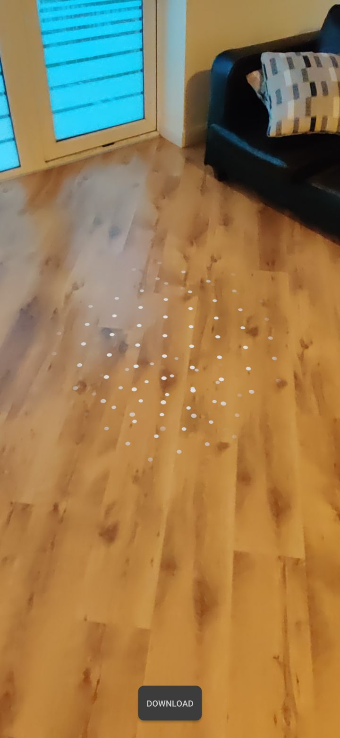After ARCore has control over the fragment it loads a small animation that alerts the user to move the device around. This action is needed as the technology that ARCore uses to detect any given surface is called SLAM. I talked about SLAM in section 2.3.3.2, but the phone sends out an infrared light to which the camera will find when it shines off the service. This type of special awareness factors what devices can use ARCore or not as the camera equipped on the smartphone needs to have this infrared sensor attached. From testing this feature I tried finding a surface on my wooded floors, grass, cement and tiles and it worked for all surfaces. However, if a given surface is not light up well then, the camera will have trouble detecting that there is any surface. Once ARCore detects a level ground, it notifies the user but placing dots on the ground to represent the area in which objects can be placed. Please see the below figure as a reference to this happening.

**Figure 60:** AR Core SLAM

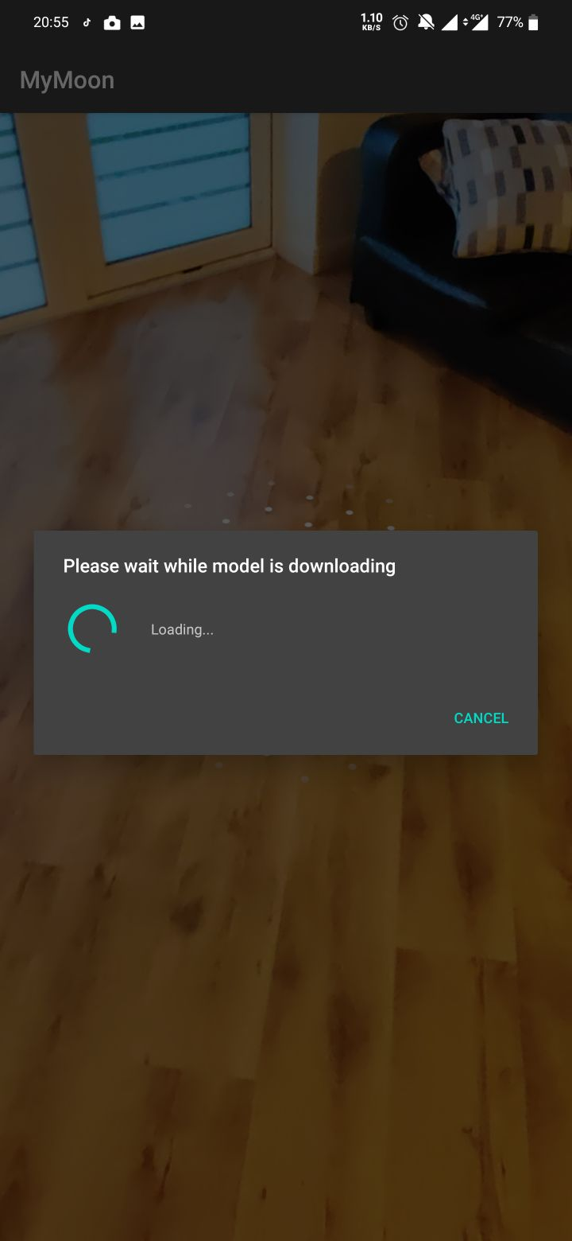The environment is now ready to set up the models to be placed on the surface detected. For this to happen the user must download the models to their device so that it can be rendered. As mentioned previously, I decided to house the models online so that they can be altered and modified at any given time without updating the entire android application. The download button, when clicked will do two actions on two different asynchronous threads. Running more than one thread does increase the performance strain on the application but this is needed as it gives the user some sort of representation that the models are being downloaded and rendered.

**Figure 61:** Augmented Reality Download

When this screen is active, the user cannot click or move away from this screen unless they click the cancel button which will kill the processes. I added this screen as I knew, there will be some time needed to download, render, and build my models and wanted to visually alert the user that they must wait until it is downloaded before moving on. I have added the code in the Appendix under section 2 of this process of downloading and calling the database to retrieve the 3D model.

Once the model has been downloaded, the application needs to build and render the model before the user can place it on the ground. Inside the download function the application is calling ‘buildModel’ with the reference to the file name. This method that I created handles both the rendering and modelling of the 3D objects. I have attached this code under Appendix 3. This method is responsible for converting the object file from the Firebase database into Sceneform which is the conversion tool used within AR Core. The application needs to convert this build into a renderable model so that the user can visually see the object that the system has created.

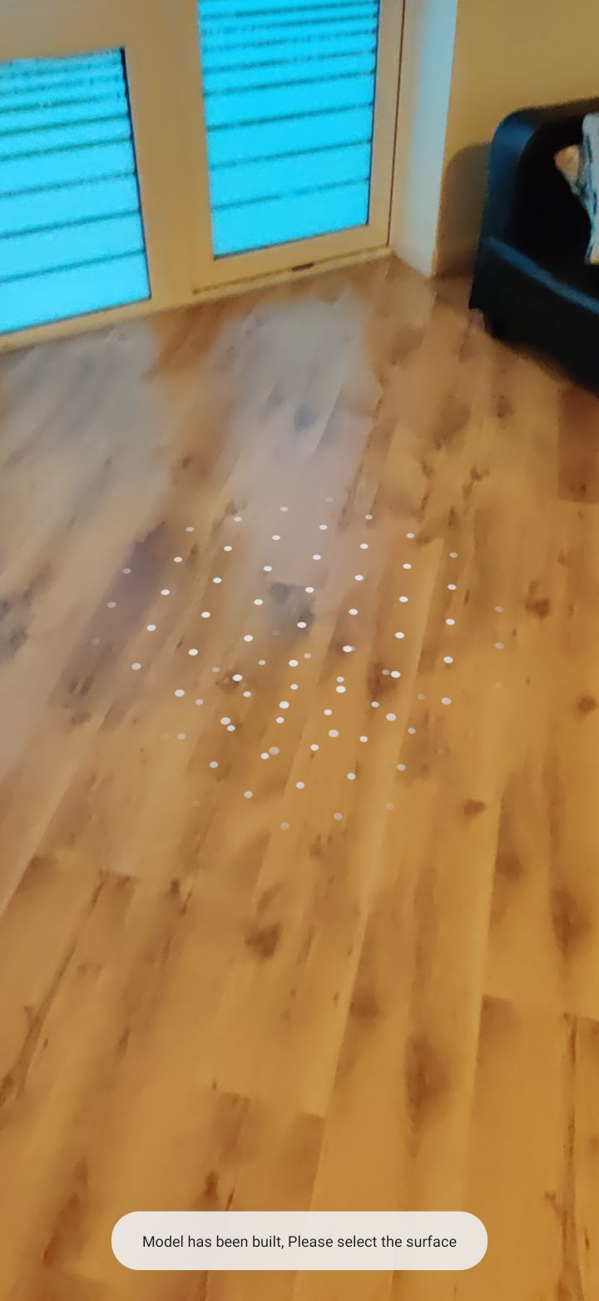When this process is fully complete the user will be notified with a little Toast message box informing them that the environment has been fully set up as seen in the below figure.

**Figure 62:** Augmented Reality Ready

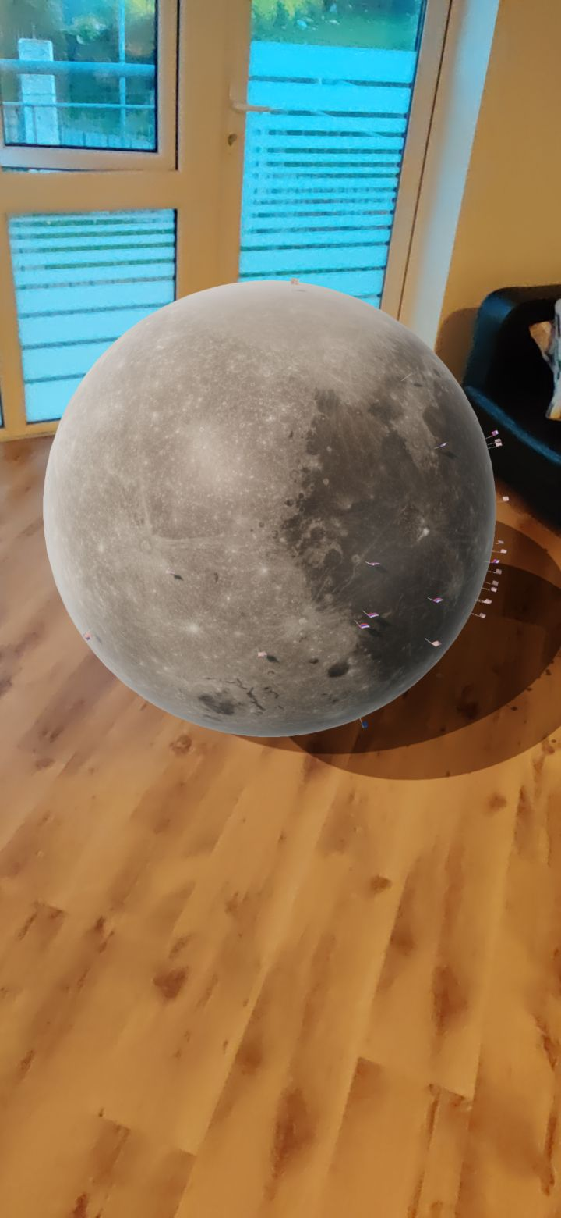When the user clicks on the survive the Augmented Reality object will be placed immediately.

**Figure 63:** Augmented Reality

**Figure 64:** Augmented Moon with/without flags and Earth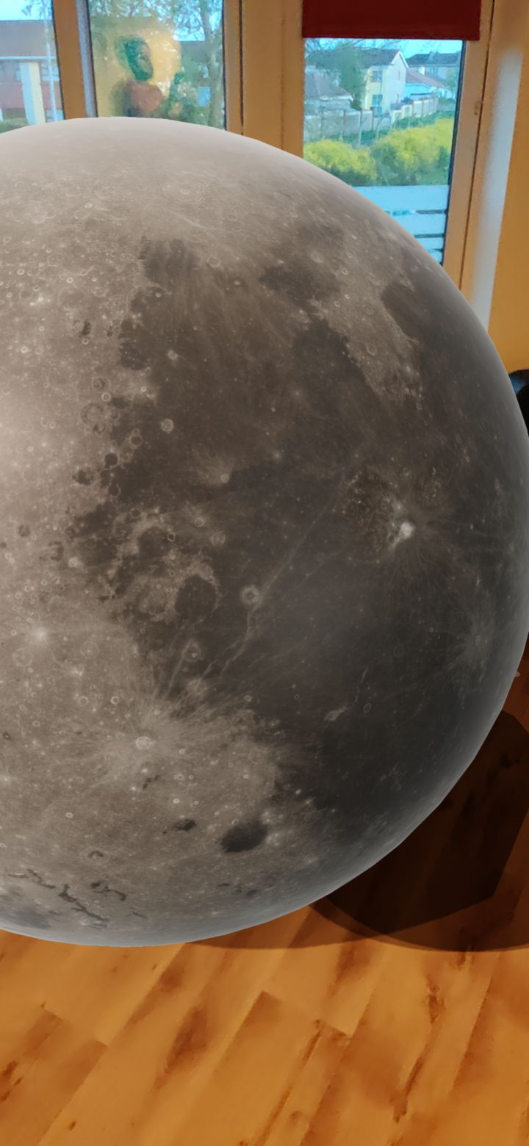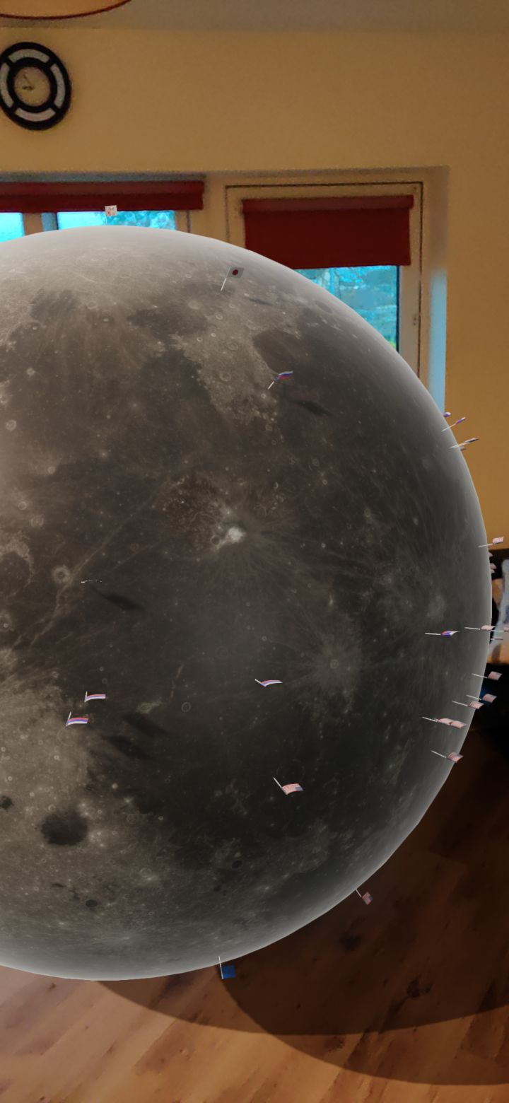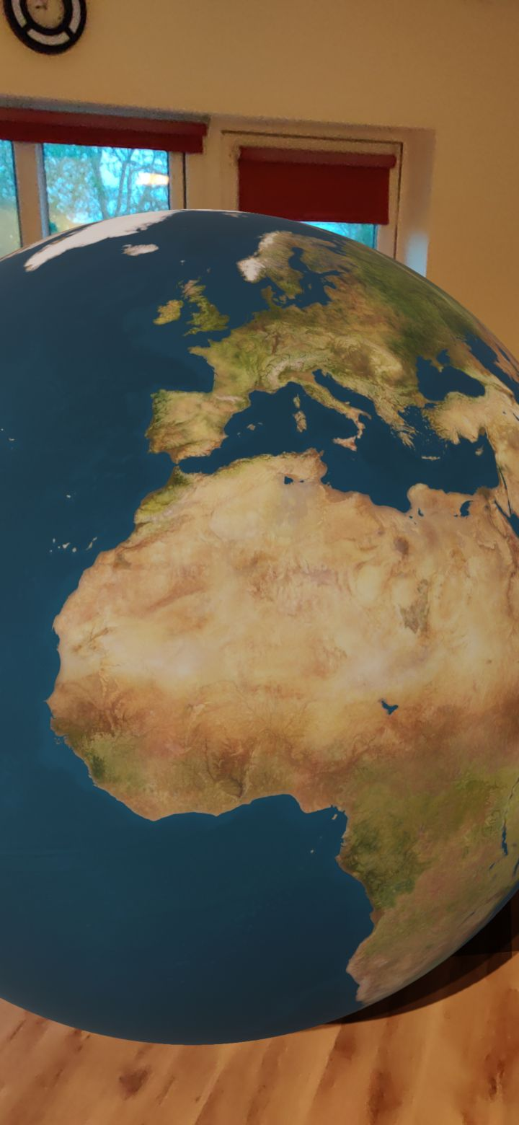 models

Figure 64 shows the three models that I created on Blender, successfully being rendered on my phone. All models can be scaled, moved, and rotated thanks to a class within ARCore called TransformableNode. This class can track where the original point the user clicks so if can use the phones own sensors to manipulate the model in real time. The point in which the user clicks on the surface is called an anchor point. This anchor point is used for the TransformableNode class to make the object scalable and renderable. If the user, uses their two fingers they can use the pinch and rotate gestures to manipulate the 3D models. Check Appendix 4 for this code segment.

**Discovery**

For this section I wanted the user to be given the opportunity to learn more about the Moon using more than simple text. The design of this activity wanted me to have a list of options where the user picks from and carries them into a new screen. After developing that concept, I decided I wanted to change this up as having a plain list of options was boring and needed some visual cues. This change allowed me to utilise a new, modern approach to option screens by using a tabular grid splitting up to two rows and two columns. I make a custom onClick listener to handle the functional operation behind the table. This table I had created give the user four options in which they can choose from. These options are Moon, Mission, Video, and Image. It was my belief that having facts about the Moon and the Mission were vital as facts that are peer reviewed cannot be disputed for fiction. Having videos and images allows the user a chance to view visual media about the moon on sections that I thought were of interest to know. Here are the sources I used to combine the list of facts I gathered, (SpaceFacts, 2021) (NASA Science, 2021) (Royal Museums Greenwich, 2021) (Planets for Kids, 2021).

I developed all four options in a way that at any chance, I could update the list for all four options to exciting new lists. This can be done using Androids RecyclerView and CardView. As mentioned, before in my design chapter, both RecyclerView and CardView are both instances of material design that is recommended for Android UX design. I will talk about the different versions of these views shortly.

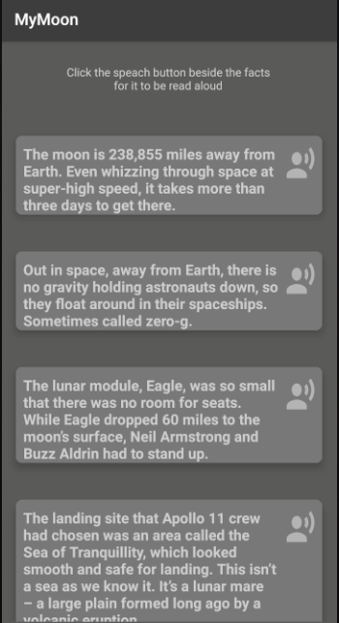If the user decides they want to learn facts about either the Moon or missions, they will be brought to a new screen that are similar in function. The goal behind these two screens as show in figure 65 and 66is to present the user with a list of facts that they can scroll through or have a TTS engine read out the facts to them.

**Figure 65:** Discover Moon Facts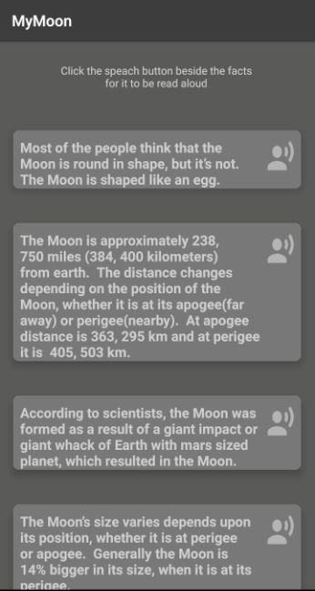 **Figure 66:** Discover Mission Facts

As you can see from the above figures, a list of facts is presented both on the Moon and the Mission. The ability to display facts to the user allowed me to use TTS for each fact. These views are both using a RecyclerView and CardView. Implementing a RecyclerView required me to only drag and drop a container onto the activity screen, like the previous versions of Android ListViews. However, the new material design uses CardView’s instead of plain text. CardView’s can be imported into a RecyclerView as many times as the developer wants, and they have complete control of the look and feel of those. The figure below shows the custom CardView I created for any given fact and when called it will be populated with a string and 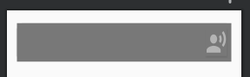formatted with round corners.

**Figure 67:** Discover Facts CardView

I needed to make a custom adapter and model so that each fact could be translated into the CardView. This adapter handles the string for the text as well as converting that string into the TTS engine. The way I implemented this TTS is by having a button on the right-hand side that when clicked will read aloud that desired fact. When the adapter gets the signal that it has been pressed, the application will use its own index to find the fact and convert it into Android TextToSpeech engine. Please see Appendix 5 for the custom adapter that handles this function.

The way I programmed the TextToSpeech within Android Studio is a way in which the adapter already stores an instance of each of the facts when it is being created initially. When the string for the fact, is passed to the adapter, there is a function I wrote that sends that immediately to the TextToSpeech library. So, when the button is clicked the application must only convert it to the syntactic voice. Android uses voices that are pre render for all Googles engines. Google has a wide array of TTS implementations from Google translate to Google Home and Google Assistant. With technology growing Google will be able to create a more human like voice compared to today’s semi-robotic tone.

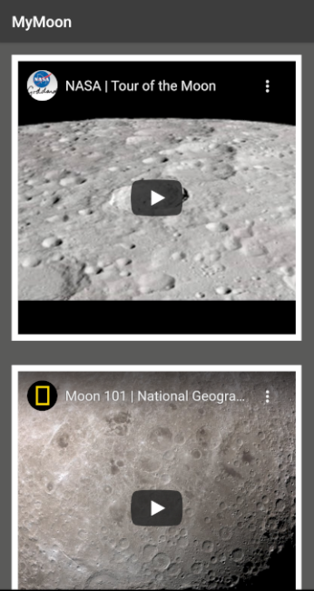If the user navigates to the video option, they will be created with another RecyclerView and CardView set up. This page is set up different to the facts page as the CardView needs to be different. Please see Appendix 6 for the full Video Adapter code segments.

**Figure 68:** Discovery Video

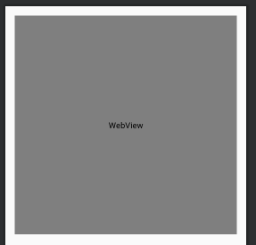­­­­­This screen is similar however as it has its own RecyclerView that updates itself with YouTube video links of interesting videos I have found online. Like before, I am passing a string with the embed YouTubes URL into a custom video adapter. I needed to use the embed URL instead of the mobile or desktop URL as Android’s WebView would not be able to render the full website. That was okay as I only needed the video itself to be sent to the application. The embed URL will create an instance of YouTube onto the WebView I have created in the CardView and allows the user to view the media on a mini YouTube player. If the user at any point wanted to watch it on the official YouTube application, they may do so by clicking on the title of the video.

**Figure 69:** Discover Video CardView

If the user decides that they want to navigate to the Image section, they will be presented with a few images I found would be of interest to the user. These images show the topography of the lunar surface, atlas of the moon, image of a Red Moon, how a red Moon happens, how the Moon and Sun effect Earths tidal waves as well as how the Moon appears depending on the hemisphere you are viewing the Moon on. All these images were found on NASAs home gallery.

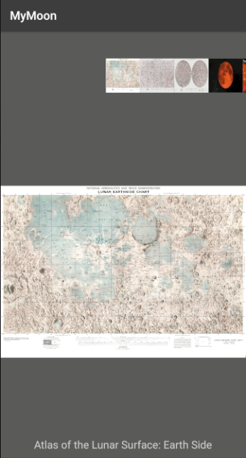Android Studio’s default Image view does not have a function in which a user can simply zoom into the image so I needed to create a custom ImageView that could have this feature. The layout is handled with a Grid with an image adapter being used to populate the gallery as well as the image itself. The custom touch ImageView was a complex function to program as it was based on finding the locations of where the users two fingers are and calculate the rate in which they are being separated. I have added the code to the Appendix 7.

**Figure 70:** Discover Image.

Once the image was passed into this custom image the user would be able to zoom in as they desire. On testing this function if the user zooms into an image and decides to move onto a new image, via the gallery, the zoom function stays and distorts the new image.

**Moon phases**

For this activity I wanted the user to be able to input a given date and have an image representation of the Moon, with its lamination rating as well as the name given to that specific phase. I added a custom DateTimePicker, which is a pre rendered calendar that Android has pre-installed in Android Studio. This calendar allows the user to pick a date of their choosing and on submission the application will calculate the rest. While researching how the illumination can be calculated, I found a mathematician called John Horton Conway who came up with a formula to do just that (Jefferys, 2018). Sadly, as of writing this dissertation John has passed at the end of 2020 due to Covid-19.

The website gave me a step-by-step guide in how this formula calculates the moon phase using a known full moon date as reference. How this formula works as follows:

1. In the 20th century, calculate the remainder upon dividing the last two digits of the year by nineteen; if greater than nine, subtract nineteen from this to get a number between -9 and nine.
2. Multiply the result by eleven and reduce modulo thirty to obtain a number between -29 and +29.
3. Add the day of the month and the number of the month (except for Jan and Feb use 3 and 4 for the month number instead of 1 and 2).
4. Subtract four.
5. Reduce modulo thirty to get a number between 0 and 29. This is the age of the Moon.
6. In the 21st century use -8.3 days instead of -4 for the last number.

From this guide I was able to create a Java representation which I have included in Appendix 8. The age of the Moon is a term used in Astronomy that describes how far the Moon is in its orbital rotation around the Earth. If the user picked the date, 24th of April 2021, the application would send this date to a custom DateTimePicker class I created to fetch and receive the users chosen date. This date would be sent back to the PhaseFragment class to be handled in the calculations. From the calculated age all I had to do is run that number in a switch loop to find the name of the calculated age as well as updating the image of the moon to the given age. 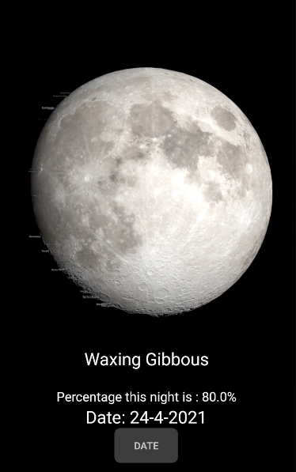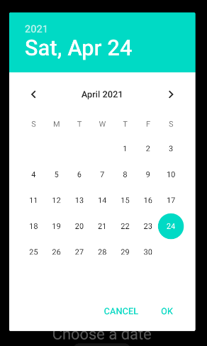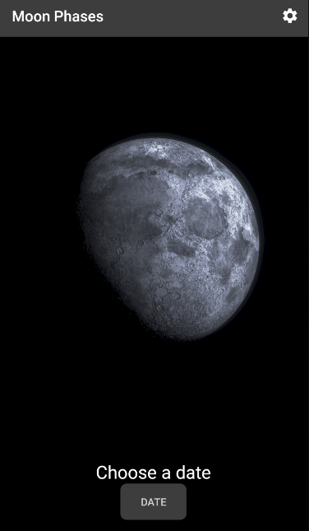Please see the below figures as an example of this screen. The working result came out exactly as designed.

**Figure 71:** Moon Phase Screen

### Conclusion

Developing this Android application was extremely exciting to undertake. At many stages I came across issues I needed to combat and spent a lot of researching those issues, but I learned so much in doing so. I have used this application a few times to play with the 3D models as well as checking the age of the Moon for that given day.

I installed a plugin into Android studio so that I can get the total statistics from the project. This plugin is called ‘Statistic’ and it allows me to view how many lines of code my project has. Figure 72 below highlights Android studios overview.

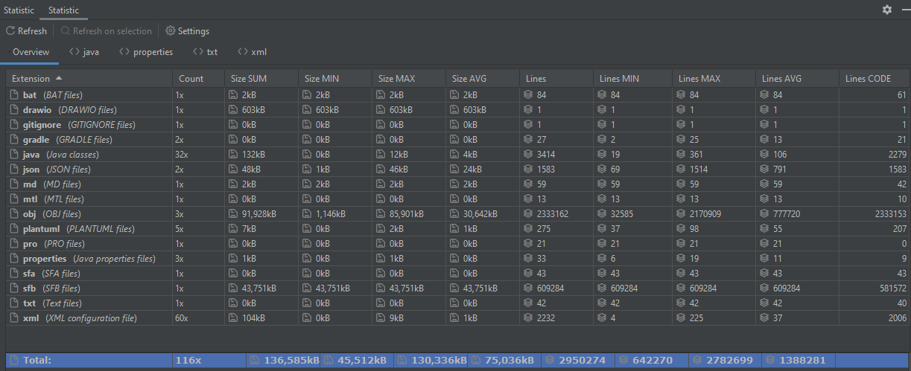**Figure 72**: Project Statistics

## Chapter 2: Testing

### Introduction

In this chapter I will be talking about the testing process that I have done for this entire project. Throughout the development lifecycle I have been doing a lot of testing in all aspects from the requirements, functional, code and integration testing. Testing is a huge area in which we, the software developers, needs to include in every project. The aim of testing is to raise the level of confidence between the system application and its clients. Even if clients do not think we need to allocate some time towards testing, its vital that we have testing integrated at every stage. This project has been created using agile approach to the v-model which means that at each stage of the development there is the appropriate tests included. I also used Test Driven Development (TDD) at some stages in the project as I needed to test limitations of the system. During my time studying in Limerick Institute of Technology I have undergo several different testing methods that I will be utilising for my final year project. I will be documenting each stage and outline the reason of those specific tests. There is some types of tests that I did not use before regarding the testing of the Androids UX/UI implementation, so this only furthers my knowledge in this area.

### Test Objectives

Being able to set what the test objectives are important as it will outline what is it that I want to be find out from these tests.

* Does the software application meet the requirements?
* Is the software secure?
* What is the software usability?
* Do the functions or algorithms function correctly under all reasonable conditions?
* What will cause the application to crash?
* Does there need to be further development to help users use the application.

I will also be testing my research objectives to make sure that I was able to answer and meet the requirements set up at the very beginning of the project.

### Android Studio Debug

Android studio was the IDE that I was developing my Android application on throughout the project’s lifecycle. From my previous experience as a student software developer, I learned how to best use the debugging function in all the IDE’s I was working on. What the debugging function does for the developer is allowing them to set break points where they would be able to check sections of code to see what processes their code is acting upon. When a breakpoint is selected on a given line of code, the application will run as normal until it comes across this point. At this point the system will halt and the IDE will show what variables are in use. The developer now have the option to step into, step over, or jump out of the code section to investigate that given code section. I have used this feature a lot, as I had some syntax errors that was crashing the system and needed to figure out where this crash was coming from. It also allowed me transparency for each process as I was able to follow along the steps of a code section, method, or class to make sure the given architecture is working.

I used a lot of basic programming console prints as well throughout the project as not only did, I want to see what areas the code was activating but I wanted to test certain methods quickly. This was done but having a simple print to console followed but some text and variable.

### Test Cases

Here are all the requirements I have gathered from the requirements and design in which the system must perform. These requirements are both functional and non-functional requirements.

**Requirements**

1. Application can open.
2. System displays splash screen.
3. System displays Dashboard.
4. System displays HomePage via Dashboard.
   1. User can see data on home page.
   2. AR Moon button works on Home page.
   3. AR Earth button works on Home page.
5. System displays AR page via Dashboard.
   1. User can see data on AR page.
   2. Instruction button opens fragment when clicked.
   3. Button for AR Moon opens AR Moon fragment.
      1. System checks if device is capable of AR Core.
      2. System hands over fragment to AR Core library.
      3. User grants permission to use Camera if not done so already.
      4. User grants permission to use Internet if not done so already.
      5. User downloads the 3D models of Moon.
      6. System downloads model from Firebase.
      7. System builds and renders 3D models.
      8. User clicks on surface to place Model.
      9. Moon Model can be scaled and rotated.
   4. Button for AR Moon and flags opens AR Moon with flags fragment.
      1. System checks if device is capable of AR Core.
      2. System hands over fragment to AR Core library.
      3. User grants permission to use Camera if not done so already.
      4. User grants permission to use Internet if not done so already.
      5. User downloads the 3D models of Moon.
      6. System downloads model from Firebase.
      7. System builds and renders 3D models.
      8. User clicks on surface to place Model.
      9. Moon with flags Model can be scaled and rotated.
   5. Button for AR Moon opens AR Earth fragment.
      1. System checks if device is capable of AR Core.
      2. System hands over fragment to AR Core library.
      3. User grants permission to use Camera if not done so already.
      4. User grants permission to use Internet if not done so already.
      5. User downloads the 3D models of Moon.
      6. System downloads model from Firebase.
      7. System builds and renders 3D models.
      8. User clicks on surface to place Model.
      9. Earth Model can be scaled and rotated.
6. System displays Discover via Dashboard.
   1. User can see data on Discover page.
   2. Discover table is created.
      1. Table is populated with Moon icon, text, and button.
         1. Moon button opens MoonFacts fragment.
         2. Fragment is populated with RecyclerView and CardView’s.
         3. CardView is populated with facts and TTS Button.
         4. TTS Button convert and reads aloud the fact.
      2. Table is populated with Mission icon, text, and button.
         1. Mission button opens Mission Facts fragment.
         2. Fragment is populated with RecyclerView and CardView’s.
         3. CardView is populated with facts and TTS Button.
         4. TTS Button convert and reads aloud the fact.
      3. Table is populated with Video icon, text, and button.
         1. Video button opens Video fragment.
         2. Fragment is populated with RecyclerView and WebVideoViews.
         3. WebVideoView is populated with embed YouTube URL.
         4. User can watch YouTube Videos.
         5. User can open link in original YouTube Application.
      4. Table is populated with Image icon, text, and button.
         1. Image button opens Image fragment.
         2. Fragment is populated with GridView, Gallery and ImageView
         3. User can scale up image.
         4. User can change image from gallery.
         5. System updates image from chosen image.
         6. System updates textview with chosen images name.
7. System displays MoonPhase via Dashboard.
   1. User can see data on MoonPhase page.
   2. System shows image, button, and text to user.
      1. User clicks button to open DateTimePicker.
      2. DateTimePicker is called and opened.
      3. User clicks on a given date.
      4. Date is passed into MoonAgeCalculator.
      5. MoonAgeCalculator calculates the Moon age.
      6. System updates Image and text with correct Moon age.
8. System displays Settings via Menu bar.
   1. User can see data on Settings page.
   2. System displays buttons for contact us, about and back.
      1. Contact us button when clicked, opens contactUs fragment.
         1. User can see labels, textboxes, and buttons.
         2. User updates textboxes.
         3. User sends email.
            1. Email is passed into Android Email Provider.
            2. Email is sent.
         4. User clicks clear.
            1. Textboxes are emptied.
      2. Contact us button when clicked, opens aboutUs fragment.
         1. User can see data on aboutUs page.
      3. Back button opens the Home page screen.

### Test Data

|  |  |
| --- | --- |
| **Use Case Name:** | User opens the application and views the Homepage |
| **Test Number**  **Test Description** | 1  This test shows that the system will open splash screen, dashboard, and homepage. |
| **Data input** | N/A |
| **Test data entered using user interface.** | User clicks on the launcher icon for MyMoon. |
| **Data output** | N/A |
| **Output Data displayed on user interface.** | System calls the main activity which shows the splash screen to the user. After the splash screen has been called and view, the activity will move control to the dashboard. The dashboard populates its navigation system, and the homepage is loaded as the default screen. |
| **Expected result.**  I expected that the application will call the splash screen, generate, and populate the dashboard and display the home screen to the user. | |
| **Observed Result**  Results expected. | |

|  |  |
| --- | --- |
| **Use Case Name:** | User clicks on the AR Moon button on the home page |
| **Test Number**  **Test Description** | 2  This test shows that the AR fragment will be called when the user clicks on the ‘Jump To’ AR Moon button |
| **Data input** | N/A |
| **Test data entered using user interface.** | User clicks on the AR Moon button on the homepage. |
| **Data output** | N/A |
| **Output Data displayed on user interface.** | System calls Augmented Reality fragment |
| **Expected result.**  I expected that the application will call the Augmented Reality Moon fragment | |
| **Observed Result**  Results expected. | |

|  |  |
| --- | --- |
| **Use Case Name:** | User clicks on the AR Earth button on the home page |
| **Test Number**  **Test Description** | 3  This test shows that the AR fragment will be called when the user clicks on the ‘Jump To’ AR Earth button |
| **Data input** | N/A |
| **Test data entered using user interface.** | User clicks on the AR Earth button on the homepage. |
| **Data output** | N/A |
| **Output Data displayed on user interface.** | System calls Augmented Reality fragment |
| **Expected result.**  I expected that the application will call the Augmented Reality Earth fragment | |
| **Observed Result**  Results expected. | |

|  |  |
| --- | --- |
| **Use Case Name:** | User clicks on the AR instructions on the AR page |
| **Test Number**  **Test Description** | 4  This test shows that the AR fragment will be called when the user clicks on the AR dashboard and can view the instructions when they have clicked the instructions button. |
| **Data input** | N/A |
| **Test data entered using user interface.** | User clicks on the AR navigation button to open the AR screen and clicks on the instructions button to view the steps. |
| **Data output** | N/A |
| **Output Data displayed on user interface.** | System calls Augmented Reality screen from the dashboard; it presents the user with all the data from textview and buttons. The system will display the instructions view in front of the Augmented Reality screen when the instructions button is clicked. |
| **Expected result.**  I expected that the application will call the Augmented Reality screen from the dashboard and correctly show the instructions when called. | |
| **Observed Result**  Results expected. | |

|  |  |
| --- | --- |
| **Use Case Name:** | User clicks on the AR Moon with flags button and views the 3D model on the surface in front of them. |
| **Test Number**  **Test Description** | 5  This test shows that the AR Moon with flags will be displayed on the surface in front of the user. |
| **Data input** | N/A |
| **Test data entered using user interface.** | User clicks on the AR Moon with flags button on the AR screen, the AR Moon with flags fragment appears on screen, user accepts camera and internet permissions, user scans the floor with the camera, user downloads the model, User taps on the surface. |
| **Data output** | N/A |
| **Output Data displayed on user interface.** | System calls AR Moon with flag fragment, system asks the user for camera and internet permissions, system connects and downloads models from Firebase, system builds and renders 3D model, system translate these models into AR Core and will display on screen. |
| **Expected result.**  I expected that the application will display the AR Moon with flag 3D model to the user | |
| **Observed Result**  Results expected. | |

|  |  |
| --- | --- |
| **Use Case Name:** | User clicks on the AR Moon button and views the 3D model on the surface in front of them. |
| **Test Number**  **Test Description** | 6  This test shows that the AR Moon will be displayed on the surface in front of the user. |
| **Data input** | N/A |
| **Test data entered using user interface.** | User clicks on the AR Moon button on the AR screen, the AR Moon fragment appears on screen, user accepts camera and internet permissions, user scans the floor with the camera, user downloads the model, User taps on the surface. |
| **Data output** | N/A |
| **Output Data displayed on user interface.** | System calls AR Moon fragment, system asks the user for camera and internet permissions, system connects and downloads models from Firebase, system builds and renders 3D model, system translate these models into AR Core and will display on screen. |
| **Expected result.**  I expected that the application will display the AR Moon 3D model to the user | |
| **Observed Result**  Results expected. | |

|  |  |
| --- | --- |
| **Use Case Name:** | User clicks on the AR Earth button and views the 3D model on the surface in front of them. |
| **Test Number**  **Test Description** | 7  This test shows that the AR Earth will be displayed on the surface in front of the user. |
| **Data input** | N/A |
| **Test data entered using user interface.** | User clicks on the AR Earth button on the AR screen, the AR Earth fragment appears on screen, user accepts camera and internet permissions, user scans the floor with the camera, user downloads the model, User taps on the surface. |
| **Data output** | N/A |
| **Output Data displayed on user interface.** | System calls AR Earth fragment, system asks the user for camera and internet permissions, system connects and downloads models from Firebase, system builds and renders 3D model, system translate these models into AR Core and will display on screen. |
| **Expected result.**  I expected that the application will display the AR Earth 3D model to the user | |
| **Observed Result**  Results expected. | |

|  |  |
| --- | --- |
| **Use Case Name:** | User scales and rotates the 3D model. |
| **Test Number**  **Test Description** | 8  This test shows that the user can manipulate the 3D AR models |
| **Data input** | 3D model from firebase |
| **Test data entered using user interface.** | User clicks on the 3D model with two fingers and pinches the model in and out to scale the model, user rotates the models by rotating their fingers while holding the model with two fingers. |
| **Data output** | N/A |
| **Output Data displayed on user interface.** | System scales and rotates the model but translating the models into the TransformableNode. |
| **Expected result.**  I expected that the application will be able to manipulate the 3D model using their fingers. | |
| **Observed Result**  Results expected. | |

|  |  |
| --- | --- |
| **Use Case Name:** | User opens the Moon facts fragment from the Discovery page. |
| **Test Number**  **Test Description** | 9  This test shows that user can view the Moon facts by clicking the Moon button on the Discovery page. |
| **Data input** | N/A |
| **Test data entered using user interface.** | User opens the Discovery page from the dashboard navigation and clicks on the Moon Facts button from the Discovery page |
| **Data output** | N/A |
| **Output Data displayed on user interface.** | System displays the discovery page, system presents the user with a table for Moon, Mission, Video and Image section, system displays the Moon fragment to the user. |
| **Expected result.**  I expected that the application will be able to display the Moon facts from the Moon button on the Discovery page. | |
| **Observed Result**  Results expected. | |

|  |  |
| --- | --- |
| **Use Case Name:** | User opens the Mission facts fragment from the Discovery page. |
| **Test Number**  **Test Description** | 10  This test shows that user can view the Mission facts by clicking the Mission button on the Discovery page. |
| **Data input** | N/A |
| **Test data entered using user interface.** | User opens the Discovery page from the dashboard navigation and clicks on the Mission Facts button from the Discovery page |
| **Data output** | N/A |
| **Output Data displayed on user interface.** | System displays the discovery page, system presents the user with a table for Moon, Mission, Video and Image section, system displays the Mission fragment to the user. |
| **Expected result.**  I expected that the application will be able to display the Mission facts from the Mission button on the Discovery page. | |
| **Observed Result**  Results expected. | |

|  |  |
| --- | --- |
| **Use Case Name:** | User clicks on the TTS button on a Moon Fact |
| **Test Number**  **Test Description** | 11  This test shows that the system will display all facts to the user and will convert the string to the Text to Speech. |
| **Data input** | The Moon is eighty-one times lighter than Earth. |
| **Test data entered using user interface.** | User clicks on the TTS button associated with the fact “The Moon is 81 times lighter than Earth.” |
| **Data output** | N/A |
| **Output Data displayed on user interface.** | System displays the Moon fact using a RecyclerView and CardView to the user, System converts the fact from string to the TTS engine. |
| **Expected result.**  I expected that the application will be read aloud the Moon fact that the user has chosen. | |
| **Observed Result**  Results expected. | |

|  |  |
| --- | --- |
| **Use Case Name:** | User clicks on the TTS button on a Mission Fact |
| **Test Number**  **Test Description** | 12  This test shows that the system will display all facts to the user and will convert the string to the Text to Speech. |
| **Data input** | When Neil Armstrong landed the lunar module, there were only 30 seconds of fuel left. |
| **Test data entered using user interface.** | User clicks on the TTS button associated with the fact “When Neil Armstrong landed the lunar module, there were only 30 seconds of fuel left.” |
| **Data output** | N/A |
| **Output Data displayed on user interface.** | System displays the Mission fact using a RecyclerView and CardView to the user, System converts the fact from string to the TTS engine. |
| **Expected result.**  I expected that the application will be read aloud the Mission fact that the user has chosen. | |
| **Observed Result**  Results expected. | |

|  |  |
| --- | --- |
| **Use Case Name:** | User clicks on a YouTube link and opens YouTube player from the Video fragment. |
| **Test Number**  **Test Description** | 13  This test shows that the system will display all videos to the user and will open the video on the YouTube application when the title has been clicked. |
| **Data input** | https://www.youtube.com/embed/2iSZMv64wuU |
| **Test data entered using user interface.** | User clicks on the Video button on the Discovery page, the user chooses the video that interests them, user clicks on the title of the video to open on the original YouTube player. |
| **Data output** | Embedded YouTube link opens the YouTube player |
| **Output Data displayed on user interface.** | System displays all Videos using a RecyclerView and WebVideoView to the user, system embeds the YouTube videos into those WebVideoView, system opens the videos on the YouTube player when title is clicked. |
| **Expected result.**  I expected that the application will be open the YouTube video in the original player. | |
| **Observed Result**  Results expected. | |

|  |  |
| --- | --- |
| **Use Case Name:** | User zooms in on the image of how a red Moon occurs on the Image fragment. |
| **Test Number**  **Test Description** | 14  This test shows that the system will display all images to the user and will scale up the image. |
| **Data input** | Photo of how the red Moon occurs. |
| **Test data entered using user interface.** | User clicks on the Image button on the Discovery page, the user chooses the image that interests them, user pinches on the image to scale it up. |
| **Data output** | N/A |
| **Output Data displayed on user interface.** | System displays all Images using a Grid layout, System calls the image the user has chosen and scales up according to how much the user moves their fingers. |
| **Expected result.**  I expected that the application will be able to zoom in and out of an image on the Image fragment. | |
| **Observed Result**  Results expected. | |

|  |  |
| --- | --- |
| **Use Case Name:** | User wants to view the age of the Moon for the 28th of July 2021 |
| **Test Number**  **Test Description** | 15  This test shows that the system will display the Moon Phase from the dashboard and will calculate the correct Moon age using the date given. |
| **Data input** | 28/07/2021 |
| **Test data entered using user interface.** | User clicks on the Moon Phase on the dashboard navigation bar, user clicks the date button and chooses the 28th of July 2021 as their desired date. |
| **Data output** | Moon name: Waning Gibbous.  Lamination: 74%  Date: 28-7-2021 |
| **Output Data displayed on user interface.** | System displays the MoonPhase fragment to the user, system shows the user an image, text and button, system uses the date provided to calculate the age of the Moon, system updates the image and text according to the calculations preformed. |
| **Expected result.**  I expected that the application will be update the image, text according to the date provided by the user | |
| **Observed Result**  Results expected. | |

|  |  |
| --- | --- |
| **Use Case Name:** | User sends an email to developer using the Contact us screen |
| **Test Number**  **Test Description** | 16  This test shows that the system can send the email with the users’ data to “mymoonjonathan@gmail.com” |
| **Data input** | Contact name: Jonathan Roddy.  Subject Header: Best wishes  Email body: Really enjoying the application! |
| **Test data entered using user interface.** | User clicks on the Settings gear icon on the top of any screen, user clicks the contact us button, user fills in the above data and hits send, user confirms email on their default email provider. |
| **Data output** | Contact name: Jonathan Roddy.  Subject Header: Best wishes  Email body: Really enjoying the application! |
| **Output Data displayed on user interface.** | System displays the settings fragment to the user, system shows the user buttons to navigate to the about and contact us page, system displays labels, textboxes and buttons to the user, system sends the above data into the default communications provider, email is sent. |
| **Expected result.**  I expected that the application will be able to send the data from the user to an email client on the user’s phone to send an email. | |
| **Observed Result**  Results expected. | |

|  |  |
| --- | --- |
| **Use Case Name:** | User clears the email they have written on the Contact us screen |
| **Test Number**  **Test Description** | 17  This test shows that the system can empty the input textboxes when the clear button is selected |
| **Data input** | Contact name: Jonathan Roddy.  Subject Header: Best wishes  Email body: Really enjoying the application! |
| **Test data entered using user interface.** | User clicks on the Settings gear icon on the top of any screen, user clicks the contact us button, user fills in the above data and hits send, user clicks clear all. |
| **Data output** | Contact name: “”  Subject Header: “”  Email body: “ ” |
| **Output Data displayed on user interface.** | System displays the settings fragment to the user, system shows the user buttons to navigate to the about and contact us page, system displays labels, textboxes and buttons to the user, system will remove all strings from the textbox when clear button is clicked. |
| **Expected result.**  I expected that the application will be able to empty all textboxes when the user clicks the clear all buttons. | |
| **Observed Result**  Results expected. | |

|  |  |
| --- | --- |
| **Use Case Name:** | User clicks the back button after viewing the about us page from the settings page. |
| **Test Number**  **Test Description** | 18  This test shows that the system will display homepage about viewing the about us page. |
| **Data input** | N/A |
| **Test data entered using user interface.** | User clicks on the Settings gear icon on the top of any screen, user clicks the about us button, user clicks back two times. |
| **Data output** | N/A |
| **Output Data displayed on user interface.** | System displays the settings fragment to the user, system shows the user buttons to navigate to the about and contact us page, system navigates back to the home page when the back button is clicked. |
| **Expected result.**  I expected that the application will be able to head back to the default landing page when clicked back on the settings page. | |
| **Observed Result**  Results expected. | |

### Verification/Validation Traceability Matrix

**Figure 73:** Verification and Validation Traceability Matrix

Jonathan Roddy 1-Jun-21 136

### Firebase Test lab

Firebase Test Lab is a cloud-based app testing infrastructure that lets you test your app on a range of devices and configurations, so you can get a better idea of how it will perform in the hands of live users. The key capabilities of Test Lab are as follows.

**Test both Android and iOS apps**

Run tests on a wide range of Android and iOS devices hosted by Test Lab.

**Run on real devices.**

Test Lab exercise your app on devices installed and running in a Google data centre, so you can find issues that only occur on specific devices and configurations.

**Workflow integration**

Test Lab is integrated with the Firebase console, Android studio, and the gcloud CLI. You can also use it with Continuous Integration (CI) systems

This feature, that Firebase offers, was a new learning curve for me to use but it did not take long for me to utilise and respect the power in which this service holds. With the power of Test Lab, I was able to test my application on other devices both physical and virtual. If I were to test my application on those applications myself then I would have spent a lot of time configuring and installing the application. This service allowed my project to be run on many devices at one time by connecting to remote devices on Googles own data centres. Test Lab can test an entire application from UI/UX, performance and accessibility which I will documented in a later section.

For me to use Test Labs I needed to add the dependencies to my projects ‘build. grade’ file. This allowed my project to house the relevant files that Test Lab needs to scan and record the application. Test Lab requires a complete build of the projects ‘APK’ file that can be build and exported straight from Android Studio.

An APK file is an executable installation file that when loaded onto a given device, it will install the entire application. Every Android application, that is on the Google Play store are APK files that will be downloaded and installed straight from the Play store. APK files can be installed outside of the Google Play store but it is not a common operation to do as Google holds strong security checks on all applications on its store. You can download any APK file from the internet but by default, Android devices are set up to not allow any other APK files to be installed as it has not been approved but Google and may be harmful to the user.

To create an APK file with Android Studio you need to make sure the application is first able to build successfully. After this you will be prompted by Android Studio to create a certificate signature with your name, password, organisation, and county code. This can be used as a certificate to you name that can be tracked back to the original developer.

Once I had an APK file I needed to perform a Robo script, which is a complete run-through of the application that you preform. This run through will be used as a navigational path within Test Lab so that its infrastructure will know what paths to test. It is the developer’s best interest to open, test all buttons and tabs so that it can be optimised to cover all aspects of the project.

To access Test Labs was a simple click in the Firebase console. See figure 73 below of my console screen. Here you can run a test where you supply the console the APK file and the Robo script. You then decide on what devices you want Test Labs to check.

**Figure 74:** Firebase Test Lab Console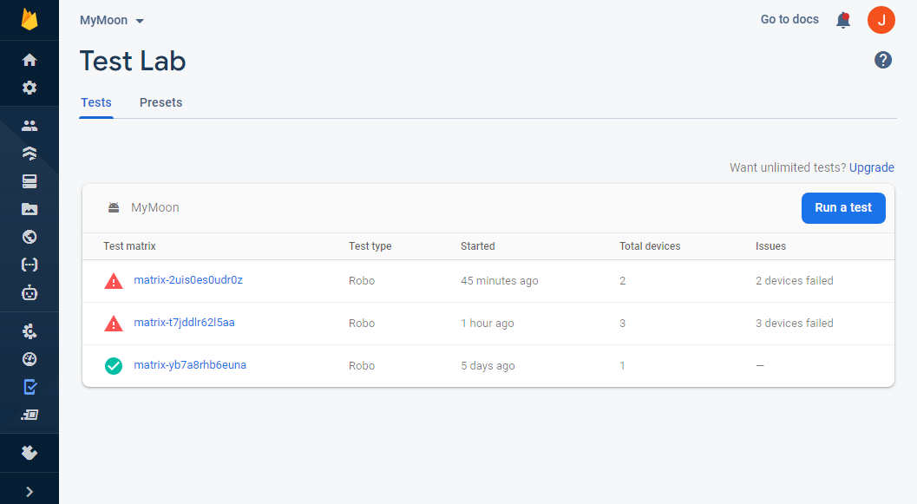

As you can see from the above figure, I have run 3 Robo scripts on my application. The account that I was using was limited to only having the ability to run tests on five physical and ten virtual tests. You can see that one test was fully successful and two had some errors found. I purposely decided that I wanted to test my application on phones that I knew would not work down to some dependencies not being accessible on certain Android devices like AR Core.

As mentioned in section 2.3.3.2, AR Core will only work on devices with Android API 27 or higher, so I choose phones that both were capably and ones that were not.

During the implementation of this project, I was able to test the application using both my physical phone as well as my partners one. I was also able to test the application virtually using Android Studios virtual emulators. All devices I have tested my Application on as seen in the below table.

|  |  |
| --- | --- |
| Android Device Name | API level |
| OnePlus 7 Pro | 30 |
| OnePlus 5T | 28 |
| OnePlus Nord | 30 |
| Pixel 5e | 30 |
| Pixel 4 XL | 30 |
| Pixel three | 30 |
| Pixel 3a | 30 |
| Pixel C | 30 |
| Pixel two | 28 |
| Pixel | 26 |
| Galaxy Tab S5e | 28 |

**Table 2:** Tested Android Devices

Given more time and resources I would want to test the application on more devices so that I could make a defined list of all compatible phones that I knew the application would work on.

#### UX/UI Testing

Testing the Applications UI/UX happened as early as the start of the project. I was testing each button, label, navigation, and permissions whenever I added them to a screen. This type of UI/UX testing is an iterative form meaning that I kept testing as the project progressed. Firebase Test Lab offers a great service when it comes to the UI/UX with its ability to test it on several devices. Below I have added the Crawl graph under figure 74, that Firebase used from my Robo script I created that tested each element of the application. This crawl graph is the full complete scope of the application and was used on all the devices when testing. Down to the nature of having Firebase Test Lab test my application on its devices, it will not be able to full test the AR screens as it needs to have access to a live camera where these dummies devices falsify.

**Figure 75:** MyMoon Crawl graph

Jonathan Roddy 1-Jun-21 141

It is hard to show the full picture down to the scale of which this graph is created but figure 74, shows the path in which the application is tested. The goal of the crawl graph is to navigate throughout the application finding any faults with the design.

For the devices that are below API version 27, Firebase has indicated that it was not able to continue and aborts the tests.

#### Accessibility

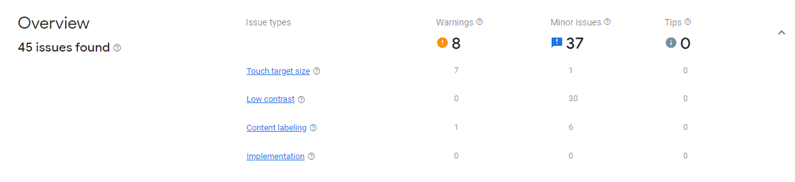Firebase Test Lab can do a complete application accessibility test for my project. It was able to check the application for Touch target size, Low contrast, Content labelling and implementation. I have added figure 75 below to show the results that Test Lab has given me after it has completely scanned my project.

**Figure 76:** Firebase Test Lab Accessibility Overview Pixel 2

The overview is shower eight warnings with thirty-seven minor issues that it has found. These warnings are mostly coming from my touch target size and most of my minor issues coming from low contrast. If I were given more time, I would go back into the development stage and improve upon those issues so that they would not be such an issue.

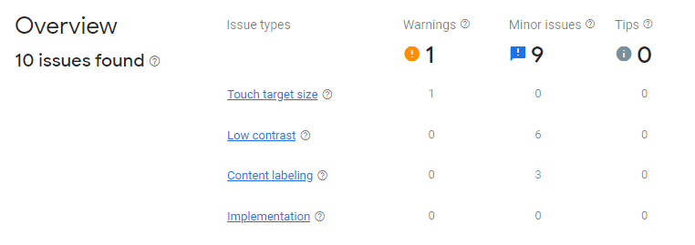However, when testing other devices that have a bigger screen then a Google Pixel 2, the overview results are different.

**Figure 77:** Firebase Test Lab Accessibility Overview Pixel 4

From looking at these results, they differ from the previous results but having less warnings and minor issues. This is a great insight to know as it means that with further development, I would need some sort of check to see what device the user is using and change the appearance and layout according to the appreciate measures.

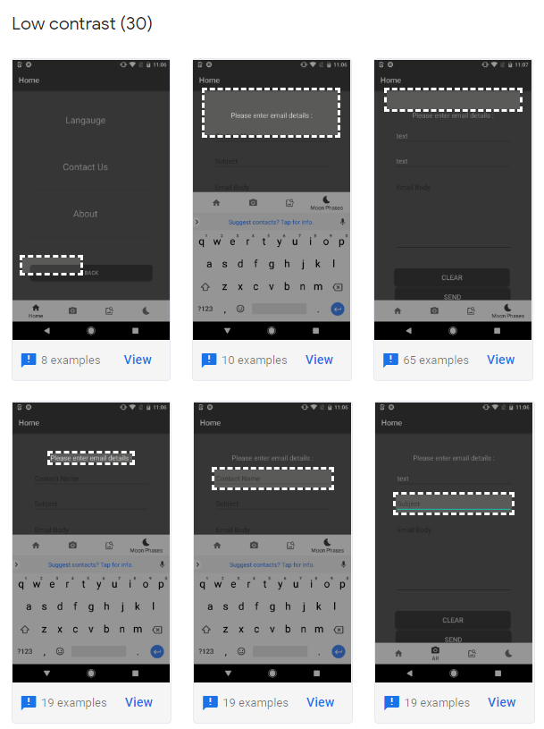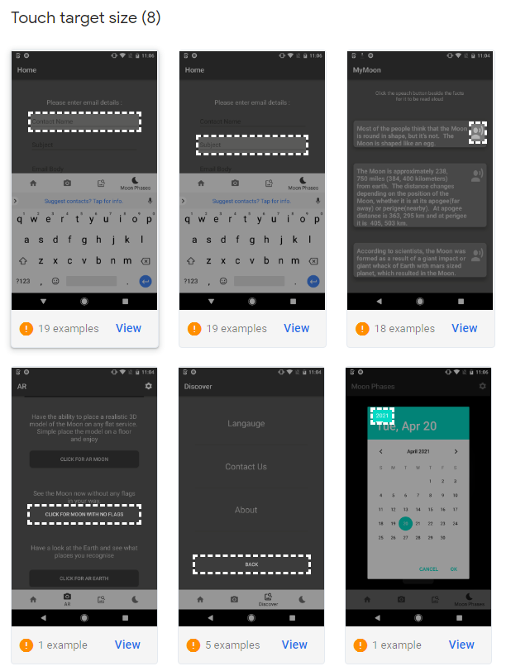Firebase has given screen shots on areas that are of interest for each occasion, and I have included some references to them all.

**Figure 78:** Touch Target Size **Figure 79:** Low contrast

#### Performance Test

Performance tests refers to the physical hardware’s capability and usage when an application is running. It is important to test this aspect as it is important to optimise applications to best suit a wide rand of devices. If an application is slow or suffers while using an application, that user will be more inclined to not want to use this application. As a developer, I know that we do not want customers to be leaving our site or application down to this and want to have as many users as we can.

Test Labs records the performance of each of its devices and allows me to visually see how much the system effects the hardware it is running on.

From testing the Pixel 2, a device that came out in 2017 to the pixel five which was released in 2020 the 3-year difference has a major effect on the hardware that the phones are running. Such hardware can be CPU, RAM, graphic cards, batteries, and the OS itself.

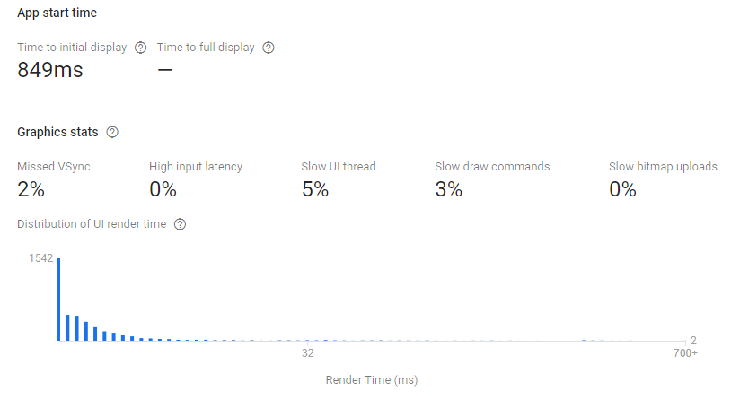The performance of my application on the Pixel 2 are as follows.

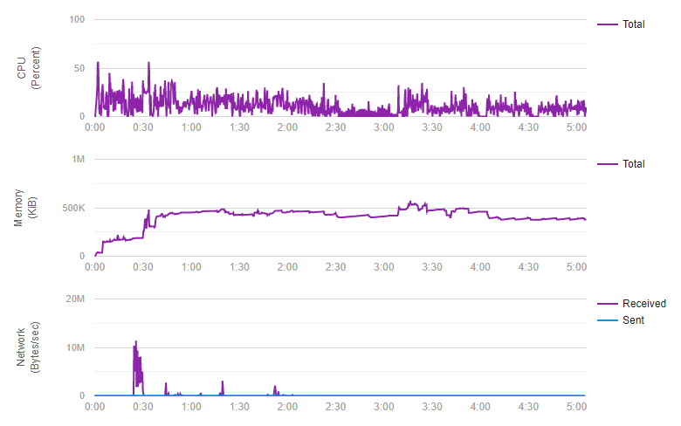**Figure 80:** Pixel 2 Performance Overview

**Figure 81:** Pixel 2 CPU, Memory, Network Performance

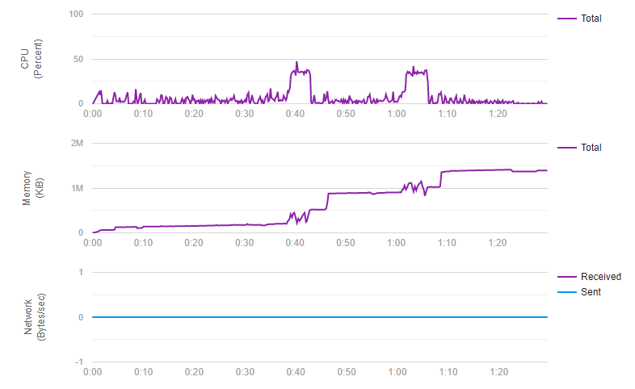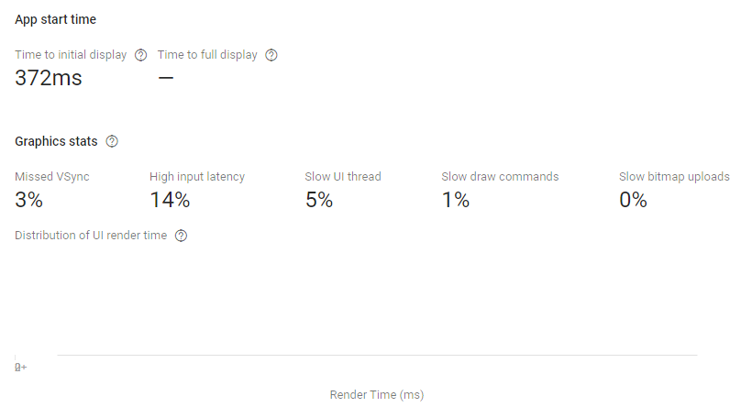**Figure 82:** Pixel 5 Performance Overview

**Figure 83:** Pixel 5 CPU, Memory and Network Performance

As you can see from comparing the last few figures, the response time for the newer phone was more than half the speed it was for the older model. You can see that the CPU for the Pixel is throttling more than the Pixel 5 meaning that the older model needs to use more of its processing power to render the application. The same can be said about the memory but the newer model is able to allocate more memory as it is fitted with more memory on its device. The more memory on a device, the more memory that a specific application can be granted to use.

This insight is a great tool to use as it shows me the specific data on all the devices that I have tested. There is a direct coloration with the model of the phone and how fast it can render and process certain aspects of my application.

### Integration Tests

Integration tests is the phase in software testing in which individual software modules are combined and tested as a group. Integration testing is conducted to evaluate the compliance of a system or component with specified functional requirements.

I tested my application regarding integration tests by making regular updates to my android application and my firebase storage. I cannot create a stub cloud database, so I was using the live database to be able to test the models. I would test, calling the models at different stages of the application to make sure there was a connection set up as well as being passed fully into ARCore.

### Conclusion

Testing is a vital aspect for any project and should be considered as early as the requirement stage of the project lifecycle. I did as much testing as I could in the period that was allocated to me. If I were given more time and resources, I would do a lot more tests on the application to make it more suitable for other phones. I was incredibly lucky that Firebase Test Labs has a service that allows projects to be scanned and check for UI/UX, performance and accessibility. This allowed me to see results on different devices more then what I could from the resources that I had at hand.

# Discussion

As I am coming to the end of this project’s lifecycle, I want to spend some time talking about some of the issues I faced throughout this project as well as my own reflections. This project has changed over its entire lifecycle and the application I have developed is more than I initially thought I would be able to create. I feel it is important to step back now that I have the project complete to discuss the process in general and where I have grown as a developer and as a person.

## Issues faced.

Here I would like to talk about some of the issues I have had to combat over this project’s lifecycle. At every stage I feel there was something that I needed to fix, alter or upgrade to get the functionality that I wanted to work as intended.

**Learning Curve**

The learning curve for this project was steep. Before coming back to L.I.T, I did not know how to develop an android application, anything about Augmented Reality and its uses, UI/UX best practices, 3D modelling and rendering. All these areas, I needed to learn from the ground up for me to succeed in this project. If I were not lucky enough in securing a place in the mobile development elective in the first half of my final year, I would have had to do another elective on top of researching how to make an Android application. This elective gave me so much insight in how to develop an Android application and how similar it was compared to desktop and web development. I learned how to use Android studio and Firebase efficiently as well as the best practices for both. I only ever used Augmented Reality in a mobile game before but did not know how I could implement it without further research. Without learning how to use Blender I would have suffered creating the 3D models. I was grateful that my supervisor advised me to use LinkedIn Learning as the course I found thought me a lot, more than just documentation alone. I can safely say that I started learning new information about this project from the very begging all the way to the end of the project. It was a continuous learning curve which I am grateful I overcame.

**Time Management**

Time Management was one of the top issues I needed to work around throughout this project. I knew that this project I had to complete was not going to be done within a week or even a month and it would take several months of preparation for me to develop. This project was a time limited resource, meaning I did not have the luxury in delaying any deadlines and I had to meet those deadlines head one. If I only had this project to work on and nothing more, there would have been a better result. I had to complete my final year as a student of L.I.T. while developing this project. This meant I needed time to complete other electives and exams so juggling my time for that was hard. Not only did I need to allocate time for my college work, but I also had to give some time for my own personal wellbeing and mental health as there was a lot happening in my personal life. Each day, no matter the day, I spent at least one to two hours on this project and some days reaching well over twelve hours. Realistic in a project handled by an organisation, this type of work attitude would not be feasible but no matter the cause I put in the time so that I could really focus myself on this project.

**Software Updates**

At many times, the software that I was using needed to be updated. This did not cause me an issue, but it did mean I had to quickly change some syntax as well as adding new features that was brough in from the new update. Android itself has released its newest version of its operation system, Android 11 which I needed to watch out for. Android studio, the IDE I was developing on updated at least four times on top of my own personal computer. I knew it was best practice to back up everything before updating as I did not want to face having to redo sections of my code due to a software crash.

**Lunar Surface needing a game engine to run.**

One of the top goals I wanted for this application was to have the ability where a user can create an augmented portal that they could walk into and they would be on the surface of the Moon. This was the first thing I wanted to develop as This is something I want to use myself. It was not until I was already in the development stage when I released that the technology that I was using could not do this. This meant I had to disregard this feature. I was able to create an Augmented reality portal using source code I found online using the Unity game engine. I tried to export projects across but down to the limitation of AR Core and Android studio this was not a feasible solution. I was a little upset at this discovery, but It did not stop me trying to find a solution. I had to give up on this idea as I was spending more time learning Unity then I was developing the project.

**Animations**

Another setback that I had to address was the fact that version of AR Core could not do animations. I had two animation models I created using Blender that I thought would be nice to use but unfortunately, I could not export them into Android Studio. Sceneform was the 3D model library, that I used, that works in tangent with AR Core that renders models inside the IDE. When I first started developing this project, Sceneform was still supported but with a new update that came, it was no longer supported. I was able to still use it, but it was an older version of the software.

**Emulator vs physical phone,**

Android Studios is a powerful IDE and allows users to simulate Android devices within your own computer. I found this to be remarkably interesting as these emulators worked like a complete physical representation of some of Googles very own smartphones. I was thankful that my computer was up to scratch as the emulators are created using resources from my computer. This meant that some of the CPU, RAM and GPU power was allocated for each phone I was simulating. At a few points during the development stage, I had several of these devices open at once testing our different screen to see where I could crash the application. These devices allowed me to test different screens, form factors, themes, and icons as with each device I had set up different configurations. I was able to develop knowing that I could test a screen on many screens to find where I could improve upon.

I knew from my research, that AR Core will not work on any Android device running API 26 or lower. This is down to the software compatibility that the libraries in AR Core needs to run. For this case I could not test any augmented reality functions on the emulated phone and used my own personal phone for all those tests. I was lucky enough that my phone as able to test as if it were not, it would not have been able to test any of the AR functions.

**Covid-19**

Finally, I want to talk about Covid-19 and the issues it gave me. As of writing this document, Covid-19 has been a worldwide issue that has affected each part of the globe for the last year. Unfortunately, many people have died due to this illness and thus, needed to be taken with the highest level of precaution available. As far as having a complete level five restrictions all around Ireland. This meant, for my entire final year, I studied at home to reduce the spread of this deadly disease. This disease is still around and has not shown any signs or leaving anything soon. I have missed out in face-to-face learning and being able to see my fellow students’ members. It has also affected my own personal life as it meant I could not see most of my friends of family beside using a webcam to talk though. It has affected my personal and mental health more than I would have thought. Being at home for all this year meant that I was able to spend more time then usually on my computer where I was able to use it to my advantage.

## Future Work

If I was now going to continue with this project, there is a lot of work that can be done to make this project even better. Future iterations of this project could investigate utilising a game engine like Unity or Unreal engine to create a more adapt AR environment. More 3D models could be created with the ability of filtering though the models in real time. A notification system could be created where the user is informed when a new model has been released and ready to download. Better database storage solutions could be utilised to have more data and bandwidth. I could develop another application or API where I send videos, images, and facts that I have found that would be send to this project and updated whenever I sent requests to it. A better UI/UX design could be utilised by having an alpha and beta version being released to people. There are lots of areas in which this project could continue and given the time in the future I hope to tackle them myself.

## Reflections

Now let us address the objective that I had set out at the early stage of the project. In section 1.1.2, I stated that the aim of this project was to create an immersive Android application that teaches the user about the Moon and its surface using Augmented Reality. So, the question is, did I?

It is to my belief that I have created such an application for several reasons. I have created an Android application that uses augmented reality showing 3D representations of the Moon. I have given user some facts, videos, and images that I have found uses media to educate people about things they did not know themselves. I learned a lot from those facts as well as some of the images. When I was testing this application with family and friends, most of them have never seen the Moon in such detail as they live near cities where the sky is usually populated with lights. Everyone said that they did not ever know what the far side of the moon looked like and by using my application they were able to see the difference. This proves that I have educated users by letting them view what normally is hidden from our view.

My research questions in section 1.1.3 asked several questions mostly regarding the ability to teach users about the Moon using an Android device as well as using augmented reality. These are the exact questions I wanted to answer by doing this final year project.

1. How can Augmented Reality be used in an effective educational environment?
2. How can Augmented Reality and Mobile applications reduce the inaccessibility of environments such as the Moon?
3. How can you explore the lunar surface utilizing Immersive technologies?
4. How can Augmented Reality help educate people on new topics?
5. How much can someone learn about the Moon using an Android device.

Augmented Reality can be used in an effective educational environment by allowing users to interact with virtual models at their own comfort. When testing this application with people who have not used any form of AR, I wanted to see what they can learn just from playing around with this project. It took people some time to learn how to set it up but when they did, they all spend a lot of time looking at the small details on the Moon. I am a huge advocate of visual learning as I learn much faster and more effectively when I see something being shown in front of me.

By having facts and media shown to users that was collected using reliable sources that have been peer reviewed included in this project meant that the data I was portraying was factual and not fiction. Most of the Moon and mission facts were new to people I had shown them too which people being shocked at a few of them. Those people how far and big the Moon is. Most of the people who used my Android application gave me great feedback as well as what they have learned. In all cases where I showed people, when asked at the end, what they have learned? All of them said that they did not know what the back of the moon looked like and loved the idea of having something this could look at while walking around. Most of them did not know that the Moon will look different depending on where you stand on the Earths hemisphere, some did not know that the Moon and the Sun control the Earths tides as well as how a solar eclipse works.

By having people, I could test this application on, allowed me to find out if the project that I created was educational. From my result I can conclude saying, that AR can be used in an effective educational environment that excites people in wanting to learn more.

# Conclusion

The day I came up with this project back in August of 2020 was also the day I had to upload my proposal for my final year project. Initially I was going to create an application that would be using data about Covid-19 as it was continuing to grow. I did not feel excited for that project and was only going to do it for the sake of having to do a final year project. The idea came to me when I was thinking to myself at home in Kerry while I was star gazing. Astronomy is one of my own personal hobbies and interests that I love to learn about. As I watched the night sky go by my eyes met the Moon. I remember spending many hours as a young boy looking up at this big white rock in the night sky. I have spent many nights watching with awe at our Moon wondering about its being and origin. The problem I had is having to be outside in the cold while I wanted to watch the Moon.

The idea of creating an application that teaches users about the Moon jumped right out in front of me while I was watching the Moon. I knew that this idea was going to be my final year project as the moment I came up with it, my head was thinking about all the possible solutions I could come up with. This topic was exciting as I knew that I could create a good project as I was going to spend a lot of time researching the Moon which I had no problem with. I immediately got to work that night on coming designs on how I wanted this project to look like. Currently in this time of my life, I had never created any mobile application as I was only developing on desktops and web architectures, so I knew it had to be a mobile application.

I know myself enough to know where my faults and where my strengths lie when it comes to putting in a lot of work. Created a final year project is no easy joke and requires hours of endless research, development, testing and documentation. My faults when it comes to starting any project is the nervous anxiety that comes with not knowing how long or how much of my time needs to be giving at any one time. If I do not like doing something, then my attitude subconsciously is altering the way in which I will work. However, if I really enjoy doing something and it excites me, then I am willing to put in serious about of hours into that project wanting to see a good result. This held true for this project but because the topic I had decided on excited me I was researching and prototyping possible solutions before I even came back into college. Being able to combine my love for Astronomy and technology really benefitting me for this project. I enjoyed each step regardless of the issues I had to face.

Looking back at this project now, after completing a mobile development elective, put in countless hours of research, design, implementation, testing and documentation, I am more than proud to put my name to this project. Given the current climate I face, I can happily say I have done more than enough to make myself proud. I have answered the questions I have asked at the very beginning and have educated people about the Moon spreading my own fascination to those who used my application.

# Bibliography

Agrawal, S., 2020. *What is the Difference Between Marker-based AR and Marker-less AR?.* [Online]   
Available at: https://www.brsoftech.com/blog/marker-based-ar-and-marker-less-ar/

Allen, J., 1987. *From text to speech.* Cambridge : Cambridge University Press.

Amazon, 2021. *Amazon Sumerian.* [Online]   
Available at: https://aws.amazon.com/sumerian/

Andy0101, n.d. *Overview of a typical TTS system.* [Art].

Anon., 2019. *Visual Studio 2019.* [Online]   
Available at: https://visualstudio.microsoft.com/vs/

Anon., 2020. *Pokemon Go revenue and Usage.* [Online]   
Available at: https://www.businessofapps.com/data/pokemon-go-statistics/#:~:text=Indeed%2C%20Pok%C3%A9mon%20GO%20stats%20from,starting%20from%20this%20May%20bump.  
[Accessed 2 11 2020].

Apple, 2020. *Face tracking with ARKit.* [Online]   
Available at: https://developer.apple.com/videos/play/tech-talks/601/  
[Accessed 2 11 2020].

AXON, S., 2016. *Unity at 10: For better—or worse—game development has never been easier.* [Online]   
Available at: https://arstechnica.com/gaming/2016/09/unity-at-10-for-better-or-worse-game-development-has-never-been-easier/

BioID, 2020. *BioID Facial Recognition App with face login.* [Online]   
Available at: https://www.bioid.com/facial-recognition-app/  
[Accessed 2 11 2020].

Black, A. W., 2002. Perfect Synthesis for all of the people all of the time. *Unit Selection Synthesis.*

Blender, 2021. *About Blender.* [Online]   
Available at: https://www.blender.org/

Cambridge Dictionary, 2021. *edutainment.* [Online]   
Available at: https://dictionary.cambridge.org/dictionary/english/edutainment

Corey M. Fortezzo (USGS), P. D. S. (. S. L. H. (. M., 2020. *Unified Geologic Map of the Moon.* [Online]   
Available at: https://astrogeology.usgs.gov/search/map/Moon/Geology/Unified_Geologic_Map_of_the_Moon_GIS

cyberneticzoo.com, n.d. *1960 – Rudy the Robot – Michael Freeman (American).* [Online]   
Available at: http://cyberneticzoo.com/robots/1960-rudy-the-robot-michael-freeman-american/

Darmouth College, 2011. *Music and Computers.* [Online]   
Available at: https://web.archive.org/web/20110608035309/http://digitalmusics.dartmouth.edu/~book/MATCpages/chap.4/4.4.formant_synth.html

Dasey, D., 2017. *IKEA Place App.* [Online]   
Available at: https://www.ikea.com/ms/en_JP/this-is-ikea/ikea-highlights/2017/ikea-place-app/index.html  
[Accessed 2 11 2020].

Daum, K., 2013. *How to Teach Anything to Anyone.* [Online]   
Available at: https://www.inc.com/kevin-daum/how-to-teach-anything-to-anyone.html

Dori, A., 2019. *Game Design User Experience Best Practices // Ultimate Guide.* [Online]   
Available at: https://www.gamedev.net/articles/game-design/ux-for-games/game-design-user-experience-best-practices-ultimate-guide-r5204/

Dudkin, I., 2019. *VUFORIA VS ARKIT VS ARCORE: CHOOSING AN AUGMENTED REALITY SDK.* [Online]   
Available at: https://skywell.software/blog/vuforia-vs-arkit-vs-arcore-choosing-an-augmented-reality-sdk/

EyeTap, 2020. *EyeTap.* [Online]   
Available at: http://www.eyetap.org/video/  
[Accessed 1 11 2020].

Fisher, S., 1988. *OS/2 EE to Get 3270 Interface Early.* s.l.:InfoWorld Media Group, Inc..

Furht, B., 2011. *Handbook of Augmented Reality.* s.l.:Springer Science & Business Media.

G.Mattingly, I., 1974. Speech Synthesis for phonetic and phonological models. *Current trends in linguistics.*

GlobalStats, 2020. *Desktop vs Mobile vs Tablet Market Share Worldwide.* [Online]   
Available at: https://gs.statcounter.com/platform-market-share/desktop-mobile-tablet/worldwide

Google, 2020. *ARCore.* [Online]   
Available at: https://developers.google.com/ar

Google, 2021. *2021.* [Online]   
Available at: https://developer.android.com/guide/topics/ui/look-and-feel

Google, 2021. *Android Studio.* [Online]   
Available at: https://developer.android.com/studio/

Google, 2021. *ARCore supported devices.* [Online]   
Available at: https://developers.google.com/ar/devices  
[Accessed 05 01 2021].

Google, 2021. *Firebase.* [Online]   
Available at: https://firebase.google.com/

Hanafizan Hussain, E., 2003. A Conceptualized Framework for Edutainment. *Where Parelles Intersect.*

Helsinki University of Technology, 2006. History and Development of Speech Synthesis. *History and Development of Speech Synthesis.*

Herpich, F., 2018. *AR Application Architecture.* [Online]   
Available at: https://www.researchgate.net/figure/AR-Application-Architecture_fig1_326045229

Hui-Jeong Kim, J. C. H. J. K., 2020. Augmented Reality Based Edutainment Content Design about. p. 46.

J. B. Degen, W., n.d. *Mechanism of the human speech with description of its speaking machine.* s.l.:s.n.

Jadhav, G., n.d. *A manually drawn decision tree diagram drawn on a flip chart.* [Art].

Jan P.H. van Santen, R. W. J. P. O. J. H., 1997. *texts.* New York : Springer.

Jefferys, B., 2018. *47 How do I calculate the phase of the moon?.* [Online]   
Available at: https://stason.org/TULARC/science-engineering/astronomy/47-How-do-I-calculate-the-phase-of-the-moon.html  
[Accessed 05 01 2021].

John Kominek, A. W. B., 2004. the CMU Arctic speech databases.

Kher, A., 2021. *Why Does the Moon Turn Red?.* [Online]   
Available at: https://www.timeanddate.com/eclipse/why-does-moon-look-red-lunar-eclipse.html

Kwon, J., 2019. *What is Software Development Lifecycle (SDLC)?.* [Online]   
Available at: https://blog.usejournal.com/what-is-software-development-lifecycle-sdlc-523fd09340a6

L.F. Lamel, J. G. B. P. C. B. R. B., 1993. Generation and Synthesis of Broadcast Messages.

Lardinois, F., 2019. *Kotlin is now Google’s preferred language for Android app development.* [Online]   
Available at: https://techcrunch.com/2019/05/07/kotlin-is-now-googles-preferred-language-for-android-app-development/?guccounter=1

Masters, J., 2013. *Writing a simple Android app: 2. Creating the main screen.* [Online]   
Available at: https://geekilyinteresting.wordpress.com/2013/05/10/writing-a-simple-android-app-2-creating-the-main-screen/

Mayer, R. E., 2009. *Multimedia Learning.* s.l.:Cambridge University Press.

Microsoft, 2019. *Welcome to the Visual Studio IDE.* [Online]   
Available at: https://docs.microsoft.com/en-us/visualstudio/get-started/visual-studio-ide?view=vs-2019

mit, 2021. *Building a Flexible UI.* [Online]   
Available at: https://stuff.mit.edu/afs/sipb/project/android/docs/training/basics/fragments/fragment-ui.html

NASA Science, 2021. *All About the Moon.* [Online]   
Available at: https://spaceplace.nasa.gov/all-about-the-moon/en/  
[Accessed 05 01 2021].

NASA, 2017. *Moon Landing Sites.* [Online]   
Available at: https://moon.nasa.gov/resources/65/moon-landing-sites/  
[Accessed 05 01 2021].

NASA, 2021. *Lunar Reconnaissance Orbiter.* [Online]   
Available at: https://lunar.gsfc.nasa.gov/  
[Accessed 05 01 2021].

Norton, K., 2019. *API Definition & Meaning.* [Online]   
Available at: https://www.webopedia.com/definitions/api/

Oxford Learner's Dictionaires, 2020. [Online]   
Available at: https://www.oxfordlearnersdictionaries.com/definition/english/edutainment?q=edutainment  
[Accessed 2 11 2020].

Planets for Kids, 2021. *Moon Missions.* [Online]   
Available at: https://www.planetsforkids.org/missions/moon-missions.html  
[Accessed 05 01 2021].

Poetker, B., 2019. *A brief history of Augmented REality.* [Online]   
Available at: https://learn.g2.com/history-of-augmented-reality  
[Accessed 1 11 2020].

ppgb, 2001. *PSOLA synthesis.* [Online]   
Available at: http://www.fon.hum.uva.nl/praat/manual/PSOLA.html  
[Accessed 6 11 2020].

R.Muralishankar, 2004. Modification of pitch using DCT in the source domain. *Speech Communication,* pp. 143-154.

Redd, N. T., 2019. *How Old Is Earth?.* [Online]   
Available at: https://www.space.com/24854-how-old-is-earth.html  
[Accessed 19 October 2020].

Reed, N. T., 2017. *How Was the Moon Formed?.* [Online]   
Available at: https://www.space.com/19275-moon-formation.html  
[Accessed 19 October 2020].

Royal Museums Greenwich, 2021. *Interesting facts about the Moon.* [Online]   
Available at: https://www.rmg.co.uk/stories/topics/interesting-facts-about-moon  
[Accessed 05 01 2021].

Santen, J. P., 1994. Assignment of segmental duration in text-to-speech synthesis. *Computer Speech & Language,* pp. 95-128.

Shahrai, A., 2020. *High resolution satellite image of Earth in equirectangular projection..* [Online]   
Available at: https://www.shutterstock.com/image-illustration/high-resolution-satellite-image-earth-equirectangular-784406950

Skarredghost, 2018. *Amazon Sumerian: what is it and hands-on review.* [Online]   
Available at: https://skarredghost.com/2018/02/27/amazon-sumerian-hands-review/

Space Facts, 2019. *Moon Facts.* [Online]   
Available at: https://space-facts.com/the-moon/

SpaceFacts, 2021. *Moon Facts.* [Online]   
Available at: https://space-facts.com/the-moon/  
[Accessed 05 01 2021].

Statt, N., 2017. *Pokemon Go IOS ipdate will deliver more advanced augmented reality thanks to ARKit.* [Online]   
Available at: https://www.theverge.com/2017/12/20/16798388/pokemon-go-niantic-apple-iphone-ios-arkit-augmented-reality-ar-plus  
[Accessed 2 11 2020].

tutorialspoint, 2021. *UML - Class Diagram.* [Online]   
Available at: https://www.tutorialspoint.com/uml/uml_class_diagram.htm

Unity Tecnologies, 2021. *Everything you need to succeed.* [Online]   
Available at: https://unity.com/  
[Accessed 04 01 2021].

Unity, 2021. *Unity Mars.* [Online]   
Available at: https://unity.com/products/unity-mars

USC School of Cinematic Arts, 2020. *USC School of Cinematic Arts.* [Online]   
Available at: http://uschefnerarchive.com/mortonheilig/  
[Accessed 1 11 2020].

Usman, F., 2020. *Augmented Reality in sports.* [Online]   
Available at: https://www.glidarone.com/augmented-reality-in-sports/  
[Accessed 2 11 2020].

Visual Paradigm, 2021. *What is Sequence Diagram?.* [Online]   
Available at: https://www.visual-paradigm.com/guide/uml-unified-modeling-language/what-is-sequence-diagram/

Wall, M., 2017. *How Old Is the Moon? Scientists Say They Finally Know.* [Online]   
Available at: https://www.space.com/35291-moon-age-pinned-down.html  
[Accessed 19 October 2020].

wdisseny, 2021. *Moon Phases API.* [Online]   
Available at: http://www.wdisseny.com/lluna/?lang=en

William Yang Wang, K. G., n.d. Automatic Detection of Unnatural Word-Level. *2011,* p. 54.

Williams, A., 2019. *Android Studio 3.3 advances with the Navigation Editor.* [Online]   
Available at: https://www.electronicsweekly.com/blogs/eyes-on-android/programming/android-studio-3-3-advances-navigation-editor-2019-01/

Williams, D. D. R., 2020. *Lunar Exploration Timeline.* [Online]   
Available at: https://nssdc.gsfc.nasa.gov/planetary/lunar/lunartimeline.html

World Future Society, 1978. *The Futurist.* s.l.:s.n.

Wright, E., 2019. *CGI Moon Kit.* [Online]   
Available at: https://svs.gsfc.nasa.gov/4720

Wright, E., 2019. *CGI Moon Kit.* [Online]   
Available at: https://svs.gsfc.nasa.gov/4720  
[Accessed 05 01 2021].

Zhang, J., 2004. Language Generation and Speech Synthesis in.

# Appendices

1. **Check if device is supported.**

// Code to check if device can be used  
public boolean checkIsSupportedDeviceOrFinish(final Activity activity) {  
  
 String openGlVersionString =  
 ((ActivityManager) Objects.*requireNonNull*(activity.getSystemService(Context.*ACTIVITY_SERVICE*)))  
 .getDeviceConfigurationInfo()  
 .getGlEsVersion();  
 if (Double.*parseDouble*(openGlVersionString) < *MIN_OPENGL_VERSION*) {  
 Log.*e*(*TAG*, "Sceneform requires OpenGL ES 3.0 later");  
 Toast.*makeText*(activity, "Sceneform requires OpenGL ES 3.0 or later", Toast.*LENGTH_LONG*)  
 .show();  
 activity.finish();  
 return false;  
 }  
 return true;  
}

1. **Downloading from Firebase**

download.setOnClickListener(v -> {  
  
 _handler = new Handler();  
  
  
 download.setVisibility(View.*GONE*);  
  
 ////////////////////////////////////////////////////////////////////////////////////  
 progressDialog = new ProgressDialog(AugmentedMoon.this);  
 progressDialog.setMax(100); // Progress Dialog Max Value  
 progressDialog.setMessage("Loading..."); // Setting Message  
 progressDialog.setTitle("Please wait while model is downloading"); // Setting Title  
 progressDialog.setProgressStyle(ProgressDialog.*STYLE_SPINNER*); // Progress Dialog Style Horizontal  
  
 progressDialog.setButton(DialogInterface.*BUTTON_NEGATIVE*, "Cancel",  
  
 new DialogInterface.OnClickListener() {  
  
 @Override  
  
 public void onClick(DialogInterface dialogInterface, int i) {  
  
 Toast.*makeText*(getBaseContext(), "Cancel clicked", Toast.*LENGTH_SHORT*).show();  
  
 }  
  
 });  
 progressDialog.show(); // Display Progress Dialog  
  
/////////////////////////////////////////////////////////////////////////////////////////////////////////////////////////////  
 File = null;  
 try {  
 file = File.*createTempFile*("untitled", "glb");  
 File finalFile = file;  
 modelRef.getFile(file).addOnSuccessListener(new OnSuccessListener<FileDownloadTask.TaskSnapshot>() {  
 @Override  
 public void onSuccess(FileDownloadTask.TaskSnapshot taskSnapshot) {  
  
 buildModel(finalFile);  
  
 }  
 });  
 } catch (IOException e) {  
 e.printStackTrace();  
 }  
 buildModel(file);  
/////////////////////////////////////////////////////////////////////////////////////////////////////////////////////////////  
  
 ////////////////////////////////////////////////////////////////////////////////////  
  
 new Thread(new Runnable() {  
 @Override  
 public void run() {  
 try {  
  
 // some stuff to do the task...  
 while (progressDialog.getProgress() <= progressDialog.getMax()) {  
  
 Thread.*sleep*(300);  
  
 _handler.post(new Runnable() {  
 public void run() {  
 progressDialog.incrementProgressBy(1);  
 }  
 });  
  
 if (progressDialog.getProgress() == progressDialog.getMax()) {  
 progressDialog.dismiss();  
 }  
 }  
 } catch (Exception e) {  
 e.printStackTrace();  
 }  
 }  
 }).start();  
 ////////////////////////////////////////////////////////////////////////////////////  
  
 });

## Build and Render 3D Models.

// Build and Render Model  
 @RequiresApi(api = Build.VERSION_CODES.*N*)  
 private void buildModel(File file) {  
 RenderableSource renderableSource = RenderableSource  
 .*builder*()  
 .setSource(this, Uri.*parse*(file.getPath()), RenderableSource.SourceType.*GLB*)  
 .setRecenterMode(RenderableSource.RecenterMode.*ROOT*)  
 .build();  
  
 ModelRenderable  
 .*builder*()  
 .setSource(this, renderableSource)  
// .setRegistryId(file.getPath())  
 .build()  
 .thenAccept(modelRenderable -> {  
 Toast.*makeText*(this, "Model has been built, Please select the surface", Toast.*LENGTH_SHORT*).show();  
 renderable = modelRenderable;  
 progressDialog.dismiss();  
 });  
// progressdialog.dismiss();  
  
 }

1. **Scaling the 3D models**

arFragment.setOnTapArPlaneListener((hitResult, plane, motionEvent) -> {  
 // Creating an anchor for the 3D model to stay on  
 AnchorNode anchorNode = new AnchorNode(hitResult.createAnchor());  
 anchorNode.setRenderable(renderable);  
 arFragment.getArSceneView().getScene().addChild(anchorNode);  
  
 // Ability to scale AR model  
 TransformableNode scale = new TransformableNode(arFragment.getTransformationSystem());  
 scale.getRotationController().setEnabled(true);  
 scale.setParent(anchorNode);  
 scale.setRenderable(renderable);  
 scale.select();  
  
});

## Fact Adapter

public class FactAdapter extends RecyclerView.Adapter<FactAdapter.Viewholder> {  
  
 private Context;  
 private ArrayList<FactModel> factModelArrayList;  
  
 // Constructor  
 public FactAdapter(Context context, ArrayList<FactModel> factModelArrayList) {  
 this.context = context;  
 this.factModelArrayList = factModelArrayList;  
 }  
  
 @NonNull  
 @Override  
 public FactAdapter.Viewholder onCreateViewHolder(@NonNull ViewGroup parent, int viewType) {  
 // to inflate the layout for each item of recycler view.  
 View = LayoutInflater.*from*(parent.getContext()).inflate(R.layout.*discover_layout*, parent, false);  
 return new Viewholder(view);  
 }  
  
 @Override  
 public void onBindViewHolder(@NonNull FactAdapter.Viewholder holder, int position) {  
 // to set data to textview and imageview of each card layout  
 FactModel model = factModelArrayList.get(position);  
 holder.factNameTV.setText(model.getFact());  
 }  
  
 @Override  
 public int getItemCount() {  
 // this method is used for showing number  
 // of card items in recycler view.  
 return factModelArrayList.size();  
 }  
  
 // View holder class for initializing of  
 // your views such as TextView and Imageview.  
 public class Viewholder extends RecyclerView.ViewHolder {  
  
 private TextView factNameTV;  
 private Button voiceBtn;  
 private TextToSpeech textToSpeech;  
  
 public Viewholder(@NonNull View itemView) {  
 super(itemView);  
  
 factNameTV = itemView.findViewById(R.id.*idFactName*);  
 voiceBtn = itemView.findViewById(R.id.*idBTNVoice*);  
  
 textToSpeech = new TextToSpeech(context.getApplicationContext(), new TextToSpeech.OnInitListener() {  
 @Override  
 public void onInit(int status) {  
 if (status == TextToSpeech.*SUCCESS*) {  
 int ttsLang = textToSpeech.setLanguage(Locale.*UK*);  
  
 if (ttsLang == TextToSpeech.*LANG_MISSING_DATA* || ttsLang == TextToSpeech.*LANG_NOT_SUPPORTED*) {  
 Log.*e*("TTS", "The Language is not supported!");  
 } else {  
 Log.*i*("TTS", "Language Supported.");  
 }  
 Log.*i*("TTS", "Initialization success.");  
 } else {  
// Toast.makeText(context.getApplicationContext(), "TTS Initialization failed!", Toast.LENGTH_SHORT).show();  
 }  
 }  
 });  
  
 voiceBtn.setOnClickListener(new View.OnClickListener() {  
 @Override  
 public void onClick(View arg0) {  
 String data = factNameTV.getText().toString();  
 Log.*i*("TTS", "button clicked: " + data);  
 int speechStatus = textToSpeech.speak(data, TextToSpeech.*QUEUE_FLUSH*, null);  
  
 if (speechStatus == TextToSpeech.*ERROR*) {  
 Log.*e*("TTS", "Error in converting Text to Speech!");  
 }  
  
 }  
  
 @NotNull  
 private View.OnClickListener getOnClickListener() {  
 return this;  
 }  
 });  
 }  
 }  
}

1. **Video Adapter**

public class VideoAdapter extends RecyclerView.Adapter<VideoAdapter.VideoViewHolder> {  
  
 List<YouTubeVideos> youtubeVideoList;  
  
 public VideoAdapter() {  
 }  
  
 public VideoAdapter(List<YouTubeVideos> youtubeVideoList) {  
 this.youtubeVideoList = youtubeVideoList;  
 }  
  
 @Override  
 public VideoViewHolder onCreateViewHolder(ViewGroup parent, int viewType) {  
  
 View = LayoutInflater.*from*( parent.getContext()).inflate(R.layout.*video_view*, parent, false);  
  
 return new VideoViewHolder(view);  
  
 }  
  
 @Override  
 public void onBindViewHolder(VideoViewHolder holder, int position) {  
  
 holder.videoWeb.loadData( youtubeVideoList.get(position).getVideoUrl(), "text/html" , "utf-8" );  
  
 }  
  
 @Override  
 public int getItemCount() {  
 return youtubeVideoList.size();  
 }  
  
 public class VideoViewHolder extends RecyclerView.ViewHolder{  
  
 WebView videoWeb;  
  
 public VideoViewHolder(View itemView) {  
 super(itemView);  
  
 videoWeb = (WebView) itemView.findViewById(R.id.*videoWebView*);  
  
 videoWeb.getSettings().setJavaScriptEnabled(true);  
 videoWeb.setWebChromeClient(new WebChromeClient() {  
  
 } );  
 }  
 }  
}

1. **Touch Image View**

public class TouchImageView extends androidx.appcompat.widget.AppCompatImageView{  
 Matrix;  
 // We can be in one of these 3 states  
 static final int *NONE* = 0;  
 static final int *DRAG* = 1;  
 static final int *ZOOM* = 2;  
 int mode = *NONE*;  
 // Remember some things for zooming  
 PointF last = new PointF();  
 PointF start = new PointF();  
 float minScale = 1f;  
 float maxScale = 3f;  
 float[] m;  
 int viewWidth, viewHeight;  
 static final int *CLICK* = 3;  
 float saveScale = 1f;  
 protected float origWidth, origHeight;  
 int oldMeasuredWidth, oldMeasuredHeight;  
 ScaleGestureDetector mScaleDetector;  
 Context;  
 public TouchImageView(Context context) {  
 super(context);  
 sharedConstructing(context);  
 }  
  
 public TouchImageView(Context context, AttributeSet attrs) {  
 super(context, attrs);  
 sharedConstructing(context);  
 }  
 private void sharedConstructing(Context context) {  
 super.setClickable(true);  
 this.context = context;  
 mScaleDetector = new ScaleGestureDetector(context, new ScaleListener());  
 matrix = new Matrix();  
 m = new float[9];  
 setImageMatrix(matrix);  
 setScaleType(ScaleType.*MATRIX*);  
 setOnTouchListener(new OnTouchListener() {  
 @Override  
 public boolean onTouch(View v, MotionEvent event) {  
 mScaleDetector.onTouchEvent(event);  
 PointF curr = new PointF(event.getX(), event.getY());  
 switch (event.getAction()) {  
 case MotionEvent.*ACTION_DOWN*:  
 last.set(curr);  
 start.set(last);  
 mode = *DRAG*;  
 break;  
 case MotionEvent.*ACTION_MOVE*:  
 if (mode == *DRAG*) {  
 float deltaX = curr.x - last.x;  
 float deltaY = curr.y - last.y;  
 float fixTransX = getFixDragTrans(deltaX, viewWidth, origWidth * saveScale);  
 float fixTransY = getFixDragTrans(deltaY, viewHeight, origHeight * saveScale);  
 matrix.postTranslate(fixTransX, fixTransY);  
 fixTrans();  
 last.set(curr.x, curr.y);  
 }  
 break;  
 case MotionEvent.*ACTION_UP*:  
 mode = *NONE*;  
 int xDiff = (int) Math.*abs*(curr.x - start.x);  
 int yDiff = (int) Math.*abs*(curr.y - start.y);  
 if (xDiff < *CLICK* && yDiff < *CLICK*)  
 performClick();  
 break;  
 case MotionEvent.*ACTION_POINTER_UP*:  
 mode = *NONE*;  
 break;  
 }  
 setImageMatrix(matrix);  
 invalidate();  
 return true; // indicate event was handled  
 }  
 });  
 }  
 public void setMaxZoom(float x) {  
 maxScale = x;  
 }  
 private class ScaleListener extends ScaleGestureDetector.SimpleOnScaleGestureListener {  
 @Override  
 public boolean onScaleBegin(ScaleGestureDetector detector) {  
 mode = *ZOOM*;  
 return true;  
 }  
 @Override  
 public boolean onScale(ScaleGestureDetector detector) {  
 float mScaleFactor = detector.getScaleFactor();  
 float origScale = saveScale;  
 saveScale *= mScaleFactor;  
 if (saveScale > maxScale) {  
 saveScale = maxScale;  
 mScaleFactor = maxScale / origScale;  
 } else if (saveScale < minScale) {  
 saveScale = minScale;  
 mScaleFactor = minScale / origScale;  
 }  
 if (origWidth * saveScale <= viewWidth || origHeight * saveScale <= viewHeight)  
 matrix.postScale(mScaleFactor, mScaleFactor, viewWidth / 2, viewHeight / 2);  
 else  
 matrix.postScale(mScaleFactor, mScaleFactor, detector.getFocusX(), detector.getFocusY());  
 fixTrans();  
 return true;  
 }  
 }  
 void fixTrans() {  
 matrix.getValues(m);  
 float transX = m[Matrix.*MTRANS_X*];  
 float transY = m[Matrix.*MTRANS_Y*];  
 float fixTransX = getFixTrans(transX, viewWidth, origWidth * saveScale);  
 float fixTransY = getFixTrans(transY, viewHeight, origHeight * saveScale);  
 if (fixTransX != 0 || fixTransY != 0)  
 matrix.postTranslate(fixTransX, fixTransY);  
 }  
 float getFixTrans(float trans, float viewSize, float contentSize) {  
 float minTrans, maxTrans;  
 if (contentSize <= viewSize) {  
 minTrans = 0;  
 maxTrans = viewSize - contentSize;  
 } else {  
 minTrans = viewSize - contentSize;  
 maxTrans = 0;  
 }  
 if (trans < minTrans)  
 return -trans + minTrans;  
 if (trans > maxTrans)  
 return -trans + maxTrans;  
 return 0;  
 }  
 float getFixDragTrans(float delta, float viewSize, float contentSize) {  
 if (contentSize <= viewSize) {  
 return 0;  
 }  
 return delta;  
 }  
 @Override  
 protected void onMeasure(int widthMeasureSpec, int heightMeasureSpec) {  
 super.onMeasure(widthMeasureSpec, heightMeasureSpec);  
 viewWidth = MeasureSpec.*getSize*(widthMeasureSpec);  
 viewHeight = MeasureSpec.*getSize*(heightMeasureSpec);  
 //  
 // Rescales image on rotation  
 //  
 if (oldMeasuredHeight == viewWidth && oldMeasuredHeight == viewHeight  
 || viewWidth == 0 || viewHeight == 0)  
 return;  
 oldMeasuredHeight = viewHeight;  
 oldMeasuredWidth = viewWidth;  
 if (saveScale == 1) {  
 //Fit to screen.  
 float scale;  
 Drawable = getDrawable();  
 if (drawable == null || drawable.getIntrinsicWidth() == 0 || drawable.getIntrinsicHeight() == 0)  
 return;  
 int bmWidth = ((Drawable) drawable).getIntrinsicWidth();  
 int bmHeight = drawable.getIntrinsicHeight();  
 Log.*d*("bmSize", "bmWidth: " + bmWidth + " bmHeight : " + bmHeight);  
 float scaleX = (float) viewWidth / (float) bmWidth;  
 float scaleY = (float) viewHeight / (float) bmHeight;  
 scale = Math.*min*(scaleX, scaleY);  
 matrix.setScale(scale, scale);  
 // Center the image  
 float redundantYSpace = (float) viewHeight - (scale * (float) bmHeight);  
 float redundantXSpace = (float) viewWidth - (scale * (float) bmWidth);  
 redundantYSpace /= (float) 2;  
 redundantXSpace /= (float) 2;  
 matrix.postTranslate(redundantXSpace, redundantYSpace);  
 origWidth = viewWidth - 2 * redundantXSpace;  
 origHeight = viewHeight - 2 * redundantYSpace;  
 setImageMatrix(matrix);  
 }  
 fixTrans();  
 }  
}

## John Horton Conways algorithm to find lunar phases.

public static final int Conway(int year, int month, int day) {  
 double r = (double) (year % 100);  
 r %= (double) 19;  
 if (r > (double) 9) {  
 r -= (double) 19;  
 }  
  
 r = ((r * (double) 11) % (double) 30) + (double) month + (double) day;  
 if (month < 3) {  
 r += (double) 2;  
 }  
  
 if (year < 2000) {  
 r -= (double) 4;  
 } else {  
 r -= 8.3D;  
 }  
  
 double var6 = r + 0.5;  
 boolean var8 = false;  
 r = Math.*floor*(var6) % (double) 30;  
 return r < (double) 0 ? (int) (r + (double) 30): (int) r;  
}